

Kauno technologijos universitetas

Informatikos fakultetas

Objektinis programavimas 2 (P175B123)

Laboratorinių darbų ataskaita

Vytenis Kriščiūnas IFF-1/1

Studentas

**doc. dr. Svajūnas Sajavičius**

Dėstytojas

Kaunas 2022

TURINYS

1. Rekursija (L1) 4

1.1. Darbo užduotis 4

1.2. Grafinės vartotojo sąsajos schema 4

1.3. Sąsajoje panaudotų komponentų keičiamos savybės 4

1.4. Klasių diagrama 5

1.5. Programos vartotojo vadovas 5

1.6. Programos tekstas 5

1.7. Pradiniai duomenys ir rezultatai 15

1.8. Dėstytojo pastabos 18

2. Dinaminis atminties valdymas (L2) 19

2.1. Darbo užduotis 19

2.2. Grafinės vartotojo sąsajos schema 19

2.3. Sąsajoje panaudotų komponentų keičiamos savybės 20

2.4. Klasių diagrama 20

2.5. Programos vartotojo vadovas 21

2.6. Programos tekstas 21

2.7. Pradiniai duomenys ir rezultatai 45

2.8. Dėstytojo pastabos 49

3. Bendrinės klasės ir testavimas (L3) 50

3.1. Darbo užduotis 50

3.2. Grafinės vartotojo sąsajos schema 50

3.3. Sąsajoje panaudotų komponentų keičiamos savybės 50

3.4. Klasių diagrama 51

3.5. Programos vartotojo vadovas 52

3.6. Programos tekstas 52

3.7. Pradiniai duomenys ir rezultatai 77

3.8. Dėstytojo pastabos 81

4. Polimorfizmas ir išimčių valdymas (L4) 82

4.1. Darbo užduotis 82

4.2. Grafinės vartotojo sąsajos schema 82

4.3. Sąsajoje panaudotų komponentų keičiamos savybės 82

4.4. Klasių diagrama 83

4.5. Programos vartotojo vadovas 83

4.6. Programos tekstas 84

4.7. Pradiniai duomenys ir rezultatai 113

4.8. Dėstytojo pastabos 118

5. Deklaratyvusis programavimas (L5) 119

5.1. Darbo užduotis 119

5.2. Grafinės vartotojo sąsajos schema 119

5.3. Sąsajoje panaudotų komponentų keičiamos savybės 119

5.4. Klasių diagrama 120

5.5. Programos vartotojo vadovas 120

5.6. Programos tekstas 121

5.7. Pradiniai duomenys ir rezultatai 134

5.8. Dėstytojo pastabos 139

# Rekursija (L1)

## Darbo užduotis

LD_10. Kurmiai. Pavasarį sode apsigyveno kurmiai. Kiekvienas kurmis išsirausė sau atskirą urvą. Suskaičiuokite, kiek kurmių apsigyveno sode ir koks yra kiekvieno kurmio išrausto urvo dydis. Duomenys. Faile U3.txt yra pateikta sodo plokštuminė kurmių urvų schema – atvaizduota dvimačiu simbolių masyvu. Pirmoje failo eilutėje yra užrašytas schemos dydis: eilučių skaičius n (5 ≤ n ≤ 500) ir stulpelių skaičius m (5≤ m ≤ 500). Tolesnėse n eilučių yra užrašyta po m simbolių: 'z' (žemė) arba 'u' (urvas). Vienas simbolis atitinka 5 cm2 plotą. Du urvo simboliai ('u') priklauso tam pačiam urvui, jeigu jie yra greta toje pačioje eilutėje arba greta tame pačiame stulpelyje. Rezultatai. Atskirose eilutėse spausdinkite sode apsigyvenusių kurmių skaičių ir kurmių urvų dydžius (cm2 ) surikiuotus mažėjimo tvarka.

## Grafinės vartotojo sąsajos schema

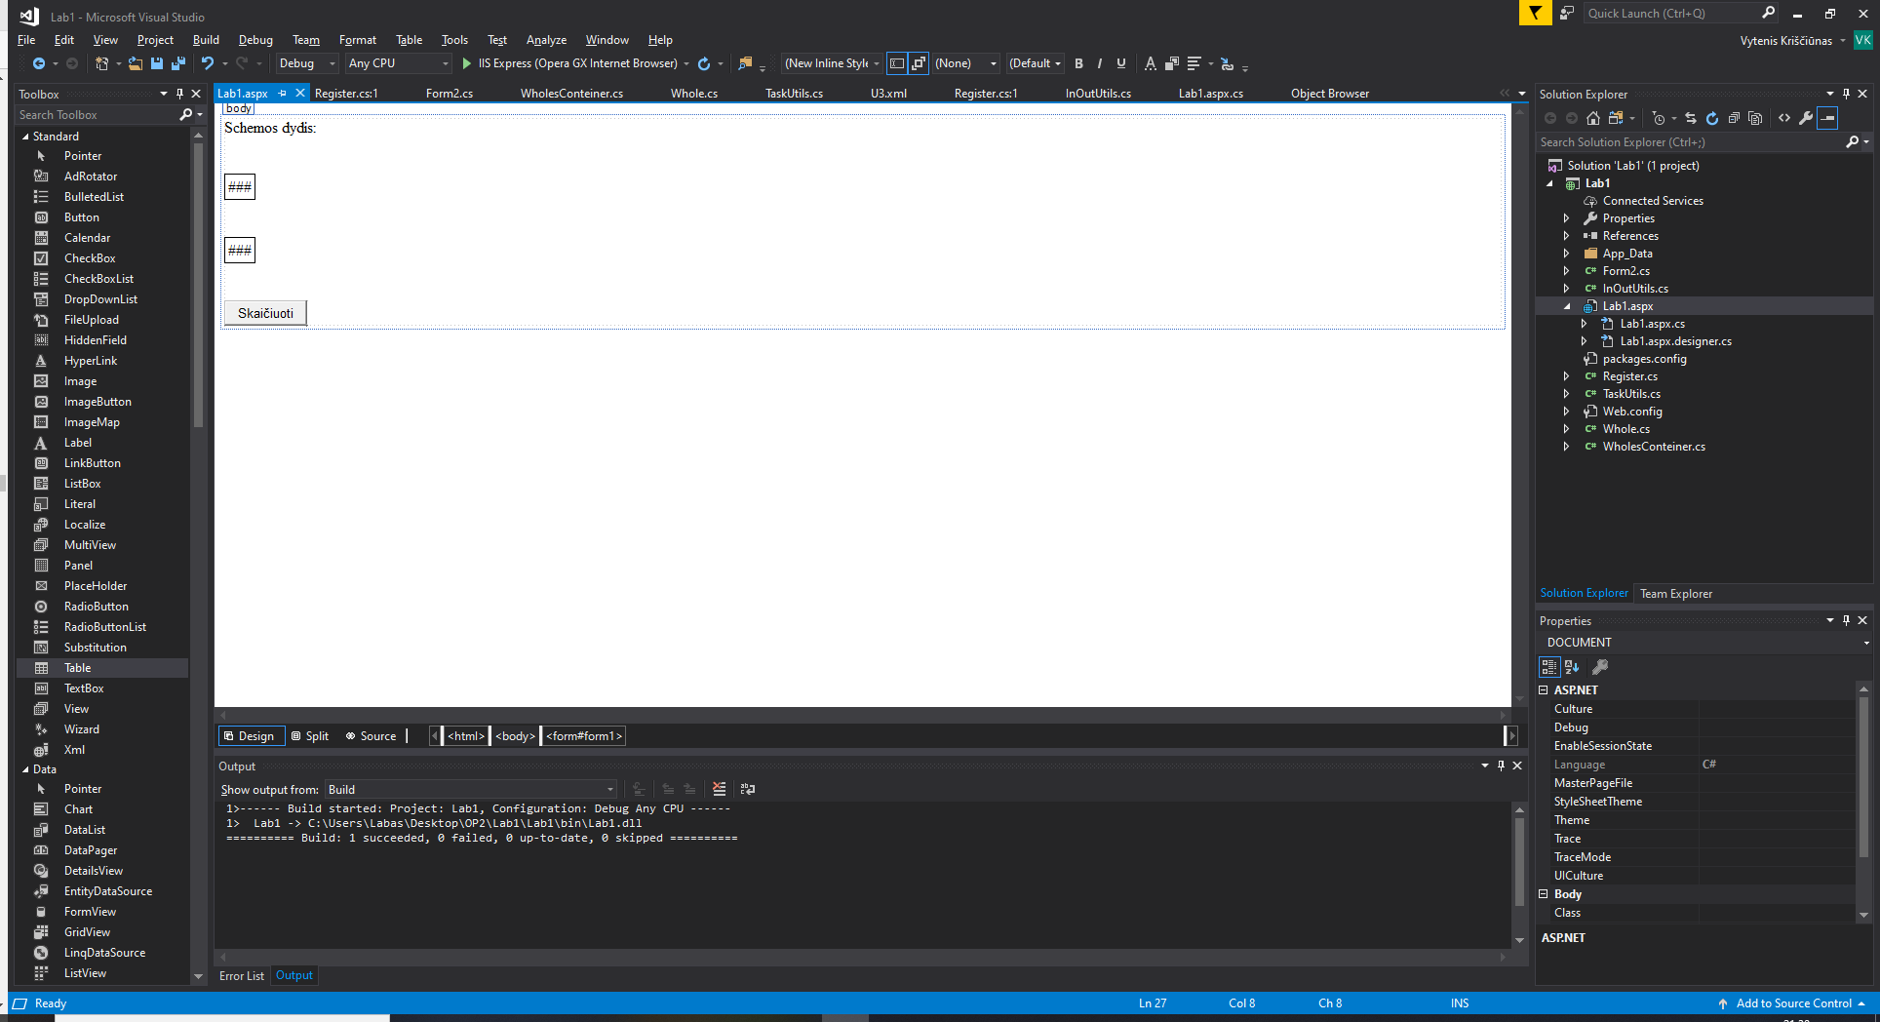

Button1

Table1

Table2

Label1

## Sąsajoje panaudotų komponentų keičiamos savybės

|  |  |  |
| --- | --- | --- |
| Komponentas | Savybė | Reikšmė |
| Button1 | Text | Skaičiuoti |
| Label1 | Text | Schemos dydis: |
| Table1 | BorderColor | Black |
| Table1 | BorderStyle | Solid |
| Table1 | BorderWidth | 1px |
| Table2 | BorderColor | Black |
| Table2 | BorderStyle | Solid |
| Table2 | BorderWidth | 1px |

## Klasių diagrama

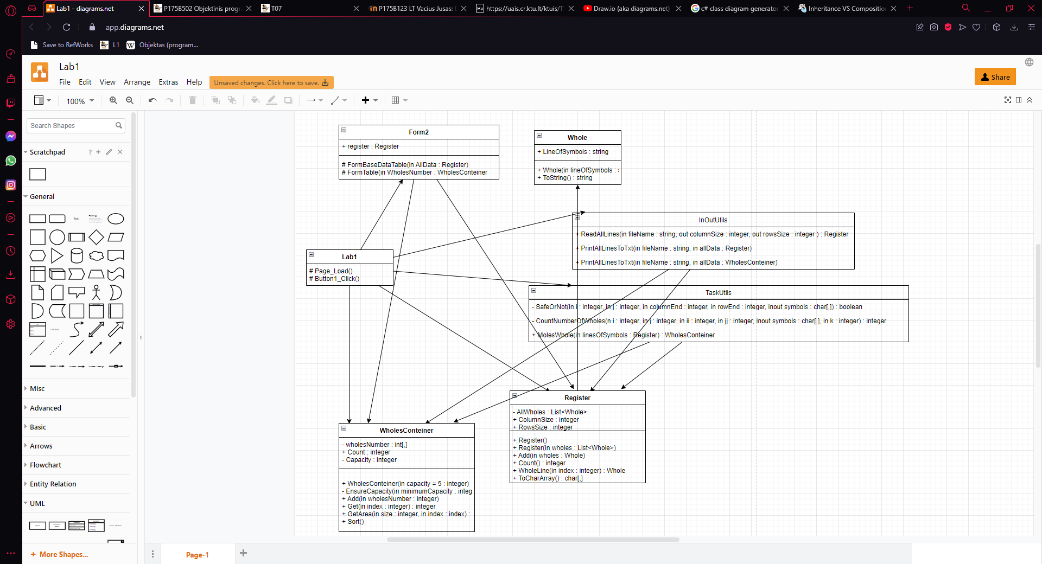

## Programos vartotojo vadovas

Atsidarius puslapiui iškarto galima matyti pirmąjį mygtuką ir pradinius duomenis: schemos dydį ir simbolių lentelę. Paspaudus mygtuką, ant kurio parašyta skaičiuoti atsiranda rezultatų lentelė.

## Programos tekstas

InOutUtils.cs

using System;

using System.Collections.Generic;

using System.Linq;

using System.Web;

using System.IO;

namespace Lab1

{

/// <summary>

/// Class that prints or reads information

/// </summary>

public static class InOutUtils

{

/// <summary>

/// Creates a register of given information

/// </summary>

/// <param name="fileName">Specific file name</param>

/// <param name="columnSize">Information about the columns size</param>

/// <param name="rowsSize">Information about the rows size</param>

/// <returns>Formated list and rows, columns information </returns>

public static Register ReadAllLines(string fileName, out int columnSize, out int rowsSize)

{

Register allWholes = new Register();

string[] allLines = File.ReadAllLines(fileName);

string[] Values = allLines[0].Split(' ');

columnSize = int.Parse(Values[0]);

rowsSize = int.Parse(Values[1]);

for (int i = 0; i < allLines.Count(); i++)

{

if (i > 0)

{

Whole whole = new Whole(allLines[i]);

allWholes.Add(whole);

}

}

return allWholes;

}

/// <summary>

/// Prints information to .txt file

/// </summary>

/// <param name="fileName">Specific file name</param>

/// <param name="allData">Register information</param>

public static void PrintAllLinesToTxt(string fileName, Register allData)

{

string[] lines = new string[allData.Count() + 6];

lines[0] = string.Format(new string('-', 47));

lines[1] = string.Format("| {0,-20} | {1,-20} |", "Eilučių skaičius", "Stulpelių skaičius");

lines[2] = string.Format(new string('-', 47));

lines[3] = string.Format("| {0,20} | {1,20} |", allData.ColumnsSize, allData.RowsSize);

lines[4] = string.Format(new string('-', 47));

for (int i = 0; i < allData.Count(); i++)

{

lines[i + 5] = allData.WholeLine(i).ToString();

}

lines[allData.Count() + 5] = string.Format(new string('-', 24));

File.WriteAllLines(fileName, lines);

}

/// <summary>

/// Prints information to .txt file

/// </summary>

/// <param name="fileName">Specific file name</param>

/// <param name="allData">Conteiner informattion</param>

public static void PrintAllLinesToTxt(string fileName, WholesConteiner allData)

{

string[] lines = new string[allData.Count + 8];

lines[0] = string.Format(new string('-', 24));

lines[1] = string.Format("| {0,-20} |", "Kurmių skaičius");

lines[2] = string.Format(new string('-', 24));

lines[3] = string.Format("| {0,20} |", allData.Count);

lines[4] = string.Format(new string('-', 24));

lines[5] = string.Format("| {0,-20} |", "Kurmių urvų dydžiai");

lines[6] = string.Format(new string('-', 24));

for (int i = 0; i < allData.Count; i++)

{

lines[i + 7] = string.Format("| {0,20} |", allData.GetArea(5, i));

}

lines[allData.Count + 7] = string.Format(new string('-', 24));

File.WriteAllLines(fileName, lines);

}

}

}

Whole.cs

using System;

using System.Collections.Generic;

using System.Linq;

using System.Web;

namespace Lab1

{

/// <summary>

/// Class that gives information about a lines of symbols

/// </summary>

public class Whole

{

/// <summary>

/// String of symbols

/// </summary>

public string LineOfSymbols { get; set; }

/// <summary>

/// Line of symbols constructor

/// </summary>

/// <param name="lineOfSymbols"></param>

public Whole(string lineOfSymbols)

{

this.LineOfSymbols = lineOfSymbols;

}

/// <summary>

/// Overrriden ToString method

/// </summary>

/// <returns>Line of text</returns>

public override string ToString()

{

return string.Format("| {0} |", this.LineOfSymbols);

}

}

}

Register.cs

using System;

using System.Collections.Generic;

using System.Linq;

using System.Web;

namespace Lab1

{

/// <summary>

/// Class that calculates given information

/// </summary>

public class Register

{

/// <summary>

/// List of wholes information

/// </summary>

private List<Whole> AllWholes;

/// <summary>

/// Size of columns

/// </summary>

public int ColumnsSize;

/// <summary>

/// Size of rows

/// </summary>

public int RowsSize;

/// <summary>

/// Formats a list

/// </summary>

public Register()

{

AllWholes = new List<Whole>();

}

/// <summary>

/// Method that disperses information

/// </summary>

/// <param name="wholes">List of members</param>

public Register(List<Whole> wholes)

{

AllWholes = new List<Whole>();

for (int i = 0; i < wholes.Count; i++)

{

AllWholes.Add(wholes[i]);

}

}

/// <summary>

/// Method that adds information to the list

/// </summary>

/// <param name="wholes">Single line of wholes</param>

public void Add(Whole wholes)

{

AllWholes.Add(wholes);

}

/// <summary>

/// Method that counts how many

/// </summary>

/// <returns>Counted rezult</returns>

public int Count()

{

return AllWholes.Count;

}

/// <summary>

/// Method that gives line of information from the list

/// </summary>

/// <param name="index"></param>

/// <returns></returns>

public Whole WholeLine(int index)

{

return AllWholes[index];

}

/// <summary>

/// Method that creates two dimensional char array

/// </summary>

/// <returns>Formated two dimensional char array</returns>

public char[,] ToCharArray()

{

char[,] symbols = new char[ColumnsSize, RowsSize];

for (int i = 0; i < ColumnsSize; i++)

{

for (int j = 0; j < RowsSize; j++)

{

symbols[i, j] = AllWholes[i].LineOfSymbols.ToCharArray()[j];

}

}

return symbols;

}

}

}

TaskUtils.cs

using System;

using System.Collections.Generic;

using System.Linq;

using System.Web;

namespace Lab1

{

/// <summary>

/// A class that does calculations and other tasks

/// </summary>

public static class TaskUtils

{

/// <summary>

/// Method that makes that characters are not out of bound of the array and that there is a searched mole's whole

/// </summary>

/// <param name="i">Column index</param>

/// <param name="j">Row index</param>

/// <param name="columnEnd">Column end index</param>

/// <param name="rowEnd">Row end index</param>

/// <param name="symbols">Array of symbols</param>

/// <returns>True or false</returns>

private static bool SafeOrNot(int i, int j, int columnEnd, int rowEnd, char[,] symbols)

{

if (i < columnEnd && i >= 0 && j < rowEnd && j >= 0 && symbols[i, j] == 'u')

{

return true;

}

else return false;

}

/// <summary>

/// Method that counts the number of mole's created wholes

/// </summary>

/// <param name="i">Column index</param>

/// <param name="j">Row index</param>

/// <param name="ii">Column end index</param>

/// <param name="jj">Row end index</param>

/// <param name="symbols">Array of symbols</param>

/// <param name="k">Integer that is equal to one</param>

/// <returns>Number of wholes</returns>

private static int CountNumberOfWholes(int i, int j, int ii, int jj, char[,] symbols, int k)

{

if (SafeOrNot(i, j, ii, jj, symbols) == true)

{

symbols[i, j] = 'z';

return k + CountNumberOfWholes(i, j + 1, ii, jj, symbols, k) + CountNumberOfWholes(i, j - 1, ii, jj, symbols, k) + CountNumberOfWholes(i + 1, j, ii, jj, symbols, k) + CountNumberOfWholes(i - 1, j, ii, jj, symbols, k);

}

return 0;

}

/// <summary>

/// Method that creates a conteiner of found information about the moles

/// </summary>

/// <param name="linesOfSymbols">Register information</param>

/// <returns>Moles Conteiner</returns>

public static WholesConteiner MolesWholes(Register linesOfSymbols)

{

WholesConteiner molesWholes = new WholesConteiner();

char[,] symbols = linesOfSymbols.ToCharArray();

for (int i = 0; i < linesOfSymbols.ColumnsSize; i++)

{

for (int j = 0; j < linesOfSymbols.RowsSize; j++)

{

int numberOfWholes = CountNumberOfWholes(i, j, linesOfSymbols.ColumnsSize, linesOfSymbols.RowsSize, symbols, 1);

if (numberOfWholes != 0)

{

molesWholes.Add(numberOfWholes);

}

}

}

return molesWholes;

}

}

}

WholesConteiner.cs

using System;

using System.Collections.Generic;

using System.Linq;

using System.Web;

namespace Lab1

{

/// <summary>

/// Conteiner of counted wholes

/// </summary>

public class WholesConteiner

{

/// <summary>

/// Array of wholes

/// </summary>

private int[] wholesNumber;

/// <summary>

/// Count of moles

/// </summary>

public int Count { get; private set; }

/// <summary>

/// Total capacity of moles

/// </summary>

private int Capacity;

/// <summary>

/// WholesConteiner constructor

/// </summary>

/// <param name="capacity">Capacity of moles</param>

public WholesConteiner(int capacity = 5)

{

this.Capacity = capacity;

this.wholesNumber = new int[capacity];

}

/// <summary>

/// Method that makes sure of the moles capacity

/// </summary>

/// <param name="minimumCapacity">Minimum capacity of moles</param>

private void EnsureCapacity(int minimumCapacity)

{

if (minimumCapacity > this.Capacity)

{

int[] temp = new int[minimumCapacity];

for (int i = 0; i < this.Count; i++)

{

temp[i] = wholesNumber[i];

}

this.Capacity = minimumCapacity;

wholesNumber = temp;

}

}

/// <summary>

/// Method that adds wholes number to the array

/// </summary>

/// <param name="wholesNumber">Wholes number</param>

public void Add(int wholesNumber)

{

if (Capacity == Count)

{

EnsureCapacity(Capacity * 2);

}

this.wholesNumber[Count++] = wholesNumber;

}

/// <summary>

/// Method that gives information about mole's number of created wholes

/// </summary>

/// <param name="index">Index of a single mole</param>

/// <returns>Number of wholes</returns>

public int Get(int index)

{

return wholesNumber[index];

}

/// <summary>

/// Method that calculates and gives information about the size of wholes

/// </summary>

/// <param name="size">Size of one whole</param>

/// <param name="index">Index of a single mole</param>

/// <returns>Claculated area informationn</returns>

public int GetArea(int size, int index)

{

return wholesNumber[index] * size;

}

/// <summary>

/// Method that sorts information the conteiner

/// </summary>

public void Sort()

{

for (int i = 0; i < wholesNumber.Count(); i++)

{

for (int j = i + 1; j < wholesNumber.Count(); j++)

{

if (wholesNumber[i] < wholesNumber[j])

{

int a = wholesNumber[i];

int b = wholesNumber[j];

wholesNumber[i] = b;

wholesNumber[j] = a;

}

}

}

}

}

}

Forma2.cs

using System;

using System.Collections.Generic;

using System.Linq;

using System.Web;

using System.Web.UI;

using System.Web.UI.WebControls;

using System.IO;

namespace Lab1

{

/// <summary>

/// Web form extention

/// </summary>

public partial class Lab1 : System.Web.UI.Page

{

/// <summary>

/// Register for given data

/// </summary>

Register register;

/// <summary>

/// Method that forms a Table to the screen

/// </summary>

/// <param name="AllData">Register of base data</param>

protected void FormBaseDataTable(Register AllData)

{

TableRow row1 = new TableRow();

TableCell item1 = new TableCell();

item1.Text = "<b>Simboliai</b>";

row1.Cells.Add(item1);

Table2.Rows.Add(row1);

for (int i = 0; i < AllData.Count(); i++)

{

TableRow row2 = new TableRow();

TableCell item2 = new TableCell();

item2.Text = AllData.WholeLine(i).LineOfSymbols;

row2.Cells.Add(item2);

Table2.Rows.Add(row2);

}

}

/// <summary>

/// Method that forms a Table to the screen

/// </summary>

/// <param name="WholesNumber">Conteiner of rezults</param>

protected void FormTable(WholesConteiner WholesNumber)

{

TableRow row1 = new TableRow();

TableCell item1 = new TableCell();

item1.Text = string.Format("Kurmių skaičius: {0}", WholesNumber.Count);

row1.Cells.Add(item1);

Table1.Rows.Add(row1);

for (int i = 0; i < WholesNumber.Count; i++)

{

TableRow row2 = new TableRow();

TableCell item2 = new TableCell();

item2.Text = string.Format("{0}", WholesNumber.GetArea(5, i));

row2.Cells.Add(item2);

Table1.Rows.Add(row2);

}

}

}

}

Lab1.aspx

<%@ Page Language="C#" AutoEventWireup="true" CodeBehind="Lab1.aspx.cs" Inherits="Lab1.Lab1" %>

<!DOCTYPE html>

<html xmlns="http://www.w3.org/1999/xhtml">

<head runat="server">

<title></title>

</head>

<body>

<form id="form1" runat="server">

<div>

<asp:Label ID="Label1" runat="server" Text="Schemos dydis: "></asp:Label>

<br />

<br />

<asp:Table ID="Table2" runat="server" BorderColor="Black" BorderStyle="Solid" BorderWidth="1px">

</asp:Table>

<br />

<br />

<asp:Table ID="Table1" runat="server" BorderColor="Black" BorderStyle="Solid" BorderWidth="1px">

</asp:Table>

<br />

<br />

<asp:Button ID="Button1" runat="server" OnClick="Button1_Click" Text="Skaičiuoti" />

</div>

</form>

</body>

</html>

Lab1.apsx.cs

using System;

using System.Collections.Generic;

using System.Linq;

using System.Web;

using System.Web.UI;

using System.Web.UI.WebControls;

using System.IO;

//Main function of this program is to find the number of moles and their created wholes numbers

//Vytenis Kriščiūnas

namespace Lab1

{

/// <summary>

/// Web form

/// </summary>

public partial class Lab1 : System.Web.UI.Page

{

/// <summary>

/// Prints information to the screen when page loads

/// </summary>

/// <param name="sender">An object variable</param>

/// <param name="e">EventArgs variable</param>

protected void Page_Load(object sender, EventArgs e)

{

if (register == null)

{

register = new Register();

}

int columnSize, rowsSize;

register = InOutUtils.ReadAllLines(Server.MapPath("App_Data/U3.txt"), out columnSize, out rowsSize);

register.ColumnsSize = columnSize;

register.RowsSize = rowsSize;

InOutUtils.PrintAllLinesToTxt(Server.MapPath("GigvenData.txt"), register);

Label1.Text = "Schemos dydis: " + register.ColumnsSize + " " + register.RowsSize;

FormBaseDataTable(register);

}

/// <summary>

/// Prints information to the screen when first button is clicked

/// </summary>

/// <param name="sender">An object variable</param>

/// <param name="e">EventArgs variable</param>

protected void Button1_Click(object sender, EventArgs e)

{

WholesConteiner countedWholes = TaskUtils.MolesWholes(register);

countedWholes.Sort();

TableRow row = new TableRow();

TableCell item = new TableCell();

item.Text = "<b>Rezultatai</b>";

row.Cells.Add(item);

Table1.Rows.Add(row);

FormTable(countedWholes);

InOutUtils.PrintAllLinesToTxt(Server.MapPath("Rezults.txt"), countedWholes);

}

}

}

Lab1.apsx.designer.cs

//------------------------------------------------------------------------------

// <auto-generated>

// This code was generated by a tool.

//

// Changes to this file may cause incorrect behavior and will be lost if

// the code is regenerated.

// </auto-generated>

//------------------------------------------------------------------------------

namespace Lab1 {

public partial class Lab1 {

/// <summary>

/// form1 control.

/// </summary>

/// <remarks>

/// Auto-generated field.

/// To modify move field declaration from designer file to code-behind file.

/// </remarks>

protected global::System.Web.UI.HtmlControls.HtmlForm form1;

/// <summary>

/// Label1 control.

/// </summary>

/// <remarks>

/// Auto-generated field.

/// To modify move field declaration from designer file to code-behind file.

/// </remarks>

protected global::System.Web.UI.WebControls.Label Label1;

/// <summary>

/// Table2 control.

/// </summary>

/// <remarks>

/// Auto-generated field.

/// To modify move field declaration from designer file to code-behind file.

/// </remarks>

protected global::System.Web.UI.WebControls.Table Table2;

/// <summary>

/// Table1 control.

/// </summary>

/// <remarks>

/// Auto-generated field.

/// To modify move field declaration from designer file to code-behind file.

/// </remarks>

protected global::System.Web.UI.WebControls.Table Table1;

/// <summary>

/// Button1 control.

/// </summary>

/// <remarks>

/// Auto-generated field.

/// To modify move field declaration from designer file to code-behind file.

/// </remarks>

protected global::System.Web.UI.WebControls.Button Button1;

}

}

## Pradiniai duomenys ir rezultatai

Duomenys nr. 1 (Duoti iš sąlygos)

U3.txt

6 15

zzzzzzzzzuzuzzz

uuzuuzuuzuuuzzz

zuzuzzuzuuzuzuz

zuzuzzuzzuzuuuz

zuuuuuuuzuzzzzz

zzzzzuuuzzzzzzz

GivenData.txt

-----------------------------------------------

| Eilučių skaičius | Stulpelių skaičius |

-----------------------------------------------

| 6 | 15 |

-----------------------------------------------

| zzzzzzzzzuzuzzz |

| uuzuuzuuzuuuzzz |

| zuzuzzuzuuzuzuz |

| zuzuzzuzzuzuuuz |

| zuuuuuuuzuzzzzz |

| zzzzzuuuzzzzzzz |

------------------------

Rezults.txt

------------------------

| Kurmių skaičius |

------------------------

| 2 |

------------------------

| Kurmių urvų dydžiai |

------------------------

| 110 |

| 70 |

------------------------

Vartotojo sąsaja

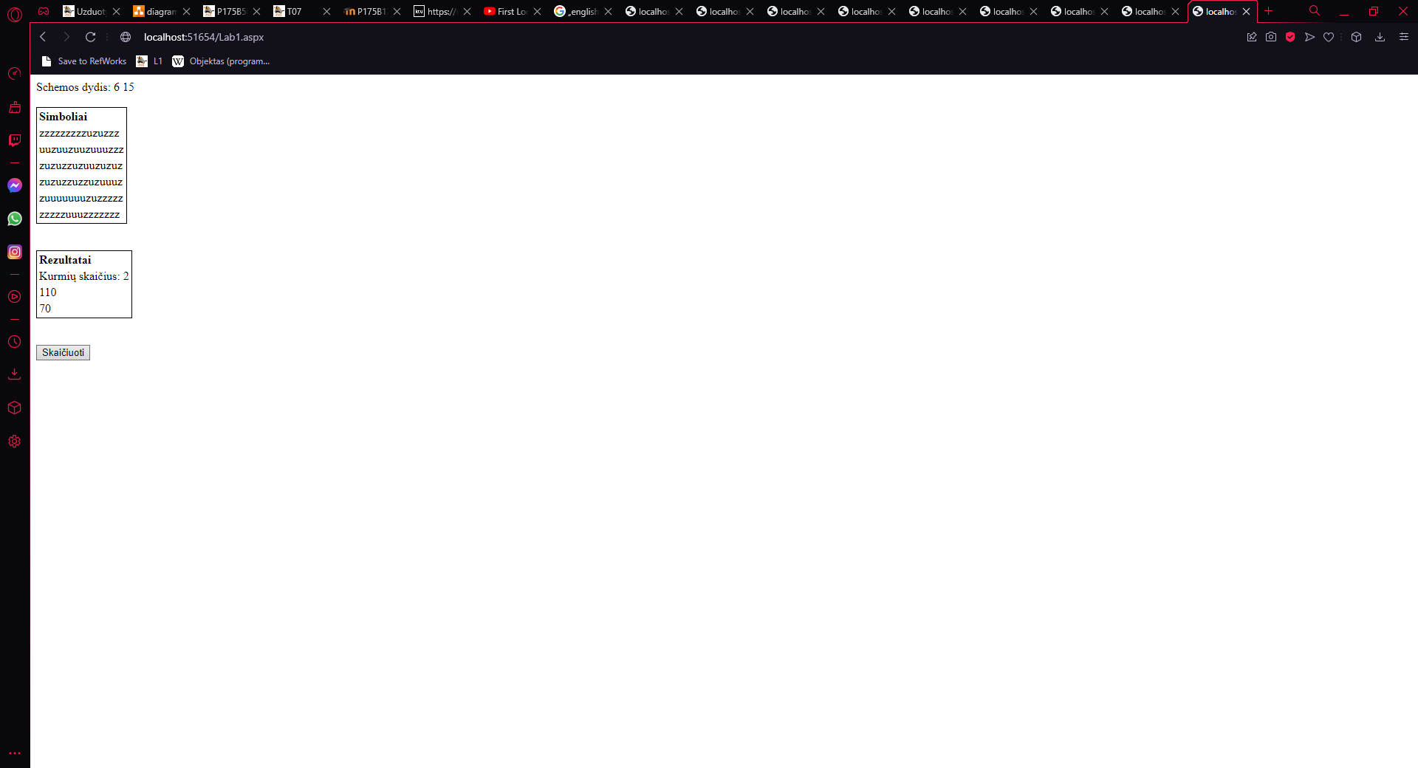

Duomenys nr. 2

U3.txt

3 8

zzzuzzzu

zzuzuuuu

uuzuzzuu

GivenData.txt

-----------------------------------------------

| Eilučių skaičius | Stulpelių skaičius |

-----------------------------------------------

| 3 | 8 |

-----------------------------------------------

| zzzuzzzu |

| zzuzuuuu |

| uuzuzzuu |

------------------------

Rezults.txt

------------------------

| Kurmių skaičius |

------------------------

| 5 |

------------------------

| Kurmių urvų dydžiai |

------------------------

| 35 |

| 10 |

| 5 |

| 5 |

| 5 |

------------------------

Vartotojo sąsaja

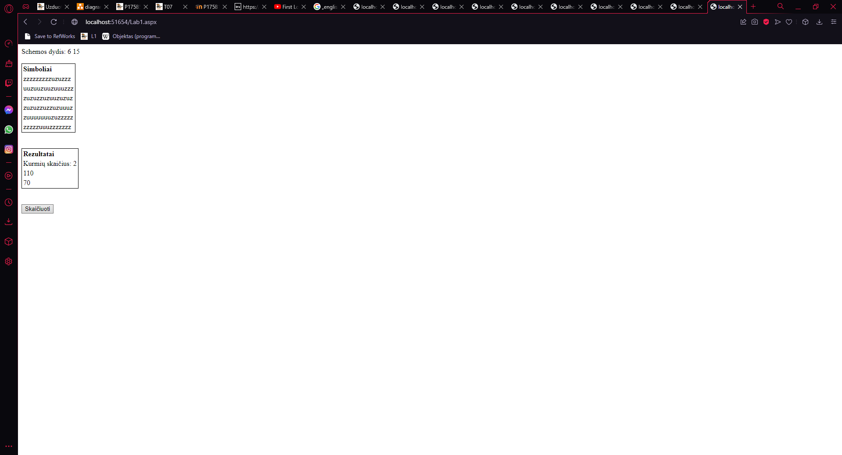

## Dėstytojo pastabos

Savarankiško darbo užduotys: 0.75 / nėra validavimo.

Gynimo testas: 0.0.

Programa: 6.

Ataskaita: 1.

Bendras įvertinimas: 7.

Dėstytojo komentarai:

P2 Sugadintas viršelio šablonas (nėra/bloga dėstytojo pavardės, nėra studento pavardės, neteisingi metai) -0,3. Neteisinga dėstytojo pavardė. P5 Vietoje grafinės naudotojo sąsajos schemos yra pateikta suprogramuotos formos ekrano nuotrauka -0,2. Klasių diagramą reikėtų patobulinti. P8 Nepilnas vartotojo vadovas (duomenys, veiksmų seka, rezultatai) -0,2. P13 Nekomentuoti (arba nepilnai pakomentuoti) metodai -0,2.

# Dinaminis atminties valdymas (L2)

## Darbo užduotis

LD_10. Gamykla. Gamykloje kiekvieną dieną registruojama informacija apie darbininkų pagamintas detales. Darbininkas gali gaminti per dieną skirtingo tipo detales. Suraskite daugiausiai uždirbusio darbininko pavardę, suskaičiuokite, kiek dienų jis dirbo, kiek iš viso detalių pagamino ir už kokią sumą. Sudarykite tik vieno pavadinimo detales gaminusių darbininkų sąrašą, pagamintų detalių skaičių ir sumą. Surikiuokite šį sąrašą pagal pavardes ir vardus. Duomenys:

• Tekstiniame faile U10a.txt surašyta: data (metai, mėnuo, diena), darbininko pavardė ir vardas, detalės kodas, pagamintų vienetų skaičius.

• Tekstiniame faile U10b.txt surašyta: detalės kodas, detalės pavadinimas, įkainis.

Iš duomenų rinkinio faile U10a.txt sudarykite naują duomenų rinkinį pagal nurodytą požymį (pagamintų vienetų skaičius > S, įkainis < K, įvedami klaviatūra). Sąrašas turi būti surikiuotas pagal pavardes ir vardus abėcėlės tvarka.

## Grafinės vartotojo sąsajos schema

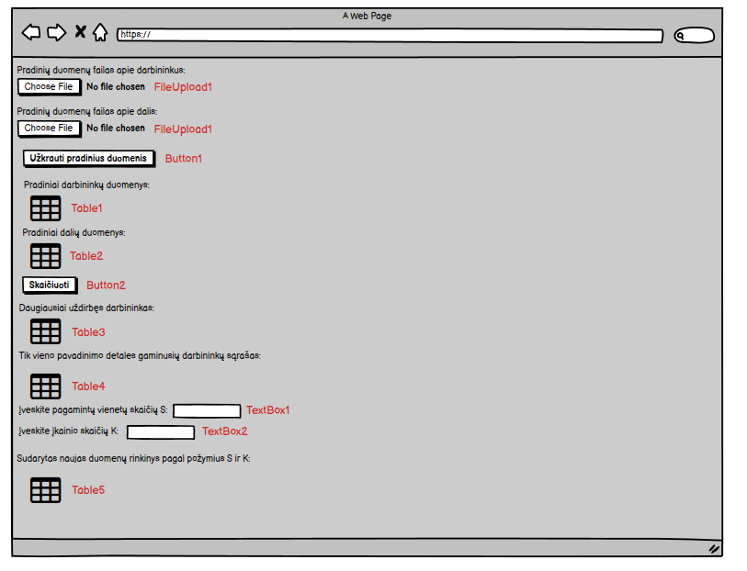

## Sąsajoje panaudotų komponentų keičiamos savybės

|  |  |  |
| --- | --- | --- |
| Komponentas | Savybė | Reikšmė |
| Div | Class | TextSize |
| Body | Backgroud-color | Cadetblue |
| FileUpload1 | CssClass | BoldText |
| FileUpload2 | CssClass | BoldText |
| Button1 | CssClass | BoldText |
| Button1 | Text | Užkrauti pradinius duomenis |
| Table1 | BorderStyle | Solid |
| Table1 | BorderWidth | 1px |
| Table1 | GridLines | Both |
| Table1 | CssClass | Table |
| Table2 | BorderStyle | Solid |
| Table2 | BorderWidth | 1px |
| Table2 | GridLines | Both |
| Table2 | CssClass | Table |
| Table3 | BorderStyle | Solid |
| Table3 | BorderWidth | 1px |
| Table3 | GridLines | Both |
| Table3 | CssClass | Table |
| Table4 | BorderStyle | Solid |
| Table4 | BorderWidth | 1px |
| Table4 | GridLines | Both |
| Table4 | CssClass | Table |
| Table5 | BorderStyle | Solid |
| Table5 | BorderWidth | 1px |
| Table5 | GridLines | Both |
| Table5 | CssClass | Table |
| Button2 | CssClass | BoldText |
| Button2 | Text | Skaičiuoti |

## Klasių diagrama

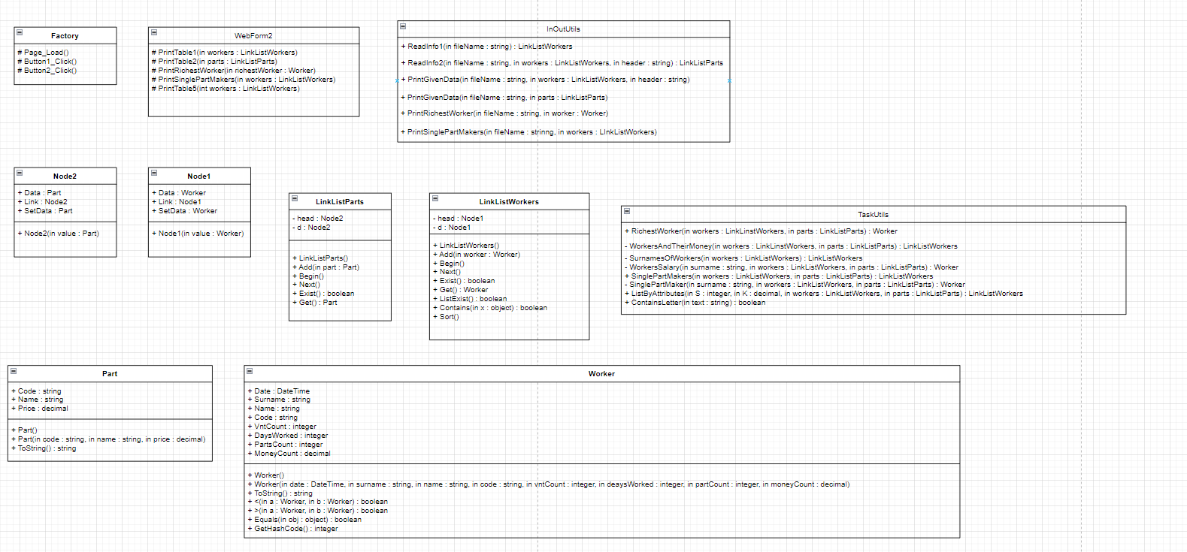

## Programos vartotojo vadovas

Kai atidarome programą, matome dvi vietas įkelti failams. Visų pirma reikia įkelti detalių gamintojų duomenis (U10a.txt), tada detalių duomenis (U10b.txt). Teksto rašymo laukeliuose vartotojas gali įrašyti darbininko pagamintų vienos rūšies detalių skaičių ir detalių įkainio vertę. Užkrovus pradinius duomenis reikia spausti ant mygtuko – užkrauti pradinius duomenis ir tada atsiranda pradinių duomenų lentelė, o į GivenData.txt failą yra išspausdinami pradiniai duomenys. Spustelėjus ant mygtuko – skaičiuoti, atsiranda dar trys lentelės su informacija ir į Rezults.txt failą yra išspausdinami rezultatai. Jeigu pradiniai duomenys nėra užkraunami, tai ir rezultatų failas nėra sukuriamas.

## Programos tekstas

InOutUtils.cs

using System;

using System.Collections.Generic;

using System.Linq;

using System.Web;

using System.IO;

using System.Text;

namespace Lab2

{

/// <summary>

/// Class that prints or reads information

/// </summary>

public static class InOutUtils

{

/// <summary>

/// Creates a list of workers

/// </summary>

/// <param name="fileName">Specific file name of given data</param>

/// <returns>Formated list</returns>

public static LinkListWorkers ReadInfo1(string fileName)

{

LinkListWorkers list = new LinkListWorkers();

string[] lines = File.ReadAllLines(fileName, Encoding.UTF8);

foreach (string line in lines)

{

string[] Values = line.Split(' ');

DateTime date = DateTime.Parse(Values[0]);

string surname = Values[1];

string name = Values[2];

string code = Values[3];

int vntCount = int.Parse(Values[4]);

Worker worker = new Worker(date, surname, name, code, vntCount, 0, 0, 0);

list.Add(worker);

}

return list;

}

/// <summary>

/// Creates a list of different parts

/// </summary>

/// <param name="fileName">Specific file name of given data</param>

/// <returns>Formated list</returns>

public static LinkListParts ReadInfo2(string fileName)

{

LinkListParts list = new LinkListParts();

string[] lines = File.ReadAllLines(fileName, Encoding.UTF8);

foreach (string line in lines)

{

string[] Values = line.Split(' ');

string code = Values[0];

string name = Values[1];

decimal price = decimal.Parse(Values[2]);

Part part = new Part(code, name, price);

list.Add(part);

}

return list;

}

/// <summary>

/// Method that print information about workers to .txt file

/// </summary>

/// <param name="fileName">Specific file name of the place where information will be printed</param>

/// <param name="workers">List of workers</param>

/// <param name="header">Specific header of the information</param>

public static void PrintGivenData(string fileName, LinkListWorkers workers, string header)

{

using (var writer = File.AppendText(fileName))

{

if (header != "")

{

writer.WriteLine(header);

}

writer.WriteLine(new string('-', 116));

for (workers.Begin(); workers.Exist(); workers.Next())

{

writer.WriteLine(workers.Get().ToString());

}

writer.WriteLine(new string('-', 116));

writer.WriteLine();

writer.Close();

}

}

/// <summary>

/// Method that print information about parts to .txt file

/// </summary>

/// <param name="fileName">Specific file name of the place where information will be printed</param>

/// <param name="parts">List of parts</param>

public static void PrintGivenData(string fileName, LinkListParts parts)

{

using (var writer = File.AppendText(fileName))

{

writer.WriteLine(new string('-', 70));

for (parts.Begin(); parts.Exist(); parts.Next())

{

writer.WriteLine(parts.Get().ToString());

}

writer.WriteLine(new string('-', 70));

writer.WriteLine();

writer.Close();

}

}

/// <summary>

/// Method that prints who is the richest worker

/// </summary>

/// <param name="fileName">Specific file name of the place where information will be printed</param>

/// <param name="worker">Information about one worker</param>

public static void PrintRichestWorker(string fileName, Worker worker)

{

using (var writer = File.AppendText(fileName))

{

writer.WriteLine("Daugiausiai uždirbęs darbininkas:");

writer.WriteLine(new string('-', 93));

writer.WriteLine(worker.ToString());

writer.WriteLine(new string('-', 93));

writer.WriteLine();

writer.Close();

}

}

/// <summary>

/// Method that prints information about workers who make only one type of parts

/// </summary>

/// <param name="fileName">Specific file name of the place where information will be printed</param>

/// <param name="workers">List of workers</param>

public static void PrintSinglePartMakers(string fileName, LinkListWorkers workers)

{

using (var writer = File.AppendText(fileName))

{

writer.WriteLine("Tik vieno pavadinimo detales gaminusių darbininkų sąrašas:");

writer.WriteLine(new string('-', 116));

for (workers.Begin(); workers.Exist(); workers.Next())

{

writer.WriteLine(workers.Get().ToString());

}

writer.WriteLine(new string('-', 116));

writer.WriteLine();

writer.Close();

}

}

}

}

Part.cs

using System;

using System.Collections.Generic;

using System.Linq;

using System.Web;

namespace Lab2

{

/// <summary>

/// Parts data class

/// </summary>

public class Part

{

/// <summary>

/// Part's code

/// </summary>

public string Code { get; set; }

/// <summary>

/// Name of the part

/// </summary>

public string Name{ get; set; }

/// <summary>

/// Part's value

/// </summary>

public decimal Price { get; set; }

/// <summary>

/// First constructor

/// </summary>

public Part()

{

}

/// <summary>

/// Second constructor

/// </summary>

/// <param name="code">Part's code</param>

/// <param name="name">Name of the part</param>

/// <param name="price">Part's value</param>

public Part(string code, string name, decimal price)

{

this.Code = code;

this.Name = name;

this.Price = price;

}

/// <summary>

/// Overriden ToString method

/// </summary>

/// <returns>A formated string</returns>

public override string ToString()

{

return string.Format("| {0,-20} | {1,-20} | {2,20} |", Code, Name, Price);

}

}

}

Worker.cs

using System;

using System.Collections.Generic;

using System.Linq;

using System.Web;

namespace Lab2

{

/// <summary>

/// Workers data class

/// </summary>

public class Worker

{

/// <summary>

/// Specific date

/// </summary>

public DateTime Date { get; set; }

/// <summary>

/// Worker's surname

/// </summary>

public string Surname { get; set; }

/// <summary>

/// Worker's name

/// </summary>

public string Name { get; set; }

/// <summary>

/// Part's code

/// </summary>

public string Code { get; set; }

/// <summary>

/// Number of parts

/// </summary>

public int VntCount { get; set; }

/// <summary>

/// Total number of days worked

/// </summary>

public int DaysWorked { get; set; }

/// <summary>

/// Total number of made parts

/// </summary>

public int PartsCount { get; set; }

/// <summary>

/// Total Salary of a worker

/// </summary>

public decimal MoneyCount { get; set; }

/// <summary>

/// First constructor

/// </summary>

public Worker()

{

}

/// <summary>

/// Second constructor

/// </summary>

/// <param name="date">Specific date </param>

/// <param name="surname">Worker's surname</param>

/// <param name="name">Worker's name</param>

/// <param name="code">Part's code</param>

/// <param name="vntCount">Number of parts</param>

/// <param name="daysWorked">Total number of days worked</param>

/// <param name="partCount">Total number of made parts</param>

/// <param name="moneyCount">Total Salary of a worker</param>

public Worker(DateTime date, string surname, string name, string code, int vntCount, int daysWorked, int partCount, decimal moneyCount)

{

this.Date = date;

this.Surname = surname;

this.Name = name;

this.Code = code;

this.VntCount = vntCount;

this.DaysWorked = daysWorked;

this.PartsCount = partCount;

this.MoneyCount = moneyCount;

}

/// <summary>

/// Overriden ToString method

/// </summary>

/// <returns>A formated string</returns>

public override string ToString()

{

if (Date != DateTime.MinValue)

{

return string.Format("| {0,-20:yyyy-MM-dd} | {1,-20} | {2,-20} | {3,-20} | {4,20} |", Date, Surname, Name, Code, VntCount);

}

else if (Name == null)

{

return string.Format("| {0,-20} | {1,20} | {2,20} | {3,20} |", Surname, DaysWorked, PartsCount, MoneyCount);

}

else

return string.Format("| {0,-20} | {1,-20} | {2,-20} | {3,20} | {4,20} |", Surname, Name, Code, PartsCount, MoneyCount);

}

/// <summary>

/// Overloading operator <

/// </summary>

/// <param name="a">First worker</param>

/// <param name="b">Second worker</param>

/// <returns>If it is true or false</returns>

public static bool operator <(Worker a, Worker b)

{

if (a.Surname != b.Surname)

{

return a.Surname.CompareTo(b.Surname) < 0;

}

else return a.Name.CompareTo(b.Name) < 0;

}

/// <summary>

/// Overloading operator >

/// </summary>

/// <param name="a">First worker</param>

/// <param name="b">Second worker</param>

/// <returns>If it is true or false</returns>

public static bool operator >(Worker a, Worker b)

{

if (a.Surname != b.Surname)

{

return a.Surname.CompareTo(b.Surname) > 0;

}

else return a.Name.CompareTo(b.Name) > 0;

}

/// <summary>

/// Overriden Equals method

/// </summary>

/// <param name="obj">An object type variable</param>

/// <returns>If it is true or false</returns>

public override bool Equals(object obj)

{

if (Surname.Equals(obj) == true)

{

return true;

}

else if (Code.Equals(obj) == true)

{

return true;

}

else if (Date.Equals(obj) == true)

{

return true;

}

return false;

}

/// <summary>

/// Overriden GetHashCode method

/// </summary>

/// <returns>Int type value</returns>

public override int GetHashCode()

{

return base.GetHashCode();

}

}

}

Node1.cs

using System;

using System.Collections.Generic;

using System.Linq;

using System.Web;

namespace Lab2

{

/// <summary>

/// Workers node class

/// </summary>

public sealed class Node1

{

/// <summary>

/// Data about a worker

/// </summary>

public Worker Data { get; private set; }

/// <summary>

/// A link to further information about workers

/// </summary>

public Node1 Link { get; set; }

/// <summary>

/// Constructor

/// </summary>

/// <param name="value">One worker's information</param>

public Node1(Worker value)

{

this.Data = value;

this.Link = null;

}

/// <summary>

/// Allows to define data's information

/// </summary>

public Worker SetData

{

set { this.Data = value; }

}

}

}

Node2.cs

using System;

using System.Collections.Generic;

using System.Linq;

using System.Web;

namespace Lab2

{

/// <summary>

/// Parts node class

/// </summary>

public sealed class Node2

{

/// <summary>

/// Data about a part

/// </summary>

public Part Data { get; private set; }

/// <summary>

/// A link to further information about parts

/// </summary>

public Node2 Link { get; set; }

/// <summary>

/// Constructor

/// </summary>

/// <param name="value">One part's information</param>

public Node2(Part value)

{

this.Data = value;

this.Link = null;

}

/// <summary>

/// Allows to define data's information

/// </summary>

public Part SetData

{

set { this.Data = value; }

}

}

}

LinkListWorkers.cs

using System;

using System.Collections.Generic;

using System.Linq;

using System.Web;

namespace Lab2

{

/// <summary>

/// Class that formats a list of workers

/// </summary>

public sealed class LinkListWorkers

{

/// <summary>

/// Head of the information

/// </summary>

private Node1 head;

/// <summary>

/// Created for interface of list

/// </summary>

private Node1 d;

/// <summary>

/// Constructor

/// </summary>

public LinkListWorkers()

{

this.head = new Node1(new Worker());

this.d = null;

}

/// <summary>

/// Method that adds information to the list

/// </summary>

/// <param name="worker">One worker</param>

public void Add(Worker worker)

{

Node1 current = head;

while (current.Link != null)

{

current = current.Link;

}

current.Link = new Node1(worker);

}

/// <summary>

/// Address of the head of the list is assigned

/// </summary>

public void Begin()

{

d = head.Link;

}

/// <summary>

/// Interface variable gets address of the next entry

/// </summary>

public void Next()

{

d = d.Link;

}

/// <summary>

/// Return true, if list is empty

/// </summary>

/// <returns>If it's true or false</returns>

public bool Exist()

{

return d != null;

}

/// <summary>

/// Method that return data according to the interface address

/// </summary>

/// <returns>Data of one worker</returns>

public Worker Get()

{

return d.Data;

}

/// <summary>

/// Return true if list has data

/// </summary>

/// <returns>If it's true or false</returns>

public bool ListExist()

{

if (this.head.Link != null)

{

return true;

}

return false;

}

/// <summary>

/// Method that finds out if list has specific data or not

/// </summary>

/// <param name="x">Specific data</param>

/// <returns>If it is true or false</returns>

public bool Contains(object x)

{

for (Node1 current = head.Link; current != null; current = current.Link)

{

if (current.Data.Equals(x))

{

return true;

}

}

return false;

}

/// <summary>

/// Method that sorts the list

/// </summary>

public void Sort()

{

for (Node1 d1 = head; d1 != null; d1 = d1.Link)

{

Node1 min = d1;

for (Node1 d2 = d1.Link; d2 != null; d2 = d2.Link)

{

if (d2.Data < min.Data)

{

min = d2;

}

}

Worker worker = d1.Data;

d1.SetData = min.Data;

min.SetData = worker;

}

}

}

}

LinkListParts.cs

using System;

using System.Collections.Generic;

using System.Linq;

using System.Web;

namespace Lab2

{

/// <summary>

/// Class that formats a list of parts

/// </summary>

public sealed class LinkListParts

{

/// <summary>

/// Head of the information

/// </summary>

private Node2 head;

/// <summary>

/// Created for interface of list

/// </summary>

private Node2 d;

/// <summary>

/// Constructor

/// </summary>

public LinkListParts()

{

this.head = new Node2(new Part());

this.d = null;

}

/// <summary>

/// Method that adds information to the list

/// </summary>

/// <param name="part">Single part</param>

public void Add(Part part)

{

Node2 current = head;

while (current.Link != null)

{

current = current.Link;

}

current.Link = new Node2(part);

}

/// <summary>

/// Address of the head of the list is assigned

/// </summary>

public void Begin()

{

d = head.Link;

}

/// <summary>

/// Interface variable gets address of the next entry

/// </summary>

public void Next()

{

d = d.Link;

}

/// <summary>

/// Return true, if list is empty

/// </summary>

/// <returns>If it's true or false</returns>

public bool Exist()

{

return d != null;

}

/// <summary>

/// Method that return data according to the interface address

/// </summary>

/// <returns>Data of one part</returns>

public Part Get()

{

return d.Data;

}

}

}

TaskUtils.cs

using System;

using System.Collections.Generic;

using System.Linq;

using System.Web;

namespace Lab2

{

/// <summary>

/// Class where calculations are being made

/// </summary>

public static class TaskUtils

{

/// <summary>

/// Method that finds the richest worker

/// </summary>

/// <param name="workers">List of workers</param>

/// <param name="parts">List of parts</param>

/// <returns>One worker</returns>

public static Worker RichestWorker(LinkListWorkers workers, LinkListParts parts)

{

LinkListWorkers workersAndTheirMoney = WorkersAndTheirMoney(workers, parts);

Worker worker = new Worker();

decimal money = 0;

for (workersAndTheirMoney.Begin(); workersAndTheirMoney.Exist(); workersAndTheirMoney.Next())

{

if (workersAndTheirMoney.Get().MoneyCount > money)

{

money = workersAndTheirMoney.Get().MoneyCount;

worker = workersAndTheirMoney.Get();

}

}

return worker;

}

/// <summary>

/// Method that formats a list of workers and their salaries

/// </summary>

/// <param name="workers">List of workers</param>

/// <param name="parts">List of parts</param>

/// <returns>A list</returns>

private static LinkListWorkers WorkersAndTheirMoney(LinkListWorkers workers, LinkListParts parts)

{

LinkListWorkers listOfWorkers = new LinkListWorkers();

LinkListWorkers surnamesOfWorkers = SurnamesOfWorkers(workers);

for (surnamesOfWorkers.Begin(); surnamesOfWorkers.Exist(); surnamesOfWorkers.Next())

{

Worker worker = WorkersSalary(surnamesOfWorkers.Get().Surname, workers, parts);

listOfWorkers.Add(worker);

}

return listOfWorkers;

}

/// <summary>

/// Method that formats a list of workers who can repeat only once

/// </summary>

/// <param name="workers">List of workers</param>

/// <returns>A list</returns>

private static LinkListWorkers SurnamesOfWorkers(LinkListWorkers workers)

{

LinkListWorkers surnames = new LinkListWorkers();

for (workers.Begin(); workers.Exist(); workers.Next())

{

if (!surnames.Contains(workers.Get().Surname))

{

surnames.Add(workers.Get());

}

}

return surnames;

}

/// <summary>

/// Method that count's worker's salary

/// </summary>

/// <param name="surname">Worker's surname</param>

/// <param name="workers">List of workers</param>

/// <param name="parts">List of parts</param>

/// <returns>One worker</returns>

private static Worker WorkersSalary(string surname, LinkListWorkers workers, LinkListParts parts)

{

int DaysWorked = 0;

int PartsCount = 0;

decimal MoneyCount = 0;

LinkListWorkers date = new LinkListWorkers();

for (workers.Begin(); workers.Exist(); workers.Next())

{

if (workers.Get().Surname == surname)

{

decimal money = 0;

PartsCount = PartsCount + workers.Get().VntCount;

for (parts.Begin(); parts.Exist(); parts.Next())

{

if (workers.Get().Code == parts.Get().Code)

{

money = workers.Get().VntCount * parts.Get().Price;

}

}

MoneyCount = MoneyCount + money;

if (!date.Contains(workers.Get().Date))

{

date.Add(workers.Get());

DaysWorked++;

}

}

}

Worker worker = new Worker(DateTime.MinValue, surname, null, null, 0, DaysWorked, PartsCount, MoneyCount);

return worker;

}

/// <summary>

/// Method that formats a list of workers who make only one type of parts

/// </summary>

/// <param name="workers">List of workers</param>

/// <param name="parts">List of parts</param>

/// <returns>Formated list</returns>

public static LinkListWorkers SinglePartMakers(LinkListWorkers workers, LinkListParts parts)

{

LinkListWorkers singlePartsWorkers = new LinkListWorkers();

LinkListWorkers surnamesOfWorkers = SurnamesOfWorkers(workers);

for (surnamesOfWorkers.Begin(); surnamesOfWorkers.Exist(); surnamesOfWorkers.Next())

{

Worker worker = SinglePartMaker(surnamesOfWorkers.Get().Surname, workers, parts);

if (worker != null)

{

singlePartsWorkers.Add(worker);

}

}

return singlePartsWorkers;

}

/// <summary>

/// Method that finds workers who make only one type of parts

/// </summary>

/// <param name="surname">Worker's surname</param>

/// <param name="workers">List of workers</param>

/// <param name="parts">List of parts</param>

/// <returns>A worker</returns>

private static Worker SinglePartMaker(string surname, LinkListWorkers workers, LinkListParts parts)

{

LinkListWorkers onePartMaker = new LinkListWorkers();

Worker worker = new Worker();

int totalNumberOfParts = 0;

decimal moneyCount = 0;

int howManyParts = 0;

for (workers.Begin(); workers.Exist(); workers.Next())

{

if (workers.Get().Surname == surname && !onePartMaker.Contains(workers.Get().Code))

{

onePartMaker.Add(workers.Get());

howManyParts++;

}

if (workers.Get().Surname == surname)

{

decimal money = 0;

totalNumberOfParts = totalNumberOfParts + workers.Get().VntCount;

for (parts.Begin(); parts.Exist(); parts.Next())

{

if (workers.Get().Code == parts.Get().Code)

{

money = workers.Get().VntCount * parts.Get().Price;

}

}

moneyCount = moneyCount + money;

worker = new Worker(DateTime.MinValue, workers.Get().Surname, workers.Get().Name, workers.Get().Code, 0, 0, totalNumberOfParts, moneyCount);

}

}

if (howManyParts == 1)

{

return worker;

}

return null;

}

/// <summary>

/// Method that formats a list of workers defined by attributes

/// </summary>

/// <param name="S">Number of parts</param>

/// <param name="K">Value of price</param>

/// <param name="workers">List of workers</param>

/// <param name="parts">List of parts</param>

/// <returns>A list</returns>

public static LinkListWorkers ListByAttributes(int S, decimal K, LinkListWorkers workers, LinkListParts parts)

{

LinkListWorkers listOfWorkers = new LinkListWorkers();

for (workers.Begin(); workers.Exist(); workers.Next())

{

if (workers.Get().VntCount > S)

{

for (parts.Begin(); parts.Exist(); parts.Next())

{

if (workers.Get().Code == parts.Get().Code && parts.Get().Price < K)

{

listOfWorkers.Add(workers.Get());

}

}

}

}

return listOfWorkers;

}

/// <summary>

/// Method that finds out if a string type variable has a specific symbol and returns true or false

/// </summary>

/// <param name="text">String type variable</param>

/// <returns>If it is true or false</returns>

public static bool ContainsLetter(string text)

{

string alphabet = "ABCDEFGHIJKLMNOPQRSTUVWXYZabcdefghjklmnopqrstuvwxyząčęėįšųūžĄČĘĖĮŠŲŪŽ";

foreach (char a in alphabet)

{

if (text.Contains(a))

{

return true;

}

}

return false;

}

}

}

WebForm2.cs

using System;

using System.Collections.Generic;

using System.Linq;

using System.Web;

using System.Web.UI;

using System.Web.UI.WebControls;

using System.IO;

namespace Lab2

{

/// <summary>

/// Web form extention

/// </summary>

public partial class Factory : System.Web.UI.Page

{

/// <summary>

/// Method that forms Table1

/// </summary>

/// <param name="workers">List of wrokers</param>

protected void PrintTable1(LinkListWorkers workers)

{

TableRow row = new TableRow();

TableCell cell1 = new TableCell();

cell1.Text = "<b>Data</b>";

row.Cells.Add(cell1);

TableCell cell2 = new TableCell();

cell2.Text = "<b>Pavardė</b>";

row.Cells.Add(cell2);

TableCell cell3 = new TableCell();

cell3.Text = "<b>Vardas</b>";

row.Cells.Add(cell3);

TableCell cell4 = new TableCell();

cell4.Text = "<b>Kodas</b>";

row.Cells.Add(cell4);

TableCell cell5 = new TableCell();

cell5.Text = "<b>Detalių skaičius</b>";

row.Cells.Add(cell5);

Table1.Rows.Add(row);

for (workers.Begin(); workers.Exist(); workers.Next())

{

TableRow newRow = new TableRow();

TableCell newCell1 = new TableCell();

newCell1.Text = string.Format("{0:yyyy-MM-dd}", workers.Get().Date);

newRow.Cells.Add(newCell1);

TableCell newCell2 = new TableCell();

newCell2.Text = string.Format("{0}", workers.Get().Surname);

newRow.Cells.Add(newCell2);

TableCell newCell3 = new TableCell();

newCell3.Text = string.Format("{0}", workers.Get().Name);

newRow.Cells.Add(newCell3);

TableCell newCell4 = new TableCell();

newCell4.Text = string.Format("{0}", workers.Get().Code);

newRow.Cells.Add(newCell4);

TableCell newCell5 = new TableCell();

newCell5.Text = string.Format("{0}", workers.Get().VntCount);

newRow.Cells.Add(newCell5);

Table1.Rows.Add(newRow);

}

}

/// <summary>

/// Method that forms Table2

/// </summary>

/// <param name="parts">List of parts</param>

protected void PrintTable2(LinkListParts parts)

{

TableRow row = new TableRow();

TableCell cell1 = new TableCell();

cell1.Text = "<b>Kodas</b>";

row.Cells.Add(cell1);

TableCell cell2 = new TableCell();

cell2.Text = "<b>Pavadinimas</b>";

row.Cells.Add(cell2);

TableCell cell3 = new TableCell();

cell3.Text = "<b>Kaina</b>";

row.Cells.Add(cell3);

Table2.Rows.Add(row);

for (parts.Begin(); parts.Exist(); parts.Next())

{

TableRow newRow = new TableRow();

TableCell newCell1 = new TableCell();

newCell1.Text = string.Format("{0}", parts.Get().Code);

newRow.Cells.Add(newCell1);

TableCell newCell2 = new TableCell();

newCell2.Text = string.Format("{0}", parts.Get().Name);

newRow.Cells.Add(newCell2);

TableCell newCell3 = new TableCell();

newCell3.Text = string.Format("{0}", parts.Get().Price);

newRow.Cells.Add(newCell3);

Table2.Rows.Add(newRow);

}

}

/// <summary>

/// Method that forms Table3

/// </summary>

/// <param name="richestWorker">A single worker</param>

protected void PrintRichestWorker(Worker richestWorker)

{

TableRow row = new TableRow();

TableCell cell1 = new TableCell();

cell1.Text = "<b>Pavardė</b>";

row.Cells.Add(cell1);

TableCell cell2 = new TableCell();

cell2.Text = "<b>Dirbtų dienų skaičius</b>";

row.Cells.Add(cell2);

TableCell cell3 = new TableCell();

cell3.Text = "<b>Pagamintų detalių skaičius</b>";

row.Cells.Add(cell3);

TableCell cell4 = new TableCell();

cell4.Text = "<b>Uždirbti pinigai</b>";

row.Cells.Add(cell4);

Table3.Rows.Add(row);

if (richestWorker.Surname != null)

{

TableRow newRow = new TableRow();

TableCell cell5 = new TableCell();

cell5.Text = string.Format("{0}", richestWorker.Surname);

newRow.Cells.Add(cell5);

TableCell cell6 = new TableCell();

cell6.Text = string.Format("{0}", richestWorker.DaysWorked);

newRow.Cells.Add(cell6);

TableCell cell7 = new TableCell();

cell7.Text = string.Format("{0}", richestWorker.PartsCount);

newRow.Cells.Add(cell7);

TableCell cell8 = new TableCell();

cell8.Text = string.Format("{0}", richestWorker.MoneyCount);

newRow.Cells.Add(cell8);

Table3.Rows.Add(newRow);

}

}

/// <summary>

/// Method that forms Table4

/// </summary>

/// <param name="workers">List of workers</param>

protected void PrintSinglePartMakers(LinkListWorkers workers)

{

TableRow row = new TableRow();

TableCell cell1 = new TableCell();

cell1.Text = "<b>Pavardė</b>";

row.Cells.Add(cell1);

TableCell cell2 = new TableCell();

cell2.Text = "<b>Vardas</b>";

row.Cells.Add(cell2);

TableCell cell3 = new TableCell();

cell3.Text = "<b>Detalės kodas</b>";

row.Cells.Add(cell3);

TableCell cell4 = new TableCell();

cell4.Text = "<b>Skaičius vienodų detalių</b>";

row.Cells.Add(cell4);

TableCell cell5 = new TableCell();

cell5.Text = "<b>Uždirbtų pinigų suma</b>";

row.Cells.Add(cell5);

Table4.Rows.Add(row);

for (workers.Begin(); workers.Exist(); workers.Next())

{

TableRow newRow = new TableRow();

TableCell newCell1 = new TableCell();

newCell1.Text = string.Format("{0}", workers.Get().Surname);

newRow.Cells.Add(newCell1);

TableCell newCell2 = new TableCell();

newCell2.Text = string.Format("{0}", workers.Get().Name);

newRow.Cells.Add(newCell2);

TableCell newCell3 = new TableCell();

newCell3.Text = string.Format("{0}", workers.Get().Code);

newRow.Cells.Add(newCell3);

TableCell newCell4 = new TableCell();

newCell4.Text = string.Format("{0}", workers.Get().PartsCount);

newRow.Cells.Add(newCell4);

TableCell newCell5 = new TableCell();

newCell5.Text = string.Format("{0}", workers.Get().MoneyCount);

newRow.Cells.Add(newCell5);

Table4.Rows.Add(newRow);

}

}

/// <summary>

/// Method that forms Table5

/// </summary>

/// <param name="workers">List of workers</param>

protected void PrintTable5(LinkListWorkers workers)

{

TableRow row = new TableRow();

TableCell cell1 = new TableCell();

cell1.Text = "<b>Data</b>";

row.Cells.Add(cell1);

TableCell cell2 = new TableCell();

cell2.Text = "<b>Pavardė</b>";

row.Cells.Add(cell2);

TableCell cell3 = new TableCell();

cell3.Text = "<b>Vardas</b>";

row.Cells.Add(cell3);

TableCell cell4 = new TableCell();

cell4.Text = "<b>Kodas</b>";

row.Cells.Add(cell4);

TableCell cell5 = new TableCell();

cell5.Text = "<b>Detalių skaičius</b>";

row.Cells.Add(cell5);

Table5.Rows.Add(row);

for (workers.Begin(); workers.Exist(); workers.Next())

{

TableRow newRow = new TableRow();

TableCell newCell1 = new TableCell();

newCell1.Text = string.Format("{0:yyyy-MM-dd}", workers.Get().Date);

newRow.Cells.Add(newCell1);

TableCell newCell2 = new TableCell();

newCell2.Text = string.Format("{0}", workers.Get().Surname);

newRow.Cells.Add(newCell2);

TableCell newCell3 = new TableCell();

newCell3.Text = string.Format("{0}", workers.Get().Name);

newRow.Cells.Add(newCell3);

TableCell newCell4 = new TableCell();

newCell4.Text = string.Format("{0}", workers.Get().Code);

newRow.Cells.Add(newCell4);

TableCell newCell5 = new TableCell();

newCell5.Text = string.Format("{0}", workers.Get().VntCount);

newRow.Cells.Add(newCell5);

Table5.Rows.Add(newRow);

}

}

}

}

StyleSheet1.css

div {

background-color :mistyrose;

}

.Table{

background-color: yellow;

}

.BoldText{

font-weight: bold;

}

body{

background-color: cadetblue;

}

.TextSize{

font-size: 18px;

}

Factory.aspx

<%@ Page Language="C#" AutoEventWireup="true" CodeBehind="Factory.aspx.cs" Inherits="Lab2.Factory" %>

<!DOCTYPE html>

<html xmlns="http://www.w3.org/1999/xhtml">

<head runat="server">

<title></title>

<link href="StyleSheet1.css" rel="stylesheet" type="text/css" />

</head>

<body>

<form id="form1" runat="server">

<div class="TextSize">

Pradinių duomenų failas apie darbininkus:<br />

<asp:FileUpload ID="FileUpload1" runat="server" CssClass="BoldText" />

<br />

<br />

Pradinių duomenų failas apie dalis:<br />

<asp:FileUpload ID="FileUpload2" runat="server" CssClass="BoldText" />

<br />

<br />

&nbsp;<asp:Button ID="Button1" runat="server" Text="Užkrauti pradinius duomenis" OnClick="Button1_Click" CssClass="BoldText" />

<br />

<br />

Pradiniai darbininkų duomenys:<br />

<asp:Table ID="Table1" runat="server" BorderStyle="Solid" BorderWidth="1px" GridLines="Both" CssClass="Table">

</asp:Table>

<br />

Pradiniai dalių duomenys:<asp:Table ID="Table2" runat="server" BorderStyle="Solid" BorderWidth="1px" GridLines="Both" CssClass="Table">

</asp:Table>

<br />

<asp:Button ID="Button2" runat="server" OnClick="Button2_Click" Text="Skaičiuoti" CssClass="BoldText" />

<br />

<br />

Daugiausiai uždirbęs darbininkas:<br />

<asp:Table ID="Table3" runat="server" BorderStyle="Solid" BorderWidth="1px" GridLines="Both" CssClass="Table">

</asp:Table>

<br />

Tik vieno pavadinimo detales gaminusių darbininkų sąrašas:<br />

<asp:Table ID="Table4" runat="server" BorderStyle="Solid" BorderWidth="1px" GridLines="Both" CssClass="Table">

</asp:Table>

<br />

Įveskite pagamintų vienetų skaičių S:

<asp:TextBox ID="TextBox1" runat="server"></asp:TextBox>

<br />

<br />

Įveskite įkainio skaičių K:

<asp:TextBox ID="TextBox2" runat="server"></asp:TextBox>

<br />

<br />

Sudarytas naujas duomenų rinkinys pagal požymius S ir K:<asp:Table ID="Table5" runat="server" BorderStyle="Solid" BorderWidth="1px" GridLines="Both" CssClass="Table">

</asp:Table>

<br />

</div>

</form>

</body>

</html>

Factory.aspx.cs

using System;

using System.Collections.Generic;

using System.Linq;

using System.Web;

using System.Web.UI;

using System.Web.UI.WebControls;

using System.IO;

//Main function of this program is to do all kinds of calculations with given data of workers and different parts

//Vytenis Kriščiūnas

namespace Lab2

{

/// <summary>

/// Web form

/// </summary>

public partial class Factory : System.Web.UI.Page

{

/// <summary>

/// List of parts

/// </summary>

LinkListParts parts;

/// <summary>

/// List of workers

/// </summary>

LinkListWorkers workers;

/// <summary>

/// The richest worker

/// </summary>

Worker richestWorker;

/// <summary>

/// List of workers who allways make the same parts

/// </summary>

LinkListWorkers singlePartMakers;

/// <summary>

/// List formed by given attributes

/// </summary>

LinkListWorkers listByAttributes;

/// <summary>

/// Prints information to the screen when page loads

/// </summary>

/// <param name="sender">An object variable</param>

/// <param name="e">EventArgs variable</param>

protected void Page_Load(object sender, EventArgs e)

{

if (parts == null)

{

parts = new LinkListParts();

}

if (workers == null)

{

workers = new LinkListWorkers();

}

if (richestWorker == null)

{

richestWorker = new Worker();

}

if (singlePartMakers == null)

{

singlePartMakers = new LinkListWorkers();

}

if (listByAttributes == null)

{

listByAttributes = new LinkListWorkers();

}

parts = Session["parts"] as LinkListParts;

workers = Session["workers"] as LinkListWorkers;

if (workers != null && parts != null)

{

PrintTable1(workers);

PrintTable2(parts);

}

}

/// <summary>

/// Prints and reads given information when the first button is clicked

/// </summary>

/// <param name="sender">An object variable</param>

/// <param name="e">EventArgs variable</param>

protected void Button1_Click(object sender, EventArgs e)

{

Session.Remove("parts");

Session.Remove("workers");

for (int i = Table1.Rows.Count - 1; i >= 0; i--)

{

Table1.Rows.RemoveAt(i);

}

for (int i = Table2.Rows.Count - 1; i >= 0; i--)

{

Table2.Rows.RemoveAt(i);

}

string Fr = Server.MapPath("App_Data/GivenData.txt");

File.Delete(Fr);

if (FileUpload1.HasFile && FileUpload2.HasFile)

{

string Fd1 = Server.MapPath("App_Data/U10a.txt"); // workers

string Fd2 = Server.MapPath("App_Data/U10b.txt"); // parts

if (FileUpload1.FileName.EndsWith("a.txt") && FileUpload2.FileName.EndsWith("b.txt"))

{

parts = InOutUtils.ReadInfo2(Fd2);

workers = InOutUtils.ReadInfo1(Fd1);

PrintTable1(workers);

PrintTable2(parts);

InOutUtils.PrintGivenData(Fr, workers, "");

InOutUtils.PrintGivenData(Fr, parts);

Session["parts"] = parts;

Session["workers"] = workers;

}

}

}

/// <summary>

/// Calculates needed information and prints it when the second button is clicked

/// </summary>

/// <param name="sender"></param>

/// <param name="e"></param>

protected void Button2_Click(object sender, EventArgs e)

{

string Fr = Server.MapPath("App_Data/Rezults.txt");

File.Delete(Fr);

int S = 0;

decimal K = 0;

if (TextBox1.Text != "" && TextBox2.Text != "" && TaskUtils.ContainsLetter(TextBox1.Text) == false && TaskUtils.ContainsLetter(TextBox2.Text) == false)

{

S = int.Parse(TextBox1.Text);

K = decimal.Parse(TextBox2.Text);

}

if (workers != null && parts != null)

{

richestWorker = TaskUtils.RichestWorker(workers, parts);

singlePartMakers = TaskUtils.SinglePartMakers(workers, parts);

singlePartMakers.Sort();

}

PrintRichestWorker(richestWorker);

PrintSinglePartMakers(singlePartMakers);

if (workers != null && parts != null && S != 0 && K != 0)

{

listByAttributes = TaskUtils.ListByAttributes(S, K, workers, parts);

listByAttributes.Sort();

}

PrintTable5(listByAttributes);

if (richestWorker.Surname != null)

{

InOutUtils.PrintRichestWorker(Fr, richestWorker);

}

if (singlePartMakers.ListExist() == true)

{

InOutUtils.PrintSinglePartMakers(Fr, singlePartMakers);

}

if (listByAttributes.ListExist() == true)

{

InOutUtils.PrintGivenData(Fr, listByAttributes, string.Format("Sudarytas naujas duomenų rinkinys pagal požymius S ir K:"));

}

if (richestWorker.Surname == null && singlePartMakers.ListExist() == false && listByAttributes.ListExist() == false)

{

File.Delete(Fr);

}

}

}

}

## Pradiniai duomenys ir rezultatai

Duomenys nr. 1

U10a.txt

2021-07-21 Pavardenis Vardenis IOp5 5

2021-07-21 Pavardenis Vardenis LkD5 4

2021-07-21 Kazkoks Kazkas LkD5 4

2021-06-21 Kazkoks Kazkas LkD5 4

2021-06-21 Kazkoks Kazkas LkD5 7

2022-06-21 Aetraitis Petras Klj 7

U10b.txt

IOp5 metal 3

LkD5 plast 6.3

Bpm6 kalp 2

Klj milst 9.3

GivenData.txt

--------------------------------------------------------------------------------------------------------------------

| 2021-07-21 | Pavardenis | Vardenis | IOp5 | 5 |

| 2021-07-21 | Pavardenis | Vardenis | LkD5 | 4 |

| 2021-07-21 | Kazkoks | Kazkas | LkD5 | 4 |

| 2021-06-21 | Kazkoks | Kazkas | LkD5 | 4 |

| 2021-06-21 | Kazkoks | Kazkas | LkD5 | 7 |

| 2022-06-21 | Aetraitis | Petras | Klj | 7 |

--------------------------------------------------------------------------------------------------------------------

----------------------------------------------------------------------

| IOp5 | metal | 3 |

| LkD5 | plast | 6.3 |

| Bpm6 | kalp | 2 |

| Klj | milst | 9.3 |

----------------------------------------------------------------------

Rezults.txt

Daugiausiai uždirbęs darbininkas:

---------------------------------------------------------------------------------------------

| Kazkoks | 2 | 15 | 94.5 |

---------------------------------------------------------------------------------------------

Tik vieno pavadinimo detales gaminusių darbininkų sąrašas:

--------------------------------------------------------------------------------------------------------------------

| Aetraitis | Petras | Klj | 7 | 65.1 |

| Kazkoks | Kazkas | LkD5 | 15 | 94.5 |

--------------------------------------------------------------------------------------------------------------------

Sudarytas naujas duomenų rinkinys pagal požymius S ir K:

--------------------------------------------------------------------------------------------------------------------

| 2022-06-21 | Aetraitis | Petras | Klj | 7 |

| 2021-07-21 | Kazkoks | Kazkas | LkD5 | 4 |

| 2021-06-21 | Kazkoks | Kazkas | LkD5 | 4 |

| 2021-06-21 | Kazkoks | Kazkas | LkD5 | 7 |

| 2021-07-21 | Pavardenis | Vardenis | LkD5 | 4 |

| 2021-07-21 | Pavardenis | Vardenis | IOp5 | 5 |

--------------------------------------------------------------------------------------------------------------------

Vartotojo sąsaja

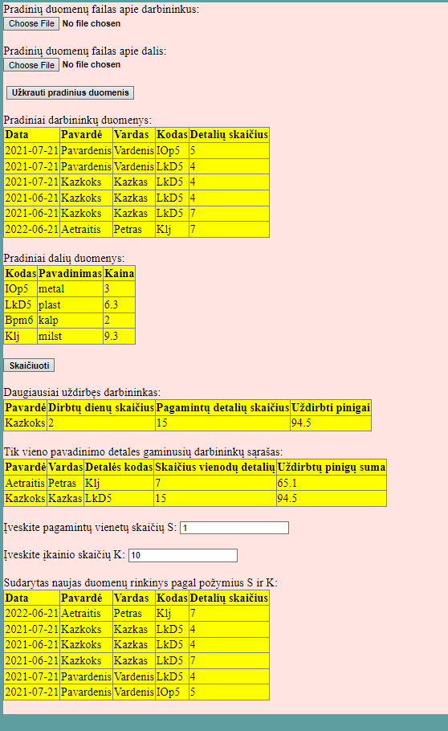

Duomenys nr. 2

U10a.txt

2021-07-21 Pavardenis Vardenis IOp5 5

2021-07-21 Pavardenis Vardenis LkD5 4

2021-07-21 Bazkoks Lazkas Bpm6 4

2021-06-21 Bazkoks Lazkas LkD5 4

2021-06-21 Bazkoks Lazkas LkD5 7

2022-06-21 Aetraitis Petras Klj 7

2022-06-28 Valancius Justas IOp5 8

U10b.txt

IOp5 metal 3

LkD5 plast 2

Bpm6 kalp 2

Klj milst 9.3

GivenData.txt

--------------------------------------------------------------------------------------------------------------------

| 2021-07-21 | Pavardenis | Vardenis | IOp5 | 5 |

| 2021-07-21 | Pavardenis | Vardenis | LkD5 | 4 |

| 2021-07-21 | Bazkoks | Lazkas | Bpm6 | 4 |

| 2021-06-21 | Bazkoks | Lazkas | LkD5 | 4 |

| 2021-06-21 | Bazkoks | Lazkas | LkD5 | 7 |

| 2022-06-21 | Aetraitis | Petras | Klj | 7 |

| 2022-06-28 | Valancius | Justas | IOp5 | 8 |

--------------------------------------------------------------------------------------------------------------------

----------------------------------------------------------------------

| IOp5 | metal | 3 |

| LkD5 | plast | 2 |

| Bpm6 | kalp | 2 |

| Klj | milst | 9.3 |

----------------------------------------------------------------------

Rezults.txt

Daugiausiai uždirbęs darbininkas:

---------------------------------------------------------------------------------------------

| Aetraitis | 1 | 7 | 65.1 |

---------------------------------------------------------------------------------------------

Tik vieno pavadinimo detales gaminusių darbininkų sąrašas:

--------------------------------------------------------------------------------------------------------------------

| Aetraitis | Petras | Klj | 7 | 65.1 |

| Valancius | Justas | IOp5 | 8 | 24 |

--------------------------------------------------------------------------------------------------------------------

Sudarytas naujas duomenų rinkinys pagal požymius S ir K:

--------------------------------------------------------------------------------------------------------------------

| 2021-06-21 | Bazkoks | Lazkas | LkD5 | 7 |

| 2021-07-21 | Pavardenis | Vardenis | IOp5 | 5 |

| 2022-06-28 | Valancius | Justas | IOp5 | 8 |

--------------------------------------------------------------------------------------------------------------------

Vartotojo sąsaja

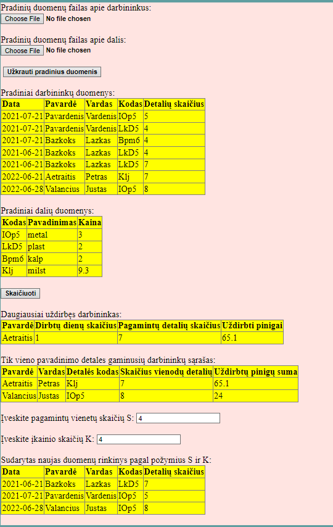

## Dėstytojo pastabos

Gynimo testas: 0.0.

Programa: 6.

Ataskaita: 1.

Bendras įvertinimas: 7.

# Bendrinės klasės ir testavimas (L3)

## Darbo užduotis

LD_10. Gamykla. Gamykloje kiekvieną dieną registruojama informacija apie darbininkų pagamintas detales. Darbininkas gali gaminti per dieną skirtingo tipo detales. Suraskite daugiausiai uždirbusio darbininko pavardę, suskaičiuokite, kiek dienų jis dirbo, kiek iš viso detalių pagamino ir už kokią sumą. Sudarykite tik vieno pavadinimo detales gaminusių darbininkų sąrašą, pagamintų detalių skaičių ir sumą. Surikiuokite šį sąrašą pagal pavardes ir vardus. Duomenys:

• Tekstiniame faile U10a.txt surašyta: data (metai, mėnuo, diena), darbininko pavardė ir vardas, detalės kodas, pagamintų vienetų skaičius.

• Tekstiniame faile U10b.txt surašyta: detalės kodas, detalės pavadinimas, įkainis.

Iš duomenų rinkinio faile U10a.txt sudarykite naują duomenų rinkinį pagal nurodytą požymį (pagamintų vienetų skaičius > S, įkainis < K, įvedami klaviatūra). Sąrašas turi būti surikiuotas pagal pavardes ir vardus abėcėlės tvarka.

## Grafinės vartotojo sąsajos schema



## Sąsajoje panaudotų komponentų keičiamos savybės

|  |  |  |
| --- | --- | --- |
| Komponentas | Savybė | Reikšmė |
| Div | Class | TextSize |
| Body | Backgroud-color | Cadetblue |
| FileUpload1 | CssClass | BoldText |
| FileUpload2 | CssClass | BoldText |
| Button1 | CssClass | BoldText |
| Button1 | Text | Užkrauti pradinius duomenis |
| Table1 | BorderStyle | Solid |
| Table1 | BorderWidth | 1px |
| Table1 | GridLines | Both |
| Table1 | CssClass | Table |
| Table2 | BorderStyle | Solid |
| Table2 | BorderWidth | 1px |
| Table2 | GridLines | Both |
| Table2 | CssClass | Table |
| Table3 | BorderStyle | Solid |
| Table3 | BorderWidth | 1px |
| Table3 | GridLines | Both |
| Table3 | CssClass | Table |
| Table4 | BorderStyle | Solid |
| Table4 | BorderWidth | 1px |
| Table4 | GridLines | Both |
| Table4 | CssClass | Table |
| Table5 | BorderStyle | Solid |
| Table5 | BorderWidth | 1px |
| Table5 | GridLines | Both |
| Table5 | CssClass | Table |
| Button2 | CssClass | BoldText |
| Button2 | Text | Skaičiuoti |

## Klasių diagrama

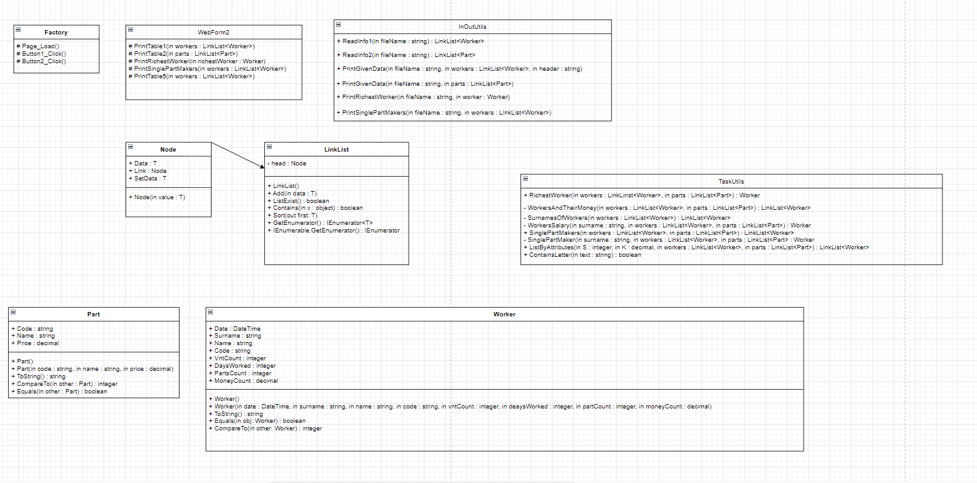

## Programos vartotojo vadovas

Kai atidarome programą, matome dvi vietas įkelti failams. Visų pirma reikia įkelti detalių gamintojų duomenis (U10a.txt), tada detalių duomenis (U10b.txt). Teksto rašymo laukeliuose vartotojas gali įrašyti darbininko pagamintų vienos rūšies detalių skaičių ir detalių įkainio vertę. Užkrovus pradinius duomenis reikia spausti ant mygtuko – užkrauti pradinius duomenis ir tada atsiranda pradinių duomenų lentelė, o į GivenData.txt failą yra išspausdinami pradiniai duomenys. Spustelėjus ant mygtuko – skaičiuoti, atsiranda dar trys lentelės su informacija ir į Rezults.txt failą yra išspausdinami rezultatai. Jeigu pradiniai duomenys nėra užkraunami, tai ir rezultatų failas nėra sukuriamas.

## Programos tekstas

InOutUtils.cs

using System;

using System.Collections.Generic;

using System.Linq;

using System.Web;

using System.IO;

using System.Text;

namespace Lab3

{

/// <summary>

/// Class that prints or reads information

/// </summary>

public static class InOutUtils

{

/// <summary>

/// Creates a list of workers

/// </summary>

/// <param name="fileName">Specific file name of given data</param>

/// <returns>Formated list</returns>

public static LinkList<Worker> ReadInfo1(string fileName)

{

LinkList<Worker> list = new LinkList<Worker>();

string[] lines = File.ReadAllLines(fileName, Encoding.UTF8);

foreach (string line in lines)

{

string[] Values = line.Split(' ');

DateTime date = DateTime.Parse(Values[0]);

string surname = Values[1];

string name = Values[2];

string code = Values[3];

int vntCount = int.Parse(Values[4]);

Worker worker = new Worker(date, surname, name, code, vntCount, 0, 0, 0);

list.Add(worker);

}

return list;

}

/// <summary>

/// Creates a list of different parts

/// </summary>

/// <param name="fileName">Specific file name of given data</param>

/// <returns>Formated list</returns>

public static LinkList<Part> ReadInfo2(string fileName)

{

LinkList<Part> list = new LinkList<Part>();

string[] lines = File.ReadAllLines(fileName, Encoding.UTF8);

foreach (string line in lines)

{

string[] Values = line.Split(' ');

string code = Values[0];

string name = Values[1];

decimal price = decimal.Parse(Values[2]);

Part part = new Part(code, name, price);

list.Add(part);

}

return list;

}

/// <summary>

/// Method that print information about workers to .txt file

/// </summary>

/// <param name="fileName">Specific file name of the place where information will be printed</param>

/// <param name="workers">List of workers</param>

/// <param name="header">Specific header of the information</param>

public static void PrintGivenData(string fileName, LinkList<Worker> workers, string header)

{

using (var writer = File.AppendText(fileName))

{

if (header != "")

{

writer.WriteLine(header);

}

writer.WriteLine(new string('-', 116));

foreach (Worker worker in workers)

{

writer.WriteLine(worker.ToString());

}

writer.WriteLine(new string('-', 116));

writer.WriteLine();

writer.Close();

}

}

/// <summary>

/// Method that print information about parts to .txt file

/// </summary>

/// <param name="fileName">Specific file name of the place where information will be printed</param>

/// <param name="parts">List of parts</param>

public static void PrintGivenData(string fileName, LinkList<Part> parts)

{

using (var writer = File.AppendText(fileName))

{

writer.WriteLine(new string('-', 70));

foreach (Part part in parts)

{

writer.WriteLine(part.ToString());

}

writer.WriteLine(new string('-', 70));

writer.WriteLine();

writer.Close();

}

}

/// <summary>

/// Method that prints who is the richest worker

/// </summary>

/// <param name="fileName">Specific file name of the place where information will be printed</param>

/// <param name="worker">Information about one worker</param>

public static void PrintRichestWorker(string fileName, Worker worker)

{

using (var writer = File.AppendText(fileName))

{

writer.WriteLine("Daugiausiai uždirbęs darbininkas:");

writer.WriteLine(new string('-', 93));

writer.WriteLine(worker.ToString());

writer.WriteLine(new string('-', 93));

writer.WriteLine();

writer.Close();

}

}

/// <summary>

/// Method that prints information about workers who make only one type of parts

/// </summary>

/// <param name="fileName">Specific file name of the place where information will be printed</param>

/// <param name="workers">List of workers</param>

public static void PrintSinglePartMakers(string fileName, LinkList<Worker> workers)

{

using (var writer = File.AppendText(fileName))

{

writer.WriteLine("Tik vieno pavadinimo detales gaminusių darbininkų sąrašas:");

writer.WriteLine(new string('-', 116));

foreach (Worker worker in workers)

{

writer.WriteLine(worker.ToString());

}

writer.WriteLine(new string('-', 116));

writer.WriteLine();

writer.Close();

}

}

}

}

Part.cs

using System;

using System.Collections.Generic;

using System.Linq;

using System.Web;

namespace Lab3

{

/// <summary>

/// Parts data class

/// </summary>

public class Part : IComparable<Part>, IEquatable<Part>

{

/// <summary>

/// Part's code

/// </summary>

public string Code { get; set; }

/// <summary>

/// Name of the part

/// </summary>

public string Name{ get; set; }

/// <summary>

/// Part's value

/// </summary>

public decimal Price { get; set; }

/// <summary>

/// First constructor

/// </summary>

public Part()

{

}

/// <summary>

/// Second constructor

/// </summary>

/// <param name="code">Part's code</param>

/// <param name="name">Name of the part</param>

/// <param name="price">Part's value</param>

public Part(string code, string name, decimal price)

{

this.Code = code;

this.Name = name;

this.Price = price;

}

/// <summary>

/// Overriden ToString method

/// </summary>

/// <returns>A formated string</returns>

public override string ToString()

{

return string.Format("| {0,-20} | {1,-20} | {2,20} |", Code, Name, Price);

}

/// <summary>

/// Method that compares parts

/// </summary>

/// <param name="other">Second part</param>

/// <returns>NotImplementedException</returns>

public int CompareTo(Part other)

{

throw new NotImplementedException();

}

/// <summary>

/// Method that finds out if parts are equal or not

/// </summary>

/// <param name="other">Second part</param>

/// <returns>NotImplementedException</returns>

public bool Equals(Part other)

{

throw new NotImplementedException();

}

}

}

Worker.cs

using System;

using System.Collections.Generic;

using System.Linq;

using System.Web;

namespace Lab3

{

/// <summary>

/// Workers data class

/// </summary>

public class Worker: IComparable<Worker>, IEquatable<Worker>

{

/// <summary>

/// Specific date

/// </summary>

public DateTime Date { get; set; }

/// <summary>

/// Worker's surname

/// </summary>

public string Surname { get; set; }

/// <summary>

/// Worker's name

/// </summary>

public string Name { get; set; }

/// <summary>

/// Part's code

/// </summary>

public string Code { get; set; }

/// <summary>

/// Number of parts

/// </summary>

public int VntCount { get; set; }

/// <summary>

/// Total number of days worked

/// </summary>

public int DaysWorked { get; set; }

/// <summary>

/// Total number of made parts

/// </summary>

public int PartsCount { get; set; }

/// <summary>

/// Total Salary of a worker

/// </summary>

public decimal MoneyCount { get; set; }

/// <summary>

/// First constructor

/// </summary>

public Worker()

{

}

/// <summary>

/// Second constructor

/// </summary>

/// <param name="date">Specific date </param>

/// <param name="surname">Worker's surname</param>

/// <param name="name">Worker's name</param>

/// <param name="code">Part's code</param>

/// <param name="vntCount">Number of parts</param>

/// <param name="daysWorked">Total number of days worked</param>

/// <param name="partCount">Total number of made parts</param>

/// <param name="moneyCount">Total Salary of a worker</param>

public Worker(DateTime date, string surname, string name, string code, int vntCount, int daysWorked, int partCount, decimal moneyCount)

{

this.Date = date;

this.Surname = surname;

this.Name = name;

this.Code = code;

this.VntCount = vntCount;

this.DaysWorked = daysWorked;

this.PartsCount = partCount;

this.MoneyCount = moneyCount;

}

/// <summary>

/// Overriden ToString method

/// </summary>

/// <returns>A formated string</returns>

public override string ToString()

{

if (Date != DateTime.MinValue)

{

return string.Format("| {0,-20:yyyy-MM-dd} | {1,-20} | {2,-20} | {3,-20} | {4,20} |", Date, Surname, Name, Code, VntCount);

}

else if (Name == null)

{

return string.Format("| {0,-20} | {1,20} | {2,20} | {3,20} |", Surname, DaysWorked, PartsCount, MoneyCount);

}

else

return string.Format("| {0,-20} | {1,-20} | {2,-20} | {3,20} | {4,20} |", Surname, Name, Code, PartsCount, MoneyCount);

}

/// <summary>

/// Equals method

/// </summary>

/// <param name="obj">Other worker</param>

/// <returns>If it is true or false</returns>

public bool Equals(Worker obj)

{

if (Surname.Equals(obj) == true)

{

return true;

}

else if (Code.Equals(obj) == true)

{

return true;

}

else if (Date.Equals(obj) == true)

{

return true;

}

return false;

}

/// <summary>

/// Method that compares two workers

/// </summary>

/// <param name="other">Other worker</param>

/// <returns>An integer</returns>

public int CompareTo(Worker other)

{

if ((object)other == null)

{

return 1;

}

if (Surname.CompareTo(other.Surname) != 0)

{

return Surname.CompareTo(other.Surname);

}

else

return Name.CompareTo(other.Name);

}

}

}

LinkList.cs

using System;

using System.Collections.Generic;

using System.Collections;

using System.Linq;

using System.Web;

namespace Lab3

{

/// <summary>

/// Class that formats a list of given data

/// </summary>

public sealed class LinkList<T> : IEnumerable<T> where T : IComparable<T>, new()

{

private sealed class Node

{

/// <summary>

/// Information about given data

/// </summary>

public T Data { get; private set; }

/// <summary>

/// A link to further information about given data

/// </summary>

public Node Link { get; set; }

/// <summary>

/// Constructor

/// </summary>

/// <param name="value">Data's information</param>

public Node(T value)

{

this.Data = value;

this.Link = null;

}

/// <summary>

/// Allows to define data's information

/// </summary>

public T SetData

{

set { this.Data = value; }

}

}

/// <summary>

/// Head of the information

/// </summary>

private Node head;

/// <summary>

/// Constructor

/// </summary>

public LinkList()

{

this.head = new Node(new T());

}

/// <summary>

/// Method that adds information to the list

/// </summary>

/// <param name="worker">Given data</param>

public void Add(T data)

{

Node current = head;

while (current.Link != null)

{

current = current.Link;

}

current.Link = new Node(data);

}

/// <summary>

/// Return true if list has data

/// </summary>

/// <returns>If it's true or false</returns>

public bool ListExist()

{

if (this.head.Link != null)

{

return true;

}

return false;

}

/// <summary>

/// Method that finds out if list has specific data or not

/// </summary>

/// <param name="x">Specific data</param>

/// <returns>If it is true or false</returns>

public bool Contains(object x)

{

for (Node current = head.Link; current != null; current = current.Link)

{

if (current.Data.Equals(x))

{

return true;

}

}

return false;

}

/// <summary>

/// Method that sorts the list

/// </summary>

/// <param name="first">Returns first member of the list</param>

public void Sort(out T first)

{

int x = 0;

first = default(T);

for (Node d1 = head.Link; d1 != null; d1 = d1.Link)

{

Node min = d1;

for (Node d2 = d1.Link; d2 != null; d2 = d2.Link)

{

if (d2.Data.CompareTo(min.Data) < 0)

{

min = d2;

}

}

T worker = d1.Data;

d1.SetData = min.Data;

min.SetData = worker;

if (x == 0)

{

first = d1.Data;

}

x++;

}

}

public IEnumerator<T> GetEnumerator()

{

for (Node dd = head.Link; dd != null; dd = dd.Link)

{

yield return dd.Data;

}

}

IEnumerator IEnumerable.GetEnumerator()

{

throw new NotImplementedException();

}

}

}

TaskUtils.cs

using System;

using System.Collections.Generic;

using System.Linq;

using System.Web;

namespace Lab3

{

/// <summary>

/// Class where calculations are being made

/// </summary>

public static class TaskUtils

{

/// <summary>

/// Method that finds the richest worker

/// </summary>

/// <param name="workers">List of workers</param>

/// <param name="parts">List of parts</param>

/// <returns>One worker</returns>

public static Worker RichestWorker(LinkList<Worker> workers, LinkList<Part> parts)

{

LinkList<Worker> workersAndTheirMoney = WorkersAndTheirMoney(workers, parts);

Worker worker = new Worker();

decimal money = 0;

foreach (Worker w in workersAndTheirMoney)

{

if (w.MoneyCount > money)

{

money = w.MoneyCount;

worker = w;

}

}

return worker;

}

/// <summary>

/// Method that formats a list of workers and their salaries

/// </summary>

/// <param name="workers">List of workers</param>

/// <param name="parts">List of parts</param>

/// <returns>A list</returns>

private static LinkList<Worker> WorkersAndTheirMoney(LinkList<Worker> workers, LinkList<Part> parts)

{

LinkList<Worker> listOfWorkers = new LinkList<Worker>();

LinkList<Worker> surnamesOfWorkers = SurnamesOfWorkers(workers);

foreach (Worker w in surnamesOfWorkers)

{

Worker worker = WorkersSalary(w.Surname, workers, parts);

listOfWorkers.Add(worker);

}

return listOfWorkers;

}

/// <summary>

/// Method that formats a list of workers who can repeat only once

/// </summary>

/// <param name="workers">List of workers</param>

/// <returns>A list</returns>

private static LinkList<Worker> SurnamesOfWorkers(LinkList<Worker> workers)

{

LinkList<Worker> surnames = new LinkList<Worker>();

foreach (Worker w in workers)

{

if (!surnames.Contains(w.Surname))

{

surnames.Add(w);

}

}

return surnames;

}

/// <summary>

/// Method that count's worker's salary

/// </summary>

/// <param name="surname">Worker's surname</param>

/// <param name="workers">List of workers</param>

/// <param name="parts">List of parts</param>

/// <returns>One worker</returns>

private static Worker WorkersSalary(string surname, LinkList<Worker> workers, LinkList<Part> parts)

{

int DaysWorked = 0;

int PartsCount = 0;

decimal MoneyCount = 0;

LinkList<Worker> date = new LinkList<Worker>();

foreach (Worker w in workers)

{

if (w.Surname == surname)

{

decimal money = 0;

PartsCount = PartsCount + w.VntCount;

foreach (Part p in parts)

{

if (w.Code == p.Code)

{

money = w.VntCount * p.Price;

}

}

MoneyCount = MoneyCount + money;

if (!date.Contains(w.Date))

{

date.Add(w);

DaysWorked++;

}

}

}

Worker worker = new Worker(DateTime.MinValue, surname, null, null, 0, DaysWorked, PartsCount, MoneyCount);

return worker;

}

/// <summary>

/// Method that formats a list of workers who make only one type of parts

/// </summary>

/// <param name="workers">List of workers</param>

/// <param name="parts">List of parts</param>

/// <returns>Formated list</returns>

public static LinkList<Worker> SinglePartMakers(LinkList<Worker> workers, LinkList<Part> parts)

{

LinkList<Worker> singlePartsWorkers = new LinkList<Worker>();

LinkList<Worker> surnamesOfWorkers = SurnamesOfWorkers(workers);

foreach (Worker w in surnamesOfWorkers)

{

Worker worker = SinglePartMaker(w.Surname, workers, parts);

if (worker != null)

{

singlePartsWorkers.Add(worker);

}

}

return singlePartsWorkers;

}

/// <summary>

/// Method that finds workers who make only one type of parts

/// </summary>

/// <param name="surname">Worker's surname</param>

/// <param name="workers">List of workers</param>

/// <param name="parts">List of parts</param>

/// <returns>A worker</returns>

private static Worker SinglePartMaker(string surname, LinkList<Worker> workers, LinkList<Part> parts)

{

LinkList<Worker> onePartMaker = new LinkList<Worker>();

Worker worker = new Worker();

int totalNumberOfParts = 0;

decimal moneyCount = 0;

int howManyParts = 0;

foreach (Worker w in workers)

{

if (w.Surname == surname && !onePartMaker.Contains(w.Code))

{

onePartMaker.Add(w);

howManyParts++;

}

if (w.Surname == surname)

{

decimal money = 0;

totalNumberOfParts = totalNumberOfParts + w.VntCount;

foreach (Part p in parts)

{

if (w.Code == p.Code)

{

money = w.VntCount * p.Price;

}

}

moneyCount = moneyCount + money;

worker = new Worker(DateTime.MinValue, w.Surname, w.Name, w.Code, 0, 0, totalNumberOfParts, moneyCount);

}

}

if (howManyParts == 1)

{

return worker;

}

return null;

}

/// <summary>

/// Method that formats a list of workers defined by attributes

/// </summary>

/// <param name="S">Number of parts</param>

/// <param name="K">Value of price</param>

/// <param name="workers">List of workers</param>

/// <param name="parts">List of parts</param>

/// <returns>A list</returns>

public static LinkList<Worker> ListByAttributes(int S, decimal K, LinkList<Worker> workers, LinkList<Part> parts)

{

LinkList<Worker> listOfWorkers = new LinkList<Worker>();

foreach (Worker w in workers)

{

if (w.VntCount > S)

{

foreach (Part p in parts)

{

if (w.Code == p.Code && p.Price < K)

{

listOfWorkers.Add(w);

}

}

}

}

return listOfWorkers;

}

/// <summary>

/// Method that finds out if a string type variable has a specific symbol and returns true or false

/// </summary>

/// <param name="text">String type variable</param>

/// <returns>If it is true or false</returns>

public static bool ContainsLetter(string text)

{

string alphabet = "ABCDEFGHIJKLMNOPQRSTUVWXYZabcdefghjklmnopqrstuvwxyząčęėįšųūžĄČĘĖĮŠŲŪŽ";

foreach (char a in alphabet)

{

if (text.Contains(a))

{

return true;

}

}

return false;

}

}

}

WebForm2.cs

using System;

using System.Collections.Generic;

using System.Linq;

using System.Web;

using System.Web.UI;

using System.Web.UI.WebControls;

using System.IO;

namespace Lab3

{

/// <summary>

/// Web form extention

/// </summary>

public partial class Factory : System.Web.UI.Page

{

/// <summary>

/// Method that forms Table1

/// </summary>

/// <param name="workers">List of wrokers</param>

protected void PrintTable1(LinkList<Worker> workers)

{

TableRow row = new TableRow();

TableCell cell1 = new TableCell();

cell1.Text = "<b>Data</b>";

row.Cells.Add(cell1);

TableCell cell2 = new TableCell();

cell2.Text = "<b>Pavardė</b>";

row.Cells.Add(cell2);

TableCell cell3 = new TableCell();

cell3.Text = "<b>Vardas</b>";

row.Cells.Add(cell3);

TableCell cell4 = new TableCell();

cell4.Text = "<b>Kodas</b>";

row.Cells.Add(cell4);

TableCell cell5 = new TableCell();

cell5.Text = "<b>Detalių skaičius</b>";

row.Cells.Add(cell5);

Table1.Rows.Add(row);

foreach (Worker w in workers)

{

TableRow newRow = new TableRow();

TableCell newCell1 = new TableCell();

newCell1.Text = string.Format("{0:yyyy-MM-dd}", w.Date);

newRow.Cells.Add(newCell1);

TableCell newCell2 = new TableCell();

newCell2.Text = string.Format("{0}", w.Surname);

newRow.Cells.Add(newCell2);

TableCell newCell3 = new TableCell();

newCell3.Text = string.Format("{0}", w.Name);

newRow.Cells.Add(newCell3);

TableCell newCell4 = new TableCell();

newCell4.Text = string.Format("{0}", w.Code);

newRow.Cells.Add(newCell4);

TableCell newCell5 = new TableCell();

newCell5.Text = string.Format("{0}", w.VntCount);

newRow.Cells.Add(newCell5);

Table1.Rows.Add(newRow);

}

}

/// <summary>

/// Method that forms Table2

/// </summary>

/// <param name="parts">List of parts</param>

protected void PrintTable2(LinkList<Part> parts)

{

TableRow row = new TableRow();

TableCell cell1 = new TableCell();

cell1.Text = "<b>Kodas</b>";

row.Cells.Add(cell1);

TableCell cell2 = new TableCell();

cell2.Text = "<b>Pavadinimas</b>";

row.Cells.Add(cell2);

TableCell cell3 = new TableCell();

cell3.Text = "<b>Kaina</b>";

row.Cells.Add(cell3);

Table2.Rows.Add(row);

foreach (Part p in parts)

{

TableRow newRow = new TableRow();

TableCell newCell1 = new TableCell();

newCell1.Text = string.Format("{0}", p.Code);

newRow.Cells.Add(newCell1);

TableCell newCell2 = new TableCell();

newCell2.Text = string.Format("{0}", p.Name);

newRow.Cells.Add(newCell2);

TableCell newCell3 = new TableCell();

newCell3.Text = string.Format("{0}", p.Price);

newRow.Cells.Add(newCell3);

Table2.Rows.Add(newRow);

}

}

/// <summary>

/// Method that forms Table3

/// </summary>

/// <param name="richestWorker">A single worker</param>

protected void PrintRichestWorker(Worker richestWorker)

{

TableRow row = new TableRow();

TableCell cell1 = new TableCell();

cell1.Text = "<b>Pavardė</b>";

row.Cells.Add(cell1);

TableCell cell2 = new TableCell();

cell2.Text = "<b>Dirbtų dienų skaičius</b>";

row.Cells.Add(cell2);

TableCell cell3 = new TableCell();

cell3.Text = "<b>Pagamintų detalių skaičius</b>";

row.Cells.Add(cell3);

TableCell cell4 = new TableCell();

cell4.Text = "<b>Uždirbti pinigai</b>";

row.Cells.Add(cell4);

Table3.Rows.Add(row);

if (richestWorker.Surname != null)

{

TableRow newRow = new TableRow();

TableCell cell5 = new TableCell();

cell5.Text = string.Format("{0}", richestWorker.Surname);

newRow.Cells.Add(cell5);

TableCell cell6 = new TableCell();

cell6.Text = string.Format("{0}", richestWorker.DaysWorked);

newRow.Cells.Add(cell6);

TableCell cell7 = new TableCell();

cell7.Text = string.Format("{0}", richestWorker.PartsCount);

newRow.Cells.Add(cell7);

TableCell cell8 = new TableCell();

cell8.Text = string.Format("{0}", richestWorker.MoneyCount);

newRow.Cells.Add(cell8);

Table3.Rows.Add(newRow);

}

}

/// <summary>

/// Method that forms Table4

/// </summary>

/// <param name="workers">List of workers</param>

protected void PrintSinglePartMakers(LinkList<Worker> workers)

{

TableRow row = new TableRow();

TableCell cell1 = new TableCell();

cell1.Text = "<b>Pavardė</b>";

row.Cells.Add(cell1);

TableCell cell2 = new TableCell();

cell2.Text = "<b>Vardas</b>";

row.Cells.Add(cell2);

TableCell cell3 = new TableCell();

cell3.Text = "<b>Detalės kodas</b>";

row.Cells.Add(cell3);

TableCell cell4 = new TableCell();

cell4.Text = "<b>Skaičius vienodų detalių</b>";

row.Cells.Add(cell4);

TableCell cell5 = new TableCell();

cell5.Text = "<b>Uždirbtų pinigų suma</b>";

row.Cells.Add(cell5);

Table4.Rows.Add(row);

foreach (Worker w in workers)

{

TableRow newRow = new TableRow();

TableCell newCell1 = new TableCell();

newCell1.Text = string.Format("{0}", w.Surname);

newRow.Cells.Add(newCell1);

TableCell newCell2 = new TableCell();

newCell2.Text = string.Format("{0}", w.Name);

newRow.Cells.Add(newCell2);

TableCell newCell3 = new TableCell();

newCell3.Text = string.Format("{0}", w.Code);

newRow.Cells.Add(newCell3);

TableCell newCell4 = new TableCell();

newCell4.Text = string.Format("{0}", w.PartsCount);

newRow.Cells.Add(newCell4);

TableCell newCell5 = new TableCell();

newCell5.Text = string.Format("{0}", w.MoneyCount);

newRow.Cells.Add(newCell5);

Table4.Rows.Add(newRow);

}

}

/// <summary>

/// Method that forms Table5

/// </summary>

/// <param name="workers">List of workers</param>

protected void PrintTable5(LinkList<Worker> workers)

{

TableRow row = new TableRow();

TableCell cell1 = new TableCell();

cell1.Text = "<b>Data</b>";

row.Cells.Add(cell1);

TableCell cell2 = new TableCell();

cell2.Text = "<b>Pavardė</b>";

row.Cells.Add(cell2);

TableCell cell3 = new TableCell();

cell3.Text = "<b>Vardas</b>";

row.Cells.Add(cell3);

TableCell cell4 = new TableCell();

cell4.Text = "<b>Kodas</b>";

row.Cells.Add(cell4);

TableCell cell5 = new TableCell();

cell5.Text = "<b>Detalių skaičius</b>";

row.Cells.Add(cell5);

Table5.Rows.Add(row);

foreach (Worker w in workers)

{

TableRow newRow = new TableRow();

TableCell newCell1 = new TableCell();

newCell1.Text = string.Format("{0:yyyy-MM-dd}", w.Date);

newRow.Cells.Add(newCell1);

TableCell newCell2 = new TableCell();

newCell2.Text = string.Format("{0}", w.Surname);

newRow.Cells.Add(newCell2);

TableCell newCell3 = new TableCell();

newCell3.Text = string.Format("{0}", w.Name);

newRow.Cells.Add(newCell3);

TableCell newCell4 = new TableCell();

newCell4.Text = string.Format("{0}", w.Code);

newRow.Cells.Add(newCell4);

TableCell newCell5 = new TableCell();

newCell5.Text = string.Format("{0}", w.VntCount);

newRow.Cells.Add(newCell5);

Table5.Rows.Add(newRow);

}

}

}

}

StyleSheet1.css

div {

background-color :mistyrose;

}

.Table{

background-color: yellow;

}

.BoldText{

font-weight: bold;

}

body{

background-color: cadetblue;

}

.TextSize{

font-size: 18px;

}

LinkListTests.cs

using Microsoft.VisualStudio.TestTools.UnitTesting;

using Lab3;

using System;

using System.Collections.Generic;

using System.Linq;

using System.Text;

using System.Threading.Tasks;

namespace Lab3.Tests

{

[TestClass()]

public class LinkListTests

{

[TestMethod()]

public void LinkList_EmptyContainerFormsAList_ReturnFalse()

{

LinkList<Worker> list = new LinkList<Worker>();

Assert.IsFalse(list.ListExist());

}

[TestMethod()]

public void LinkList_EmptyContainerContainsData_ReturnFalse()

{

LinkList<Worker> list = new LinkList<Worker>();

Worker worker = new Worker();

Assert.IsFalse(list.Contains(worker));

}

[TestMethod()]

public void Add_PutsOneWorkerInTheList_ReturnTrue()

{

LinkList<Worker> list = new LinkList<Worker>();

Worker worker = new Worker(DateTime.MinValue, null, "Vytautas", null, 0, 0, 0, 0);

list.Add(worker);

Assert.IsTrue(list.Contains(worker));

}

[TestMethod()]

public void Add_FormsAList_ReturnTrue()

{

LinkList<Worker> list = new LinkList<Worker>();

Worker worker = new Worker(DateTime.MinValue, null, "Vytautas", null, 0, 0, 0, 0);

list.Add(worker);

Assert.IsTrue(list.ListExist());

}

[TestMethod()]

public void Add_PutsTwoWorkersInTheList_ReturnTrue()

{

LinkList<Worker> list = new LinkList<Worker>();

Worker worker1 = new Worker(DateTime.MinValue, null, "Vytautas", null, 0, 0, 0, 0);

Worker worker2 = new Worker(DateTime.MinValue, null, "Nojus", null, 0, 0, 0, 0);

list.Add(worker1);

list.Add(worker2);

Assert.IsTrue(list.Contains(worker1));

Assert.IsTrue(list.Contains(worker2));

}

[TestMethod()]

public void ListExist_EmptyListHasData_ReturnFalse()

{

LinkList<Worker> list = new LinkList<Worker>();

Assert.IsFalse(list.ListExist());

}

[TestMethod()]

public void ListExist_WhenListHasData_ReturnTrue()

{

LinkList<Worker> list = new LinkList<Worker>();

Worker worker = new Worker();

list.Add(worker);

Assert.IsTrue(list.ListExist());

}

[TestMethod()]

public void ListExist_TwoListsHaveData_ReturnTrue()

{

LinkList<Worker> list1 = new LinkList<Worker>();

LinkList<Worker> list2 = new LinkList<Worker>();

Worker worker = new Worker();

list1.Add(worker);

list2.Add(worker);

Assert.IsTrue(list1.ListExist());

Assert.IsTrue(list2.ListExist());

}

[TestMethod()]

public void Contains_NoInformationAboutGivenData_ReturnTrue()

{

LinkList<Worker> list = new LinkList<Worker>();

Worker worker1 = new Worker(DateTime.Parse("2000-07-01"), "Paulavicius", "Rokas", "ifs-0", 5, 1, 5, 6);

Worker worker2 = new Worker(DateTime.Parse("2001-07-01"), "Jonaitis", "Rokas", "ifs-0", 5, 1, 5, 6);

list.Add(worker2);

Assert.IsTrue(!list.Contains(worker1));

}

[TestMethod()]

public void Contains_GivenDataAboutOneWorker_ReturnTrue()

{

LinkList<Worker> list = new LinkList<Worker>();

Worker worker1 = new Worker(DateTime.Parse("2000-07-01"), "Paulavicius", "Rokas", "ifs-0", 5, 1, 5, 6);

Worker worker2 = new Worker(DateTime.Parse("2001-07-01"), "Jonaitis", "Rokas", "ifs-0", 5, 1, 5, 6);

list.Add(worker2);

Assert.IsTrue(list.Contains(worker2));

}

[TestMethod()]

public void Contains_AllTheGivenData_ReturnTrue()

{

LinkList<Worker> list = new LinkList<Worker>();

Worker worker1 = new Worker(DateTime.Parse("2000-07-01"), "Paulavicius", "Rokas", "ifs-0", 5, 1, 5, 6);

Worker worker2 = new Worker(DateTime.Parse("2001-07-01"), "Jonaitis", "Rokas", "ifs-0", 5, 1, 5, 6);

list.Add(worker1);

list.Add(worker2);

Assert.IsTrue(list.Contains(worker1));

Assert.IsTrue(list.Contains(worker2));

}

[TestMethod()]

public void Sort_TheSameInformation_ReturnFirstAddedWorkerIsFirst()

{

var list = new LinkList<Worker>();

Worker worker1 = new Worker(DateTime.Parse("2000-07-01"), "Paulavicius", "Rokas", "ifs-0", 5, 1, 5, 6);

Worker worker2 = worker1;

list.Add(worker1);

list.Add(worker2);

Worker w = new Worker();

list.Sort(out w);

Assert.AreEqual(worker1.Surname, w.Surname);

}

[TestMethod()]

public void Sort_DifferentInformation_ReturnSecondAddedWorkerIsFirst()

{

LinkList<Worker> list = new LinkList<Worker>();

Worker worker1 = new Worker(DateTime.Parse("2000-07-01"), "Paulavicius", "Rokas", "ifs-0", 5, 1, 5, 6);

Worker worker2 = new Worker(DateTime.Parse("2000-07-01"), "Aaulavicius", "Rokas", "ifs-0", 5, 1, 5, 6);

list.Add(worker1);

list.Add(worker2);

Worker w = new Worker();

list.Sort(out w);

Assert.AreEqual(worker2.Surname, w.Surname);

}

[TestMethod()]

public void Sort_DifferentInformation_ReturnFirstAddedWorkerIsNotFirst()

{

LinkList<Worker> list = new LinkList<Worker>();

Worker worker1 = new Worker(DateTime.Parse("2000-07-01"), "Paulavicius", "Rokas", "ifs-0", 5, 1, 5, 6);

Worker worker2 = new Worker(DateTime.Parse("2000-07-01"), "Aaulavicius", "Rokas", "ifs-0", 5, 1, 5, 6);

list.Add(worker1);

list.Add(worker2);

Worker w = new Worker();

list.Sort(out w);

Assert.AreNotEqual(worker1.Surname, w.Surname);

}

}

}

Factory.aspx

<%@ Page Language="C#" AutoEventWireup="true" CodeBehind="Factory.aspx.cs" Inherits="Lab3.Factory" %>

<!DOCTYPE html>

<html xmlns="http://www.w3.org/1999/xhtml">

<head runat="server">

<title></title>

<link href="StyleSheet1.css" rel="stylesheet" type="text/css" />

</head>

<body>

<form id="form1" runat="server">

<div class="TextSize">

Pradinių duomenų failas apie darbininkus:<br />

<asp:FileUpload ID="FileUpload1" runat="server" CssClass="BoldText" />

<br />

<br />

Pradinių duomenų failas apie dalis:<br />

<asp:FileUpload ID="FileUpload2" runat="server" CssClass="BoldText" />

<br />

<br />

&nbsp;<asp:Button ID="Button1" runat="server" Text="Užkrauti pradinius duomenis" OnClick="Button1_Click" CssClass="BoldText" />

<br />

<br />

Pradiniai darbininkų duomenys:<br />

<asp:Table ID="Table1" runat="server" BorderStyle="Solid" BorderWidth="1px" GridLines="Both" CssClass="Table">

</asp:Table>

<br />

Pradiniai dalių duomenys:<asp:Table ID="Table2" runat="server" BorderStyle="Solid" BorderWidth="1px" GridLines="Both" CssClass="Table">

</asp:Table>

<br />

<asp:Button ID="Button2" runat="server" OnClick="Button2_Click" Text="Skaičiuoti" CssClass="BoldText" />

<br />

<br />

Daugiausiai uždirbęs darbininkas:<br />

<asp:Table ID="Table3" runat="server" BorderStyle="Solid" BorderWidth="1px" GridLines="Both" CssClass="Table">

</asp:Table>

<br />

Tik vieno pavadinimo detales gaminusių darbininkų sąrašas:<br />

<asp:Table ID="Table4" runat="server" BorderStyle="Solid" BorderWidth="1px" GridLines="Both" CssClass="Table">

</asp:Table>

<br />

Įveskite pagamintų vienetų skaičių S:

<asp:TextBox ID="TextBox1" runat="server"></asp:TextBox>

<br />

<br />

Įveskite įkainio skaičių K:

<asp:TextBox ID="TextBox2" runat="server"></asp:TextBox>

<br />

<br />

Sudarytas naujas duomenų rinkinys pagal požymius S ir K:<asp:Table ID="Table5" runat="server" BorderStyle="Solid" BorderWidth="1px" GridLines="Both" CssClass="Table">

</asp:Table>

<br />

</div>

</form>

</body>

</html>

Factory.aspx.cs

using System;

using System.Collections.Generic;

using System.Linq;

using System.Web;

using System.Web.UI;

using System.Web.UI.WebControls;

using System.IO;

//Main function of this program is to do all kinds of calculations with given data of workers and different parts

//Vytenis Kriščiūnas

namespace Lab3

{

/// <summary>

/// Web form

/// </summary>

public partial class Factory : System.Web.UI.Page

{

/// <summary>

/// List of parts

/// </summary>

LinkList<Part> parts;

/// <summary>

/// List of workers

/// </summary>

LinkList<Worker> workers;

/// <summary>

/// The richest worker

/// </summary>

Worker richestWorker;

/// <summary>

/// List of workers who allways make the same parts

/// </summary>

LinkList<Worker> singlePartMakers;

/// <summary>

/// List formed by given attributes

/// </summary>

LinkList<Worker> listByAttributes;

/// <summary>

/// Prints information to the screen when page loads

/// </summary>

/// <param name="sender">An object variable</param>

/// <param name="e">EventArgs variable</param>

protected void Page_Load(object sender, EventArgs e)

{

if (parts == null)

{

parts = new LinkList<Part>();

}

if (workers == null)

{

workers = new LinkList<Worker>();

}

if (richestWorker == null)

{

richestWorker = new Worker();

}

if (singlePartMakers == null)

{

singlePartMakers = new LinkList<Worker>();

}

if (listByAttributes == null)

{

listByAttributes = new LinkList<Worker>();

}

parts = Session["parts"] as LinkList<Part>;

workers = Session["workers"] as LinkList<Worker>;

if (workers != null && parts != null)

{

PrintTable1(workers);

PrintTable2(parts);

}

}

/// <summary>

/// Prints and reads given information when the first button is clicked

/// </summary>

/// <param name="sender">An object variable</param>

/// <param name="e">EventArgs variable</param>

protected void Button1_Click(object sender, EventArgs e)

{

Session.Remove("parts");

Session.Remove("workers");

for (int i = Table1.Rows.Count - 1; i >= 0; i--)

{

Table1.Rows.RemoveAt(i);

}

for (int i = Table2.Rows.Count - 1; i >= 0; i--)

{

Table2.Rows.RemoveAt(i);

}

string Fr = Server.MapPath("App_Data/GivenData.txt");

File.Delete(Fr);

if (FileUpload1.HasFile && FileUpload2.HasFile)

{

string Fd1 = Server.MapPath("App_Data/U10a.txt"); // workers

string Fd2 = Server.MapPath("App_Data/U10b.txt"); // parts

if (FileUpload1.FileName.EndsWith("a.txt") && FileUpload2.FileName.EndsWith("b.txt"))

{

parts = InOutUtils.ReadInfo2(Fd2);

workers = InOutUtils.ReadInfo1(Fd1);

PrintTable1(workers);

PrintTable2(parts);

InOutUtils.PrintGivenData(Fr, workers, "");

InOutUtils.PrintGivenData(Fr, parts);

Session["parts"] = parts;

Session["workers"] = workers;

}

}

}

/// <summary>

/// Calculates needed information and prints it when the second button is clicked

/// </summary>

/// <param name="sender"></param>

/// <param name="e"></param>

protected void Button2_Click(object sender, EventArgs e)

{

string Fr = Server.MapPath("App_Data/Rezults.txt");

File.Delete(Fr);

int S = 0;

decimal K = 0;

if (TextBox1.Text != "" && TextBox2.Text != "" && TaskUtils.ContainsLetter(TextBox1.Text) == false && TaskUtils.ContainsLetter(TextBox2.Text) == false)

{

S = int.Parse(TextBox1.Text);

K = decimal.Parse(TextBox2.Text);

}

if (workers != null && parts != null)

{

richestWorker = TaskUtils.RichestWorker(workers, parts);

singlePartMakers = TaskUtils.SinglePartMakers(workers, parts);

Worker w = new Worker();

singlePartMakers.Sort(out w);

}

PrintRichestWorker(richestWorker);

PrintSinglePartMakers(singlePartMakers);

if (workers != null && parts != null && S != 0 && K != 0)

{

listByAttributes = TaskUtils.ListByAttributes(S, K, workers, parts);

Worker w = new Worker();

listByAttributes.Sort(out w);

}

PrintTable5(listByAttributes);

if (richestWorker.Surname != null)

{

InOutUtils.PrintRichestWorker(Fr, richestWorker);

}

if (singlePartMakers.ListExist() == true)

{

InOutUtils.PrintSinglePartMakers(Fr, singlePartMakers);

}

if (listByAttributes.ListExist() == true)

{

InOutUtils.PrintGivenData(Fr, listByAttributes, string.Format("Sudarytas naujas duomenų rinkinys pagal požymius S ir K:"));

}

if (richestWorker.Surname == null && singlePartMakers.ListExist() == false && listByAttributes.ListExist() == false)

{

File.Delete(Fr);

}

}

}

}

## Pradiniai duomenys ir rezultatai

Duomenys nr. 1

U10a.txt

2021-07-21 Pavardenis Vardenis IOp5 5

2021-07-21 Pavardenis Vardenis LkD5 4

2021-07-21 Kazkoks Kazkas LkD5 4

2021-06-21 Kazkoks Kazkas LkD5 4

2021-06-21 Kazkoks Kazkas LkD5 7

2022-06-21 Aetraitis Petras Klj 7

U10b.txt

IOp5 metal 3

LkD5 plast 6.3

Bpm6 kalp 2

Klj milst 9.3

GivenData.txt

--------------------------------------------------------------------------------------------------------------------

| 2021-07-21 | Pavardenis | Vardenis | IOp5 | 5 |

| 2021-07-21 | Pavardenis | Vardenis | LkD5 | 4 |

| 2021-07-21 | Kazkoks | Kazkas | LkD5 | 4 |

| 2021-06-21 | Kazkoks | Kazkas | LkD5 | 4 |

| 2021-06-21 | Kazkoks | Kazkas | LkD5 | 7 |

| 2022-06-21 | Aetraitis | Petras | Klj | 7 |

--------------------------------------------------------------------------------------------------------------------

----------------------------------------------------------------------

| IOp5 | metal | 3 |

| LkD5 | plast | 6.3 |

| Bpm6 | kalp | 2 |

| Klj | milst | 9.3 |

----------------------------------------------------------------------

Rezults.txt

Daugiausiai uždirbęs darbininkas:

---------------------------------------------------------------------------------------------

| Kazkoks | 2 | 15 | 94.5 |

---------------------------------------------------------------------------------------------

Tik vieno pavadinimo detales gaminusių darbininkų sąrašas:

--------------------------------------------------------------------------------------------------------------------

| Aetraitis | Petras | Klj | 7 | 65.1 |

| Kazkoks | Kazkas | LkD5 | 15 | 94.5 |

--------------------------------------------------------------------------------------------------------------------

Sudarytas naujas duomenų rinkinys pagal požymius S ir K:

--------------------------------------------------------------------------------------------------------------------

| 2022-06-21 | Aetraitis | Petras | Klj | 7 |

| 2021-07-21 | Kazkoks | Kazkas | LkD5 | 4 |

| 2021-06-21 | Kazkoks | Kazkas | LkD5 | 4 |

| 2021-06-21 | Kazkoks | Kazkas | LkD5 | 7 |

| 2021-07-21 | Pavardenis | Vardenis | LkD5 | 4 |

| 2021-07-21 | Pavardenis | Vardenis | IOp5 | 5 |

--------------------------------------------------------------------------------------------------------------------

Vartotojo sąsaja



Duomenys nr. 2

U10a.txt

2021-07-21 Pavardenis Vardenis IOp5 5

2021-07-21 Pavardenis Vardenis LkD5 4

2021-07-21 Bazkoks Lazkas Bpm6 4

2021-06-21 Bazkoks Lazkas LkD5 4

2021-06-21 Bazkoks Lazkas LkD5 7

2022-06-21 Aetraitis Petras Klj 7

2022-06-28 Valancius Justas IOp5 8

U10b.txt

IOp5 metal 3

LkD5 plast 2

Bpm6 kalp 2

Klj milst 9.3

GivenData.txt

--------------------------------------------------------------------------------------------------------------------

| 2021-07-21 | Pavardenis | Vardenis | IOp5 | 5 |

| 2021-07-21 | Pavardenis | Vardenis | LkD5 | 4 |

| 2021-07-21 | Bazkoks | Lazkas | Bpm6 | 4 |

| 2021-06-21 | Bazkoks | Lazkas | LkD5 | 4 |

| 2021-06-21 | Bazkoks | Lazkas | LkD5 | 7 |

| 2022-06-21 | Aetraitis | Petras | Klj | 7 |

| 2022-06-28 | Valancius | Justas | IOp5 | 8 |

--------------------------------------------------------------------------------------------------------------------

----------------------------------------------------------------------

| IOp5 | metal | 3 |

| LkD5 | plast | 2 |

| Bpm6 | kalp | 2 |

| Klj | milst | 9.3 |

----------------------------------------------------------------------

Rezults.txt

Daugiausiai uždirbęs darbininkas:

---------------------------------------------------------------------------------------------

| Aetraitis | 1 | 7 | 65.1 |

---------------------------------------------------------------------------------------------

Tik vieno pavadinimo detales gaminusių darbininkų sąrašas:

--------------------------------------------------------------------------------------------------------------------

| Aetraitis | Petras | Klj | 7 | 65.1 |

| Valancius | Justas | IOp5 | 8 | 24 |

--------------------------------------------------------------------------------------------------------------------

Sudarytas naujas duomenų rinkinys pagal požymius S ir K:

--------------------------------------------------------------------------------------------------------------------

| 2021-06-21 | Bazkoks | Lazkas | LkD5 | 7 |

| 2021-07-21 | Pavardenis | Vardenis | IOp5 | 5 |

| 2022-06-28 | Valancius | Justas | IOp5 | 8 |

--------------------------------------------------------------------------------------------------------------------

Vartotojo sąsaja



## Dėstytojo pastabos

Ginimo testas: 1.0

Programa: 5.5

Ataskaita: 1.0

Bendras įvertinimas: 7

Dėstytojo komentarai:

Testavimas yra, bet jo nepavyko pademonstruoti;

Ataskaitoje nėra testavimo protokolo.

# Polimorfizmas ir išimčių valdymas (L4)

## Darbo užduotis

U4_10. Buitinės technikos parduotuvė. Turite informaciją apie skirtingose buitinės technikos parduotuvėse esančius šaldytuvus, mikrobangų krosneles ir elektrinius virdulius. Pirmoje eilutėje yra pavadinimas, antroje – adresas, trečioje – telefonas. Sukurkite abstrakčią klasę „Device“ (savybės - gamintojas, modelis, energijos klasė, spalva, kaina), kurią paveldės “Fridge” (savybės - talpa, montavimo tipas, požymis „turi šaldiklį“, aukštis, plotis, gylis), “Oven” (savybės – galingumas, programų skaičius) ir “Kettle” (savybės – galia, tūris).

• Suskaičiuokite, kiek skirtingų „Siemens“ šaldytuvų, mikrobangų krosnelių ir virdulių modelių siūlo kiekviena parduotuvė, rezultatą atspausdinkite ekrane.

• Sudarykite dešimties pigiausių pastatomų šaldytuvų, kurių talpa 80 litrų ar didesnė, sąrašą. Ekrane atspausdinkite šaldytuvo gamintoją, modelį, talpą ir kainą. P175B123 Objektinis programavimas 2 4

• Ar yra tokių buitinių prietaisų, kuriuos galima įsigyti tik vienoje parduotuvėje? Atspausdinkite tokių prietaisų sąrašą faile „TikTen.csv“.

• Sudarykite ir surikiuokite brangių buitinių prietaisų sąrašą, pateikdami pilną informaciją apie juos. Šaldytuvas yra brangus, jei jo kaina viršija 1000€. Mikrobangų krosnelė yra brangi, jei jos kaina viršija 500€. Virdulys yra brangus, jei jo kaina viršija 50€. Šaldytuvus rikiuokite pagal aukštį, mikrobangų krosneles – pagal galingumą, o virdulius – pagal galią. Rezultatus įrašykite į failą „Brangus.csv“.

## Grafinės vartotojo sąsajos schema

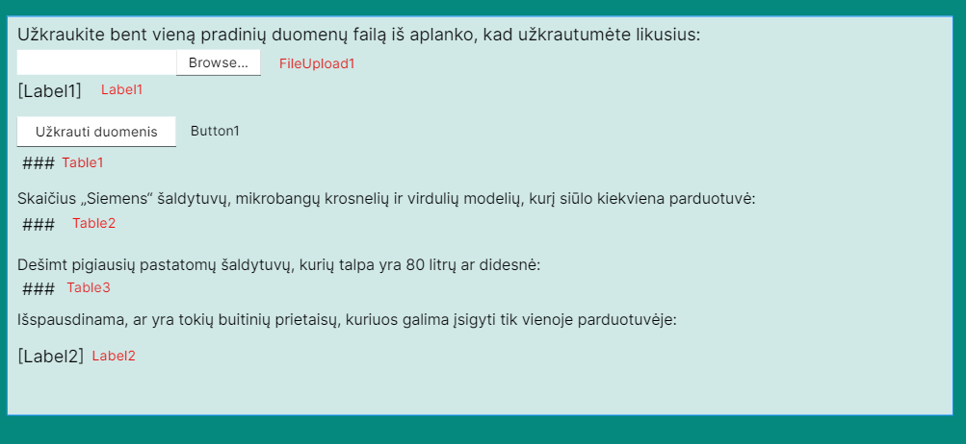

## Sąsajoje panaudotų komponentų keičiamos savybės

|  |  |  |
| --- | --- | --- |
| Komponentas | Savybė | Reikšmė |
| Div | Class | TextSize |
| Body | Backgroud-color | Cadetblue |
| FileUpload1 | CssClass | BoldText |
| Label1 | CssClass | TextSize |
| Button1 | Text | Užkrauti duomenis |
| Button1 | CssClass | BoldText |
| Table1 | BorderWidth | 1px |
| Table1 | GridLines | Both |
| Table1 | CssClass | Table |
| Table1 | ForeColor | Black |
| Table2 | BorderWidth | 1px |
| Table2 | GridLines | Both |
| Table2 | CssClass | Table |
| Table2 | ForeColor | Black |
| Table3 | BorderWidth | 1px |
| Table3 | GridLines | Both |
| Table3 | CssClass | Table |
| Table3 | ForeColor | Black |
| Label2 | CssClass | TextSize |

## Klasių diagrama

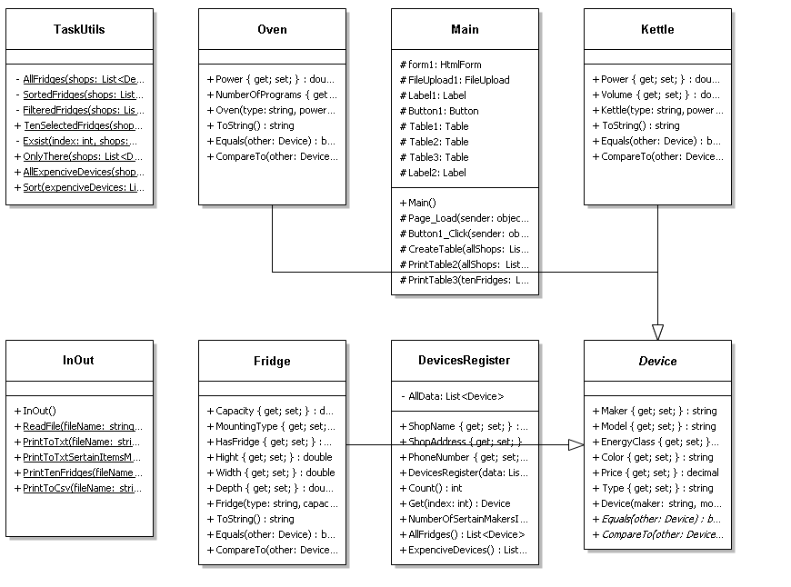

## Programos vartotojo vadovas

Kai atidarome programą, matome vieną vietą skirtą įkeltis nors vienam duomenų failui iš App_Data/Data/ aplanko. Pasirinkus vieną duomenų failą, reikia spausti mygtuką: „Užkrauti duomenis“. Mygtuką paspaudus yra sudaromos trys lentelės: pradinių duomenų ir dvi rezultatų lentelės. Taip pat pradiniai duomenys ir rezultatai yra išspausdinami į Rezults.txt failą ir likę rezultatai į TikTen.csv, Brangus.csv failus. Jeigu pradiniai duomenys nėra užkraunami, tai ir rezultatai nėra spausdinami į ekraną ir rezultatų failus.

## Programos tekstas

InOut.cs

using System;

using System.Collections.Generic;

using System.Linq;

using System.Web;

using System.IO;

namespace Lab_4

{

/// <summary>

/// Class that reads and prints information

/// </summary>

public class InOut

{

/// <summary>

/// Method that read information and forms a list

/// </summary>

/// <param name="fileName">Name of a data file</param>

/// <returns>Formated list</returns>

public static List<DevicesRegister> ReadFile(string fileName)

{

List<DevicesRegister> LibraryOfShops = new List<DevicesRegister>();

foreach (string txtName in Directory.GetFiles(fileName, "*.txt"))

{

List<Device> Shop = new List<Device>();

string[] lines = File.ReadAllLines(txtName);

string shopName = lines[0];

string shopAddress = lines[1];

string phoneNumber = lines[2];

for (int i = 3; i < lines.Length; i++)

{

string[] Values = lines[i].Split(';');

string type = Values[0];

string maker = Values[1];

string model = Values[2];

string energyClass = Values[3];

string color = Values[4];

decimal price = decimal.Parse(Values[5]);

switch (type)

{

case "Fridge":

double capacity = double.Parse(Values[6]);

string mountingType = Values[7];

string has = Values[8];

bool hasFridge = false;

if (has == "turi šaldiklį")

{

hasFridge = true;

}

double hight = double.Parse(Values[9]);

double width = double.Parse(Values[10]);

double depth = double.Parse(Values[11]);

Fridge fridge = new Fridge(type, capacity, mountingType, hasFridge, hight, width, depth, maker, model, energyClass, color, price);

Shop.Add(fridge);

break;

case "Kettle":

double power = double.Parse(Values[6]);

double volume = double.Parse(Values[7]);

Kettle kettle = new Kettle(type, power, volume, maker, model, energyClass, color, price);

Shop.Add(kettle);

break;

case "Oven":

power = double.Parse(Values[6]);

int numberOfPrograms = int.Parse(Values[7]);

Oven oven = new Oven(type, power, numberOfPrograms, maker, model, energyClass, color, price);

Shop.Add(oven);

break;

default:

break;

}

}

DevicesRegister devices = new DevicesRegister(Shop, shopName, shopAddress, phoneNumber);

LibraryOfShops.Add(devices);

}

return LibraryOfShops;

}

/// <summary>

/// Method that prints initial data information to .txt file

/// </summary>

/// <param name="fileName">Name of a rezult file</param>

/// <param name="allShops">List of information</param>

public static void PrintToTxt(string fileName, List<DevicesRegister> allShops)

{

try

{

using (var writer = File.CreateText(fileName))

{

foreach (DevicesRegister shop in allShops)

{

writer.WriteLine(shop.ShopName);

writer.WriteLine(shop.ShopAddress);

writer.WriteLine(shop.PhoneNumber);

writer.WriteLine(new string('-', 303));

writer.WriteLine(string.Format("| {0, 15} | {1, 15} | {2, 15} | {3, 15} | {4, 15} | {5, -15} | {6, -15} | {7, 15} | {8, -28} | {9, -15} | {10, -15} | {11, -15} | {12, -15} | {13, -15} | {14, -15} | {15, -15} |", "Tipas", "Gamintojas", "Modelis", "Energijos klasė", "Spalva", "Kaina", "Talpa", "Montavimo tipas", "Požymis: turi šaldiklį ar ne", "Aukštis", "Plotis", "Gylis", "Galia", "Tūris", "Galingumas", "Programų skaičius"));

writer.WriteLine(new string('-', 303));

for (int i = 0; i < shop.Count(); i++)

{

writer.WriteLine(shop.Get(i).ToString());

}

writer.WriteLine(new string('-', 303));

writer.WriteLine();

}

writer.Close();

}

}

catch (Exception ex)

{

throw new Exception(ex.Message);

}

}

/// <summary>

/// Method that prints sertain maker's devices to .txt file

/// </summary>

/// <param name="fileName">Name of a rezult file</param>

/// <param name="allShops">List of information</param>

public static void PrintToTxtSertainItemsMakers(string fileName, List<DevicesRegister> allShops)

{

using (var writer = File.AppendText(fileName))

{

writer.WriteLine("Skaičius „Siemens“ šaldytuvų, mikrobangų krosnelių ir virdulių modelių, kurį siūlo kiekviena parduotuvė:");

foreach (DevicesRegister shop in allShops)

{

writer.WriteLine("{0}", shop.NumberOfSertainMakersItems());

writer.WriteLine("Parduotuvės kontaktinė informacija:");

writer.WriteLine(shop.ShopName);

writer.WriteLine(shop.ShopAddress);

writer.WriteLine(shop.PhoneNumber);

writer.WriteLine();

}

writer.Close();

}

}

/// <summary>

/// Method that print ten selected fridges to .csv file

/// </summary>

/// <param name="fileName">Name of a rezult file</param>

/// <param name="tenFridges">List of fridges</param>

public static void PrintTenFridges(string fileName, List<Device> tenFridges)

{

using (var writer = File.AppendText(fileName))

{

writer.WriteLine("Dešimt pigiausių pastatomų šaldytuvų, kurių talpa yra 80 litrų ar didesnė:");

writer.WriteLine(new string('-', 74));

writer.WriteLine("| {0, -15} | {1, -15} | {2, 15} | {3, 15} |", "Gamintojas", "Modelis", "Talpa", "Kaina");

writer.WriteLine(new string('-', 74));

for (int i = 0; i < tenFridges.Count(); i++)

{

Device device = tenFridges[i];

if (device is Fridge)

{

writer.WriteLine("| {0, -15} | {1, -15} | {2, 15} | {3, 15} |", device.Maker, (device as Fridge).MountingType, (device as Fridge).Capacity, device.Price);

}

}

writer.WriteLine(new string('-', 74));

writer.WriteLine();

writer.Close();

}

}

/// <summary>

/// Method that prints certain information by a given type to .csv file

/// </summary>

/// <param name="fileName">Name of a rezult file</param>

/// <param name="devices">List of devices</param>

/// <param name="type">Certain type of devices</param>

public static void PrintToCsv(string fileName, List<Device> devices, string type)

{

using (var writer = File.AppendText(fileName))

{

for (int i = 0; i < devices.Count(); i++)

{

if (devices[i].Type == type)

{

writer.WriteLine(devices[i].ToString());

}

}

writer.WriteLine();

writer.Close();

}

}

}

}

Device.cs

using System;

using System.Collections;

using System.Collections.Generic;

using System.Linq;

using System.Web;

namespace Lab_4

{

/// <summary>

/// Class of device data

/// </summary>

public abstract class Device : IEquatable<Device>, IComparable<Device>

{

/// <summary>

/// Device maker

/// </summary>

public string Maker { get; set; }

/// <summary>

/// Device model

/// </summary>

public string Model { get; set; }

/// <summary>

/// Device energy class

/// </summary>

public string EnergyClass { get; set; }

/// <summary>

/// Device color

/// </summary>

public string Color { get; set; }

/// <summary>

/// Device price

/// </summary>

public decimal Price { get; set; }

/// <summary>

/// Device type

/// </summary>

public string Type { get; set; }

/// <summary>

/// Device class constructor

/// </summary>

/// <param name="maker">Device maker</param>

/// <param name="model">Device model</param>

/// <param name="energyClass">Device energy class></param>

/// <param name="color">Device color</param>

/// <param name="price">Device price</param>

/// <param name="type">Device type</param>

public Device(string maker, string model, string energyClass, string color, decimal price, string type)

{

this.Maker = maker;

this.Model = model;

this.EnergyClass = energyClass;

this.Color = color;

this.Price = price;

this.Type = type;

}

/// <summary>

/// An abstract Equals method

/// </summary>

/// <param name="other">Device information</param>

/// <returns>True of falce value</returns>

public abstract bool Equals(Device other);

/// <summary>

/// An abstract CompareTo method

/// </summary>

/// <param name="other">Device information</param>

/// <returns>True of falce value</returns>

public abstract int CompareTo(Device other);

}

}

Fridge.cs

using System;

using System.Collections.Generic;

using System.Linq;

using System.Web;

namespace Lab_4

{

/// <summary>

/// Class of fridge data

/// </summary>

public class Fridge : Device

{

/// <summary>

/// Fridge capacity

/// </summary>

public double Capacity { get; set; }

/// <summary>

/// Fridge mounting type

/// </summary>

public string MountingType { get; set; }

/// <summary>

/// Fridge has a cooler or not

/// </summary>

public bool HasFridge { get; set; }

/// <summary>

/// Fridge hight

/// </summary>

public double Hight { get; set; }

/// <summary>

/// Fridge width

/// </summary>

public double Width { get; set; }

/// <summary>

/// Fridge depth

/// </summary>

public double Depth { get; set; }

/// <summary>

/// Fridge constructor

/// </summary>

/// <param name="type">Device type</param>

/// <param name="capacity">Fridge capacity</param>

/// <param name="mountingType">Fridge mounting type</param>

/// <param name="hasFridge">Fridge has a cooler or not</param>

/// <param name="hight">Fridge hight</param>

/// <param name="width">Fridge width</param>

/// <param name="depth">Fridge depth</param>

/// <param name="maker">Fridge maker</param>

/// <param name="model">Fridge model</param>

/// <param name="energyClass">Frdige energy class</param>

/// <param name="color">Fridge color</param>

/// <param name="price">Fridge price</param>

public Fridge(string type, double capacity, string mountingType, bool hasFridge, double hight, double width, double depth, string maker, string model, string energyClass, string color, decimal price) : base(maker, model, energyClass, color, price, type)

{

this.Capacity = capacity;

this.MountingType = mountingType;

this.HasFridge = hasFridge;

this.Hight = hight;

this.Width = width;

this.Depth = depth;

}

/// <summary>

/// Method that forms a line of data in text

/// </summary>

/// <returns>Formated string</returns>

public override string ToString()

{

return string.Format("| {0, 15} | {1, 15} | {2, 15} | {3, 15} | {4, 15} | {5, -15} | {6, -15} | {7, 15} | {8, -28} | {9, -15} | {10, -15} | {11, -15} | {12, -15} | {13, -15} | {14, -15} | {15, -15} |", Type, Maker, Model, EnergyClass, Color, Price, Capacity, MountingType, HasFridge, Hight, Width, Depth, "-", "-", "-", "-");

}

/// <summary>

/// Method finds out if information is equal or not

/// </summary>

/// <param name="other">Device information</param>

/// <returns>Ture or false value</returns>

public override bool Equals(Device other)

{

return Type.CompareTo(other.Type) == 0 && Maker.CompareTo(other.Maker) == 0 && Model.CompareTo(other.Model) == 0 && EnergyClass.CompareTo(other.EnergyClass) == 0 && Color.CompareTo(other.Color) == 0 && Price.CompareTo(other.Price) == 0;

}

/// <summary>

/// Method that compares information by hight

/// </summary>

/// <param name="other">Device information</param>

/// <returns>Int type value</returns>

public override int CompareTo(Device other)

{

if (other is Fridge)

{

return this.Hight.CompareTo((other as Fridge).Hight);

}

return 0;

}

}

}

Kettle.cs

using System;

using System.Collections.Generic;

using System.Linq;

using System.Web;

namespace Lab_4

{

/// <summary>

/// Class of kettle data

/// </summary>

public class Kettle : Device

{

/// <summary>

/// Kettle's power

/// </summary>

public double Power { get; set; }

/// <summary>

/// Kettle's volume

/// </summary>

public double Volume { get; set; }

/// <summary>

/// Kettle's class constructor

/// </summary>

/// <param name="type">Device type</param>

/// <param name="power">Kettle power</param>

/// <param name="volume">Kettle volume</param>

/// <param name="maker">Kettle maker</param>

/// <param name="model">Kettle model</param>

/// <param name="energyClass">Kettle energy class</param>

/// <param name="color">Kettle color</param>

/// <param name="price">Kettle price</param>

public Kettle(string type, double power, double volume, string maker, string model, string energyClass, string color, decimal price) : base(maker, model, energyClass, color, price, type)

{

this.Power = power;

this.Volume = volume;

}

/// <summary>

/// Method that forms a line of data in text

/// </summary>

/// <returns>Formated string</returns>

public override string ToString()

{

return string.Format("| {0, 15} | {1, 15} | {2, 15} | {3, 15} | {4, 15} | {5, -15} | {6, -15} | {7, 15} | {8, -28} | {9, -15} | {10, -15} | {11, -15} | {12, -15} | {13, -15} | {14, -15} | {15, -15} |", Type, Maker, Model, EnergyClass, Color, Price, "-", "-", "-", "-", "-", "-", Power, Volume, "-", "-");

}

/// <summary>

/// Method finds out if information is equal or not

/// </summary>

/// <param name="other">Device information</param>

/// <returns>True or false value</returns>

public override bool Equals(Device other)

{

return Type.CompareTo(other.Type) == 0 && Maker.CompareTo(other.Maker) == 0 && Model.CompareTo(other.Model) == 0 && EnergyClass.CompareTo(other.EnergyClass) == 0 && Color.CompareTo(other.Color) == 0 && Price.CompareTo(other.Price) == 0;

}

/// <summary>

/// Method that compares information by hight

/// </summary>

/// <param name="other">Device information</param>

/// <returns>Int type value</returns>

public override int CompareTo(Device other)

{

if (other is Kettle)

{

return this.Power.CompareTo((other as Kettle).Power);

}

return 0;

}

}

}

Oven.cs

using System;

using System.Collections.Generic;

using System.Linq;

using System.Web;

namespace Lab_4

{

/// <summary>

/// Class of oven data

/// </summary>

public class Oven : Device

{

/// <summary>

/// Oven power

/// </summary>

public double Power { get; set; }

/// <summary>

/// Oven number of programs

/// </summary>

public int NumberOfPrograms { get; set; }

/// <summary>

/// Oven class constructor

/// </summary>

/// <param name="type">Device type</param>

/// <param name="power">Oven power</param>

/// <param name="numberOfPrograms">Oven number of programs</param>

/// <param name="maker">Oven maker</param>

/// <param name="model">Oven model</param>

/// <param name="energyClass">Oven energy class</param>

/// <param name="color">Oven color</param>

/// <param name="price">Oven price</param>

public Oven(string type, double power, int numberOfPrograms, string maker, string model, string energyClass, string color, decimal price) : base(maker, model, energyClass, color, price, type)

{

this.Power = power;

this.NumberOfPrograms = numberOfPrograms;

}

/// <summary>

/// Method that forms a line of data in text

/// </summary>

/// <returns>Formated string</returns>

public override string ToString()

{

return string.Format("| {0, 15} | {1, 15} | {2, 15} | {3, 15} | {4, 15} | {5, -15} | {6, -15} | {7, 15} | {8, -28} | {9, -15} | {10, -15} | {11, -15} | {12, -15} | {13, -15} | {14, -15} | {15, -15} |", Type, Maker, Model, EnergyClass, Color, Price, "-", "-", "-", "-", "-", "-", "-", "-", Power, NumberOfPrograms);

}

/// <summary>

/// Method finds out if information is equal or not

/// </summary>

/// <param name="other">Device information</param>

/// <returns>True of false value</returns>

public override bool Equals(Device other)

{

return Type.CompareTo(other.Type) == 0 && Maker.CompareTo(other.Maker) == 0 && Model.CompareTo(other.Model) == 0 && EnergyClass.CompareTo(other.EnergyClass) == 0 && Color.CompareTo(other.Color) == 0 && Price.CompareTo(other.Price) == 0;

}

/// <summary>

/// Method that compares information by hight

/// </summary>

/// <param name="other">Device information</param>

/// <returns>Int type value</returns>

public override int CompareTo(Device other)

{

if (other is Oven)

{

return this.Power.CompareTo((other as Oven).Power);

}

return 0;

}

}

}

DeviceRegister.cs

using System;

using System.Collections.Generic;

using System.Linq;

using System.Web;

namespace Lab_4

{

/// <summary>

/// Register of devices list

/// </summary>

public class DevicesRegister

{

/// <summary>

/// List of all data

/// </summary>

private List<Device> AllData;

/// <summary>

/// Name of the shop

/// </summary>

public string ShopName { get; set; }

/// <summary>

/// Address of the shop

/// </summary>

public string ShopAddress { get; set; }

/// <summary>

/// Shop's phone number

/// </summary>

public string PhoneNumber { get; set; }

/// <summary>

/// DeviceRegister class constructor

/// </summary>

/// <param name="data">List of all data</param>

/// <param name="shopName">Name of the shop</param>

/// <param name="shopAddress">Address of the shop</param>

/// <param name="phoneNumber">Shop's phone number</param>

public DevicesRegister(List<Device> data, string shopName, string shopAddress, string phoneNumber)

{

this.AllData = data;

this.ShopName = shopName;

this.ShopAddress = shopAddress;

this.PhoneNumber = phoneNumber;

}

/// <summary>

/// Method that count the number of total data

/// </summary>

/// <returns>Int type value</returns>

public int Count()

{

return AllData.Count;

}

/// <summary>

/// Method that gives information about one device

/// </summary>

/// <param name="index">Int type variable</param>

/// <returns>Single device</returns>

public Device Get(int index)

{

return AllData[index];

}

/// <summary>

/// Method that finds a number of sertain maker's devices

/// </summary>

/// <returns>Int type valiable</returns>

public int NumberOfSertainMakersItems()

{

int sum = 0;

for (int i = 0; i < AllData.Count(); i++)

{

if (AllData[i].Maker == "Siemens")

{

sum++;

}

}

return sum;

}

/// <summary>

/// Method that forms a list of fridges

/// </summary>

/// <returns>List of fridges</returns>

public List<Device> AllFridges()

{

List<Device> fridges = new List<Device>();

for (int i = 0; i < AllData.Count(); i++)

{

if (AllData[i] is Fridge)

{

fridges.Add(AllData[i]);

}

}

return fridges;

}

/// <summary>

/// Method that forms a list of expencive devices

/// </summary>

/// <returns>List of expencive devices</returns>

public List<Device> ExpenciveDevices()

{

List<Device> expencive = new List<Device>();

for (int i = 0; i < AllData.Count(); i++)

{

if (AllData[i] is Fridge && (AllData[i] as Fridge).Price > 1000)

{

expencive.Add(AllData[i]);

}

else if (AllData[i] is Oven && (AllData[i] as Oven).Price > 500)

{

expencive.Add(AllData[i]);

}

else if (AllData[i] is Kettle && (AllData[i] as Kettle).Price > 50)

{

expencive.Add(AllData[i]);

}

}

return expencive;

}

}

}

TaskUtils.cs

using System;

using System.Collections.Generic;

using System.Linq;

using System.Web;

namespace Lab_4

{

/// <summary>

/// Class for sertain calcultaions

/// </summary>

public static class TaskUtils

{

/// <summary>

/// Method that forms a list of all fridges

/// </summary>

/// <param name="shops">List of all devices</param>

/// <returns>Formated list</returns>

private static List<Device> AllFridges(List<DevicesRegister> shops)

{

List<Device> allFridges = new List<Device>();

foreach (DevicesRegister shop in shops)

{

List<Device> fridges = shop.AllFridges();

for (int i = 0; i < fridges.Count(); i++)

{

if (!allFridges.Exists(x => x.Equals(fridges[i])))

{

allFridges.Add(fridges[i]);

}

}

}

return allFridges;

}

/// <summary>

/// Method that forms a list of sorted fridges by price

/// </summary>

/// <param name="shops">List of all devices</param>

/// <returns>formated list</returns>

private static List<Device> SortedFridges(List<DevicesRegister> shops)

{

List<Device> allFridges = AllFridges(shops);

for (int i = 0; i < allFridges.Count(); i++)

{

for (int j = i + 1; j < allFridges.Count(); j++)

{

if (allFridges[j].Price < allFridges[i].Price)

{

Device device = allFridges[i];

allFridges[i] = allFridges[j];

allFridges[j] = device;

}

}

}

return allFridges;

}

/// <summary>

/// Method that filters list of fridges by mounting type and capacity

/// </summary>

/// <param name="shops">List of all devices</param>

/// <returns>Formated list</returns>

private static List<Device> FilteredFridges(List<DevicesRegister> shops)

{

List<Device> sortedFridges = SortedFridges(shops);

List<Device> filteredFridges = new List<Device>();

for (int i = 0; i < sortedFridges.Count(); i++)

{

if ((sortedFridges[i] as Fridge).MountingType == "Pastatomas" && (sortedFridges[i] as Fridge).Capacity >= 80)

{

filteredFridges.Add(sortedFridges[i]);

}

}

return filteredFridges;

}

/// <summary>

/// Method that forms a list of first ten fridges

/// </summary>

/// <param name="shops">List of all devices</param>

/// <returns>Formated list</returns>

public static List<Device> TenSelectedFridges(List<DevicesRegister> shops)

{

List<Device> allFridges = FilteredFridges(shops);

List<Device> onlyTenFridges = new List<Device>();

for (int i = 0; i < allFridges.Count(); i++)

{

if (i == 10)

{

break;

}

onlyTenFridges.Add(allFridges[i]);

}

return onlyTenFridges;

}

/// <summary>

/// Method that finds out if a device exsist only in one shop or not

/// </summary>

/// <param name="index">An index of certain place in the list</param>

/// <param name="shops">List of all devices</param>

/// <param name="device">Certain device</param>

/// <returns>True or false value</returns>

private static bool Exsist(int index, List<DevicesRegister> shops, Device device)

{

int x = 0;

foreach (DevicesRegister shop in shops)

{

if (x != index)

{

for (int i = 0; i < shop.Count(); i++)

{

if (shop.Get(i).Equals(device))

{

return true;

}

}

}

x++;

}

return false;

}

/// <summary>

/// Method that forms a list of devices that belong only in one shop

/// </summary>

/// <param name="shops">List of all devices</param>

/// <returns>Formated list</returns>

public static List<Device> OnlyThere(List<DevicesRegister> shops)

{

List<Device> onlyThere = new List<Device>();

int index = 0;

foreach (DevicesRegister shop in shops)

{

for (int i = 0; i < shop.Count(); i++)

{

if(Exsist(index, shops, shop.Get(i)) == false)

{

onlyThere.Add(shop.Get(i));

}

}

index++;

}

return onlyThere;

}

/// <summary>

/// Method that forms a list of all expencive devices

/// </summary>

/// <param name="shops">List of all devices</param>

/// <returns>Formated list</returns>

public static List<Device> AllExpenciveDevices(List<DevicesRegister> shops)

{

List<Device> allExpenciveDevices = new List<Device>();

foreach (DevicesRegister shop in shops)

{

List<Device> expenciveDevices = shop.ExpenciveDevices();

for (int i = 0; i < expenciveDevices.Count(); i++)

{

if (!allExpenciveDevices.Exists(x => x.Equals(expenciveDevices[i])))

{

allExpenciveDevices.Add(expenciveDevices[i]);

}

}

}

return allExpenciveDevices;

}

/// <summary>

/// Method that sorts a list of expencive devies by sertain atributes

/// </summary>

/// <param name="expenciveDevices">List of expenncive devices</param>

public static void Sort(List<Device> expenciveDevices)

{

for (int i = 0; i < expenciveDevices.Count(); i++)

{

for (int j = i + 1; j < expenciveDevices.Count(); j++)

{

if (expenciveDevices[j].CompareTo(expenciveDevices[i]) < 0)

{

Device device = expenciveDevices[i];

expenciveDevices[i] = expenciveDevices[j];

expenciveDevices[j] = device;

}

}

}

}

}

}

Main2.cs

using System;

using System.Collections.Generic;

using System.Linq;

using System.Web;

using System.Web.UI;

using System.Web.UI.WebControls;

using System.IO;

namespace Lab_4

{

/// <summary>

/// Class that forms tables

/// </summary>

public partial class Main : System.Web.UI.Page

{

/// <summary>

/// Method that creates first table of given data

/// </summary>

/// <param name="allShops">List of all devices</param>

protected void CreateTable(List<DevicesRegister> allShops)

{

foreach (DevicesRegister shop in allShops)

{

TableRow row1 = new TableRow();

TableCell Cell1 = new TableCell();

Cell1.Text = string.Format("{0}",shop.ShopName);

row1.Cells.Add(Cell1);

row1.CssClass = "ShopInformation";

Table1.Rows.Add(row1);

TableRow row2 = new TableRow();

TableCell Cell2 = new TableCell();

Cell2.Text = string.Format("{0}", shop.ShopAddress);

row2.Cells.Add(Cell2);

TableCell Cell20 = new TableCell();

Cell20.Text = "Parduotuvės informacija";

row2.Cells.Add(Cell20);

row2.CssClass = "ShopInformation";

Table1.Rows.Add(row2);

TableRow row3 = new TableRow();

TableCell Cell3 = new TableCell();

Cell3.Text = string.Format("{0}", shop.PhoneNumber);

row3.Cells.Add(Cell3);

row3.CssClass = "ShopInformation";

Table1.Rows.Add(row3);

TableRow row = new TableRow();

TableCell cell0 = new TableCell();

cell0.Text = "Tipas";

row.Cells.Add(cell0);

TableCell cell1 = new TableCell();

cell1.Text = "Gamintojas";

row.Cells.Add(cell1);

TableCell cell2 = new TableCell();

cell2.Text = "Modelis";

row.Cells.Add(cell2);

TableCell cell3 = new TableCell();

cell3.Text = "Energijos klasė";

row.Cells.Add(cell3);

TableCell cell4 = new TableCell();

cell4.Text = "Spalva";

row.Cells.Add(cell4);

TableCell cell5 = new TableCell();

cell5.Text = "Kaina";

row.Cells.Add(cell5);

TableCell cell6 = new TableCell();

cell6.Text = "Talpa";

row.Cells.Add(cell6);

TableCell cell7 = new TableCell();

cell7.Text = "Montavimo tipas";

row.Cells.Add(cell7);

TableCell cell8 = new TableCell();

cell8.Text = "Požymis: turi šaldiklį ar ne";

row.Cells.Add(cell8);

TableCell cell9 = new TableCell();

cell9.Text = "Aukštis";

row.Cells.Add(cell9);

TableCell cell10 = new TableCell();

cell10.Text = "Plotis";

row.Cells.Add(cell10);

TableCell cell11 = new TableCell();

cell11.Text = "Gylis";

row.Cells.Add(cell11);

TableCell cell12 = new TableCell();

cell12.Text = "Galia";

row.Cells.Add(cell12);

TableCell cell13 = new TableCell();

cell13.Text = "Tūris";

row.Cells.Add(cell13);

TableCell cell14 = new TableCell();

cell14.Text = "Galingumas";

row.Cells.Add(cell14);

TableCell cell15 = new TableCell();

cell15.Text = "Programų skaičius";

row.Cells.Add(cell15);

row.CssClass = "Header";

Table1.Rows.Add(row);

for (int i = 0; i < shop.Count(); i++)

{

Device device = shop.Get(i);

TableRow newRow = new TableRow();

TableCell newCell0 = new TableCell();

newCell0.Text = string.Format("{0}", device.Type);

newRow.Cells.Add(newCell0);

TableCell newCell1 = new TableCell();

newCell1.Text = string.Format("{0}", device.Maker);

newRow.Cells.Add(newCell1);

TableCell newCell2 = new TableCell();

newCell2.Text = string.Format("{0}", device.Model);

newRow.Cells.Add(newCell2);

TableCell newCell3 = new TableCell();

newCell3.Text = string.Format("{0}", device.EnergyClass);

newRow.Cells.Add(newCell3);

TableCell newCell4 = new TableCell();

newCell4.Text = string.Format("{0}", device.Color);

newRow.Cells.Add(newCell4);

TableCell newCell5 = new TableCell();

newCell5.Text = string.Format("{0}", device.Price);

newRow.Cells.Add(newCell5);

if (device is Fridge)

{

TableCell newCell6 = new TableCell();

newCell6.Text = string.Format("{0}", (device as Fridge).Capacity);

newRow.Cells.Add(newCell6);

TableCell newCell7 = new TableCell();

newCell7.Text = string.Format("{0}", (device as Fridge).MountingType);

newRow.Cells.Add(newCell7);

TableCell newCell8 = new TableCell();

newCell8.Text = string.Format("{0}", (device as Fridge).HasFridge);

newRow.Cells.Add(newCell8);

TableCell newCell9 = new TableCell();

newCell9.Text = string.Format("{0}", (device as Fridge).Hight);

newRow.Cells.Add(newCell9);

TableCell newCell10 = new TableCell();

newCell10.Text = string.Format("{0}", (device as Fridge).Width);

newRow.Cells.Add(newCell10);

TableCell newCell11 = new TableCell();

newCell11.Text = string.Format("{0}", (device as Fridge).Depth);

newRow.Cells.Add(newCell11);

}

if (device is Kettle)

{

TableCell newCell6 = new TableCell();

newCell6.Text = string.Format("{0}", " ");

newRow.Cells.Add(newCell6);

TableCell newCell7 = new TableCell();

newCell7.Text = string.Format("{0}", " ");

newRow.Cells.Add(newCell7);

TableCell newCell8 = new TableCell();

newCell8.Text = string.Format("{0}", " ");

newRow.Cells.Add(newCell8);

TableCell newCell9 = new TableCell();

newCell9.Text = string.Format("{0}", " ");

newRow.Cells.Add(newCell9);

TableCell newCell10 = new TableCell();

newCell10.Text = string.Format("{0}", " ");

newRow.Cells.Add(newCell10);

TableCell newCell11 = new TableCell();

newCell11.Text = string.Format("{0}", " ");

newRow.Cells.Add(newCell11);

TableCell newCell12 = new TableCell();

newCell12.Text = string.Format("{0}", (device as Kettle).Power);

newRow.Cells.Add(newCell12);

TableCell newCell13 = new TableCell();

newCell13.Text = string.Format("{0}", (device as Kettle).Volume);

newRow.Cells.Add(newCell13);

}

if (device is Oven)

{

TableCell newCell6 = new TableCell();

newCell6.Text = string.Format("{0}", " ");

newRow.Cells.Add(newCell6);

TableCell newCell7 = new TableCell();

newCell7.Text = string.Format("{0}", " ");

newRow.Cells.Add(newCell7);

TableCell newCell8 = new TableCell();

newCell8.Text = string.Format("{0}", " ");

newRow.Cells.Add(newCell8);

TableCell newCell9 = new TableCell();

newCell9.Text = string.Format("{0}", " ");

newRow.Cells.Add(newCell9);

TableCell newCell10 = new TableCell();

newCell10.Text = string.Format("{0}", " ");

newRow.Cells.Add(newCell10);

TableCell newCell11 = new TableCell();

newCell11.Text = string.Format("{0}", " ");

newRow.Cells.Add(newCell11);

TableCell newCell12 = new TableCell();

newCell12.Text = string.Format("{0}", " ");

newRow.Cells.Add(newCell12);

TableCell newCell13 = new TableCell();

newCell13.Text = string.Format("{0}", " ");

newRow.Cells.Add(newCell13);

TableCell newCell14 = new TableCell();

newCell14.Text = string.Format("{0}", (device as Oven).Power);

newRow.Cells.Add(newCell14);

TableCell newCell15 = new TableCell();

newCell15.Text = string.Format("{0}", (device as Oven).NumberOfPrograms);

newRow.Cells.Add(newCell15);

}

Table1.Rows.Add(newRow);

}

}

}

/// <summary>

/// Method that print information to second table

/// </summary>

/// <param name="allShops">List of all data</param>

protected void PrintTable2(List<DevicesRegister> allShops)

{

foreach (DevicesRegister shop in allShops)

{

TableRow row1 = new TableRow();

TableCell Cell1 = new TableCell();

Cell1.Text = string.Format("{0}", shop.ShopName);

row1.Cells.Add(Cell1);

row1.CssClass = "ShopInformation";

Table2.Rows.Add(row1);

TableRow row2 = new TableRow();

TableCell Cell2 = new TableCell();

Cell2.Text = string.Format("{0}", shop.ShopAddress);

row2.Cells.Add(Cell2);

TableCell Cell20 = new TableCell();

Cell20.Text = "Parduotuvės informacija";

row2.Cells.Add(Cell20);

row2.CssClass = "ShopInformation";

Table2.Rows.Add(row2);

TableRow row3 = new TableRow();

TableCell Cell3 = new TableCell();

Cell3.Text = string.Format("{0}", shop.PhoneNumber);

row3.Cells.Add(Cell3);

row3.CssClass = "ShopInformation";

Table2.Rows.Add(row3);

TableRow row4 = new TableRow();

TableCell Cell4 = new TableCell();

Cell4.Text = string.Format("{0}", shop.NumberOfSertainMakersItems());

row4.Cells.Add(Cell4);

Table2.Rows.Add(row4);

}

}

/// <summary>

/// Method that forms a third table

/// </summary>

/// <param name="tenFridges">List of ten fridges</param>

protected void PrintTable3(List<Device> tenFridges)

{

TableRow row = new TableRow();

TableCell cell1 = new TableCell();

cell1.Text = "Gamintojas";

row.Cells.Add(cell1);

TableCell cell2 = new TableCell();

cell2.Text = "Modelis";

row.Cells.Add(cell2);

TableCell cell3 = new TableCell();

cell3.Text = "Talpa";

row.Cells.Add(cell3);

TableCell cell4 = new TableCell();

cell4.Text = "Kaina";

row.Cells.Add(cell4);

row.CssClass = "Header";

Table3.Rows.Add(row);

for (int i = 0; i < tenFridges.Count(); i++)

{

TableRow newRow = new TableRow();

TableCell Cell1 = new TableCell();

Cell1.Text = string.Format("{0}", tenFridges[i].Maker);

newRow.Cells.Add(Cell1);

TableCell Cell2 = new TableCell();

Cell2.Text = string.Format("{0}", (tenFridges[i] as Fridge).MountingType);

newRow.Cells.Add(Cell2);

TableCell Cell3 = new TableCell();

Cell3.Text = string.Format("{0}", (tenFridges[i] as Fridge).Capacity);

newRow.Cells.Add(Cell3);

TableCell Cell4 = new TableCell();

Cell4.Text = string.Format("{0}", (tenFridges[i] as Fridge).Price);

newRow.Cells.Add(Cell4);

Table3.Rows.Add(newRow);

}

}

}

}

StyleSheet1.cs

div {

background-color: mistyrose;

}

.Table {

background-color: yellow;

}

body {

background-color: cadetblue;

}

.BoldText {

font-weight: bold;

}

.TextSize {

font-size: 18px;

}

.ShopInformation {

background-color: lightblue;

}

.Header {

background-color: white;

}

.LineColor {

background-color: black;

}

Main.aspx

<%@ Page Language="C#" AutoEventWireup="true" CodeBehind="Main.aspx.cs" Inherits="Lab_4.Main" %>

<!DOCTYPE html>

<html xmlns="http://www.w3.org/1999/xhtml">

<head runat="server">

<title></title>

<link href="StyleSheet1.css" rel="stylesheet" type="text/css" />

</head>

<body>

<form id="form1" runat="server">

<div class="TextSize">

Užkraukite bent vieną pradinių duomenų failą iš aplanko, kad užkrautumėte likusius:<br />

<asp:FileUpload ID="FileUpload1" runat="server" CssClass="BoldText"/>

<br />

<asp:Label ID="Label1" runat="server" CssClass="TextSize"></asp:Label>

<br />

<br />

<asp:Button ID="Button1" runat="server" OnClick="Button1_Click" Text="Užkrauti duomenis" CssClass="BoldText" />

&nbsp;<br />

<asp:Table ID="Table1" runat="server" BorderWidth="1px" ForeColor="Black" GridLines="Both" CssClass="Table">

</asp:Table>

<br />

Skaičius „Siemens“ šaldytuvų, mikrobangų krosnelių ir virdulių modelių, kurį siūlo kiekviena parduotuvė:<br />

<asp:Table ID="Table2" runat="server" BorderWidth="1px" ForeColor="Black" GridLines="Both" CssClass="Table">

</asp:Table>

<br />

Dešimt pigiausių pastatomų šaldytuvų, kurių talpa yra 80 litrų ar didesnė:<br />

<asp:Table ID="Table3" runat="server" BorderWidth="1px" ForeColor="Black" GridLines="Both" CssClass="Table">

</asp:Table>

<br />

Išspausdinama, ar yra tokių buitinių prietaisų, kuriuos galima įsigyti tik vienoje parduotuvėje:<br />

<br />

<asp:Label ID="Label2" runat="server" CssClass="TextSize"></asp:Label>

<br />

</div>

</form>

</body>

</html>

Main.aspx.cs

using System;

using System.Collections.Generic;

using System.Linq;

using System.Web;

using System.Web.UI;

using System.Web.UI.WebControls;

using System.IO;

//Main function of this program is to do all kinds of calculations with given data of devices in shops

//Vytenis Kriščiūnas

namespace Lab_4

{

/// <summary>

/// Web Form

/// </summary>

public partial class Main : System.Web.UI.Page

{

/// <summary>

/// Prints information to the screen when page loads

/// </summary>

/// <param name="sender">An object variable</param>

/// <param name="e">EventArgs variable</param>

protected void Page_Load(object sender, EventArgs e)

{

}

/// <summary>

/// Prints and reads given information when the first button is clicked

/// </summary>

/// <param name="sender">An object variable</param>

/// <param name="e">EventArgs variable</param>

protected void Button1_Click(object sender, EventArgs e)

{

List<DevicesRegister> allShops = new List<DevicesRegister>();

List<Device> TenFridges = new List<Device>();

List<Device> OnlyThere = new List<Device>();

List<Device> allExpenciveDevices = new List<Device>();

Label2.Text = "";

string pathToFile1 = Server.MapPath("App_Data/Data");

string pathToFile2 = Server.MapPath("App_Data/Results/Results.txt");

string pathToFile3 = Server.MapPath("App_Data/Results/TikTen.csv");

string pathToFile4 = Server.MapPath("App_Data/Results/Brangus.csv");

File.Delete(pathToFile2);

File.Delete(pathToFile3);

File.Delete(pathToFile4);

if (FileUpload1.HasFile)

{

Label1.Text = "Pradiniai duomenys pasirinkti.";

allShops = InOut.ReadFile(pathToFile1);

InOut.PrintToTxt(pathToFile2, allShops);

CreateTable(allShops);

Session["allShops"] = allShops;

PrintTable2(allShops);

InOut.PrintToTxtSertainItemsMakers(pathToFile2, allShops);

TenFridges = TaskUtils.TenSelectedFridges(allShops);

PrintTable3(TenFridges);

InOut.PrintTenFridges(pathToFile2, TenFridges);

Session["TenFridges"] = TenFridges;

OnlyThere = TaskUtils.OnlyThere(allShops);

try

{

string type = OnlyThere[0].Type;

Label2.Text = "Tokių buitinių prietaisų yra.";

File.AppendAllText(pathToFile3, string.Format("Prietaisai, kurių galima įsigyti tik vienoje parduotuvėje: \n"));

File.AppendAllText(pathToFile3, string.Format("| {0, 15} | {1, 15} | {2, 15} | {3, 15} | {4, 15} | {5, -15} | {6, -15} | {7, 15} | {8, -28} | {9, -15} | {10, -15} | {11, -15} | {12, -15} | {13, -15} | {14, -15} |\n", "Tipas", "Gamintojas", "Modelis", "Energijos klasė", "Spalva", "Kaina", "Talpa", "Montavimo tipas", "Požymis: turi šaldiklį ar ne", "Aukštis", "Plotis", "Gylis", "Galia", "Tūris", "Galingumas", "Programų skaičius"));

InOut.PrintToCsv(pathToFile3, OnlyThere, "Fridge");

InOut.PrintToCsv(pathToFile3, OnlyThere, "Kettle");

InOut.PrintToCsv(pathToFile3, OnlyThere, "Oven");

}

catch (Exception)

{

Label2.Text = "Tokių buitinių prietaisų nėra.";

}

allExpenciveDevices = TaskUtils.AllExpenciveDevices(allShops);

try

{

string type = allExpenciveDevices[0].Type;

TaskUtils.Sort(allExpenciveDevices);

File.AppendAllText(pathToFile4, string.Format("Brangiausių buitinių prekių sąrašas: \n"));

File.AppendAllText(pathToFile4, string.Format("| {0, 15} | {1, 15} | {2, 15} | {3, 15} | {4, 15} | {5, -15} | {6, -15} | {7, 15} | {8, -28} | {9, -15} | {10, -15} | {11, -15} | {12, -15} | {13, -15} | {14, -15} |\n", "Tipas", "Gamintojas", "Modelis", "Energijos klasė", "Spalva", "Kaina", "Talpa", "Montavimo tipas", "Požymis: turi šaldiklį ar ne", "Aukštis", "Plotis", "Gylis", "Galia", "Tūris", "Galingumas", "Programų skaičius"));

InOut.PrintToCsv(pathToFile4, allExpenciveDevices, "Fridge");

InOut.PrintToCsv(pathToFile4, allExpenciveDevices, "Kettle");

InOut.PrintToCsv(pathToFile4, allExpenciveDevices, "Oven");

}

catch (Exception ex)

{

throw new Exception(ex.Message);

}

}

else

{

Label1.Text = "Pradiniai duomenys nepasirinkti.";

}

}

}

}

## Pradiniai duomenys ir rezultatai

Shop1.txt

Senukai

Pakalnio 51 g.

8643 5034 68

Fridge;Siemens;fd6;df-5;raudona;1000;80;ypatingasis;turi šaldiklį;5;2;2

Fridge;Tiesto;35fd9;df-5;Juodas;200;90;Pastatomas;turi šaldiklį;7;3;3

Fridge;Siemens;fd9;df-5;Rudas;1500;50;Pastatomas;neturi šaldiklį;1;1.2;1.1

Kettle;Siemens;35fd4;df-5;raudona;1000;50;35

Kettle;Kold;35fd9;df-5;Juodas;200;50;35

Kettle;Siemens;35gd4;df-5;Rudas;1500;10;35

Oven;Old;35fd4;df-5;raudona;1000;50;10

Oven;Tiesto;35fd9;df-5;Juodas;200;50;10

Oven;Siemens;35gd4;df-5;Rudas;1500;50;10

Shop2.txt

Maksima

Pakalnio 53 g.

8643 5034 68

Fridge;Siemens;fd6;df-5;raudona;1000;80;ypatingasis;turi šaldiklį;5;2;2

Fridge;Tiesto;35fd9;df-5;Juodas;200;90;Pastatomas;turi šaldiklį;7;3;3

Fridge;Siemens;fd9;df-5;Rudas;1500;50;Pastatomas;neturi šaldiklį;1;1.2;1.1

Kettle;Siemens;35fd4;df-5;raudona;1000;50;35

Kettle;Kold;35fd9;df-5;Juodas;200;50;35

Kettle;Siemens;35gd4;df-5;Rudas;1500;10;35

Oven;Old;35fd4;df-5;raudona;1000;50;10

Oven;Tiesto;35fd9;df-5;Juodas;200;50;10

Oven;Siemens;35gd4;df-5;Rudas;1500;50;10

Shop3.txt

Lidlas

Piliakaln 53 g.

8643 5034 68

Fridge;Siemens;fd6;df-5;raudona;1500;80;Pastatomas;turi šaldiklį;5;2;2

Fridge;Ionas;35fd9;df-5;Juodas;200;90;Pastatomas;turi šaldiklį;7;3;3

Fridge;Pol;fd9;df-5;Rudas;1500;50;Pastatomas;neturi šaldiklį;1;1.2;1.1

Kettle;Pols;35fd4;df-5;raudona;1000;50;35

Kettle;Kold;35fd9;df-5;Juodas;200;50;35

Kettle;Nindas;35gd4;df-5;Rudas;1500;10;35

Oven;Old;35fd4;df-5;raudona;1000;50;10

Oven;Tiesto;35fd9;df-5;Juodas;200;50;10

Oven;Sold;35gd4;df-5;Rudas;1500;50;10

Rezults.txt

Senukai

Pakalnio 51 g.

8643 5034 68

---------------------------------------------------------------------------------------------------------------------------------------------------------------------------------------------------------------------------------------------------------------------------------------------------------------

| Tipas | Gamintojas | Modelis | Energijos klasė | Spalva | Kaina | Talpa | Montavimo tipas | Požymis: turi šaldiklį ar ne | Aukštis | Plotis | Gylis | Galia | Tūris | Galingumas | Programų skaičius |

---------------------------------------------------------------------------------------------------------------------------------------------------------------------------------------------------------------------------------------------------------------------------------------------------------------

| Fridge | Siemens | fd6 | df-5 | raudona | 1000 | 80 | ypatingasis | True | 5 | 2 | 2 | - | - | - | - |

| Fridge | Tiesto | 35fd9 | df-5 | Juodas | 200 | 90 | Pastatomas | True | 7 | 3 | 3 | - | - | - | - |

| Fridge | Siemens | fd9 | df-5 | Rudas | 1500 | 50 | Pastatomas | False | 1 | 1.2 | 1.1 | - | - | - | - |

| Kettle | Siemens | 35fd4 | df-5 | raudona | 1000 | - | - | - | - | - | - | 50 | 35 | - | - |

| Kettle | Kold | 35fd9 | df-5 | Juodas | 200 | - | - | - | - | - | - | 50 | 35 | - | - |

| Kettle | Siemens | 35gd4 | df-5 | Rudas | 1500 | - | - | - | - | - | - | 10 | 35 | - | - |

| Oven | Old | 35fd4 | df-5 | raudona | 1000 | - | - | - | - | - | - | - | - | 50 | 10 |

| Oven | Tiesto | 35fd9 | df-5 | Juodas | 200 | - | - | - | - | - | - | - | - | 50 | 10 |

| Oven | Siemens | 35gd4 | df-5 | Rudas | 1500 | - | - | - | - | - | - | - | - | 50 | 10 |

---------------------------------------------------------------------------------------------------------------------------------------------------------------------------------------------------------------------------------------------------------------------------------------------------------------

Maksima

Pakalnio 53 g.

8643 5034 68

---------------------------------------------------------------------------------------------------------------------------------------------------------------------------------------------------------------------------------------------------------------------------------------------------------------

| Tipas | Gamintojas | Modelis | Energijos klasė | Spalva | Kaina | Talpa | Montavimo tipas | Požymis: turi šaldiklį ar ne | Aukštis | Plotis | Gylis | Galia | Tūris | Galingumas | Programų skaičius |

---------------------------------------------------------------------------------------------------------------------------------------------------------------------------------------------------------------------------------------------------------------------------------------------------------------

| Fridge | Siemens | fd6 | df-5 | raudona | 1000 | 80 | ypatingasis | True | 5 | 2 | 2 | - | - | - | - |

| Fridge | Tiesto | 35fd9 | df-5 | Juodas | 200 | 90 | Pastatomas | True | 7 | 3 | 3 | - | - | - | - |

| Fridge | Siemens | fd9 | df-5 | Rudas | 1500 | 50 | Pastatomas | False | 1 | 1.2 | 1.1 | - | - | - | - |

| Kettle | Siemens | 35fd4 | df-5 | raudona | 1000 | - | - | - | - | - | - | 50 | 35 | - | - |

| Kettle | Kold | 35fd9 | df-5 | Juodas | 200 | - | - | - | - | - | - | 50 | 35 | - | - |

| Kettle | Siemens | 35gd4 | df-5 | Rudas | 1500 | - | - | - | - | - | - | 10 | 35 | - | - |

| Oven | Old | 35fd4 | df-5 | raudona | 1000 | - | - | - | - | - | - | - | - | 50 | 10 |

| Oven | Tiesto | 35fd9 | df-5 | Juodas | 200 | - | - | - | - | - | - | - | - | 50 | 10 |

| Oven | Siemens | 35gd4 | df-5 | Rudas | 1500 | - | - | - | - | - | - | - | - | 50 | 10 |

---------------------------------------------------------------------------------------------------------------------------------------------------------------------------------------------------------------------------------------------------------------------------------------------------------------

Lidlas

Piliakaln 53 g.

8643 5034 68

---------------------------------------------------------------------------------------------------------------------------------------------------------------------------------------------------------------------------------------------------------------------------------------------------------------

| Tipas | Gamintojas | Modelis | Energijos klasė | Spalva | Kaina | Talpa | Montavimo tipas | Požymis: turi šaldiklį ar ne | Aukštis | Plotis | Gylis | Galia | Tūris | Galingumas | Programų skaičius |

---------------------------------------------------------------------------------------------------------------------------------------------------------------------------------------------------------------------------------------------------------------------------------------------------------------

| Fridge | Siemens | fd6 | df-5 | raudona | 1500 | 80 | Pastatomas | True | 5 | 2 | 2 | - | - | - | - |

| Fridge | Ionas | 35fd9 | df-5 | Juodas | 200 | 90 | Pastatomas | True | 7 | 3 | 3 | - | - | - | - |

| Fridge | Pol | fd9 | df-5 | Rudas | 1500 | 50 | Pastatomas | False | 1 | 1.2 | 1.1 | - | - | - | - |

| Kettle | Pols | 35fd4 | df-5 | raudona | 1000 | - | - | - | - | - | - | 50 | 35 | - | - |

| Kettle | Kold | 35fd9 | df-5 | Juodas | 200 | - | - | - | - | - | - | 50 | 35 | - | - |

| Kettle | Nindas | 35gd4 | df-5 | Rudas | 1500 | - | - | - | - | - | - | 10 | 35 | - | - |

| Oven | Old | 35fd4 | df-5 | raudona | 1000 | - | - | - | - | - | - | - | - | 50 | 10 |

| Oven | Tiesto | 35fd9 | df-5 | Juodas | 200 | - | - | - | - | - | - | - | - | 50 | 10 |

| Oven | Sold | 35gd4 | df-5 | Rudas | 1500 | - | - | - | - | - | - | - | - | 50 | 10 |

---------------------------------------------------------------------------------------------------------------------------------------------------------------------------------------------------------------------------------------------------------------------------------------------------------------

Skaičius „Siemens“ šaldytuvų, mikrobangų krosnelių ir virdulių modelių, kurį siūlo kiekviena parduotuvė:

5

Parduotuvės kontaktinė informacija:

Senukai

Pakalnio 51 g.

8643 5034 68

5

Parduotuvės kontaktinė informacija:

Maksima

Pakalnio 53 g.

8643 5034 68

1

Parduotuvės kontaktinė informacija:

Lidlas

Piliakaln 53 g.

8643 5034 68

Dešimt pigiausių pastatomų šaldytuvų, kurių talpa yra 80 litrų ar didesnė:

--------------------------------------------------------------------------

| Gamintojas | Modelis | Talpa | Kaina |

--------------------------------------------------------------------------

| Tiesto | Pastatomas | 90 | 200 |

| Ionas | Pastatomas | 90 | 200 |

| Siemens | Pastatomas | 80 | 1500 |

--------------------------------------------------------------------------

Vartotojo sąsaja

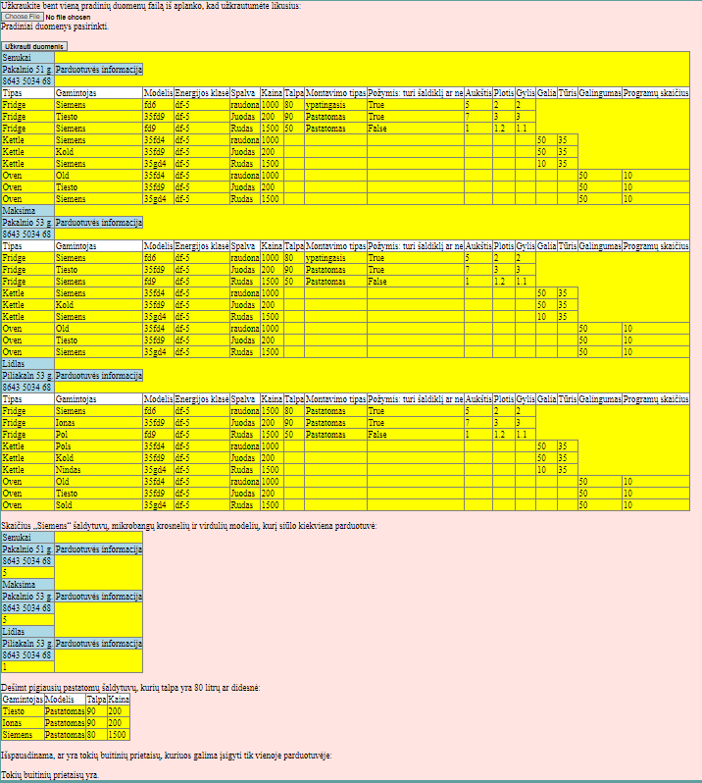

## Dėstytojo pastabos

Gynimo testas: 0

Programa: 6

Ataskaita: 0.5

Bendras įvertinimas: 6

# Deklaratyvusis programavimas (L5)

## Darbo užduotis

LDD_10. Pajamos. Žmonės užsisako spaudą. Užsakymas vyksta metų ribose. Pirmoje failo eilutėje nurodyta įvedimo data (failų daug), o tolesnėse eilutėse nurodyta prenumeratoriaus pavardė, adresas, laikotarpio pradžia (nurodyta sveiku skaičiumi 1..12), laikotarpio ilgis, leidinio kodas, leidinių kiekis. Atskirame faile duota tokia informacija apie leidinius: kodas, pavadinimas, leidėjo pavadinimas, vieno mėnesio kaina. Suskaičiuoti kiekvienam leidėjui nurodyto mėnesio (įvedama klaviatūra) pajamas. Atspausdinkite leidėjų pajamas, surikiuotas pagal dydį ir leidėjų pavadinimus, nurodant ir leidėjų leidinius su jų atneštomis pajamomis. Leidėjų pavadinimai neturi kartotis.

## Grafinės vartotojo sąsajos schema

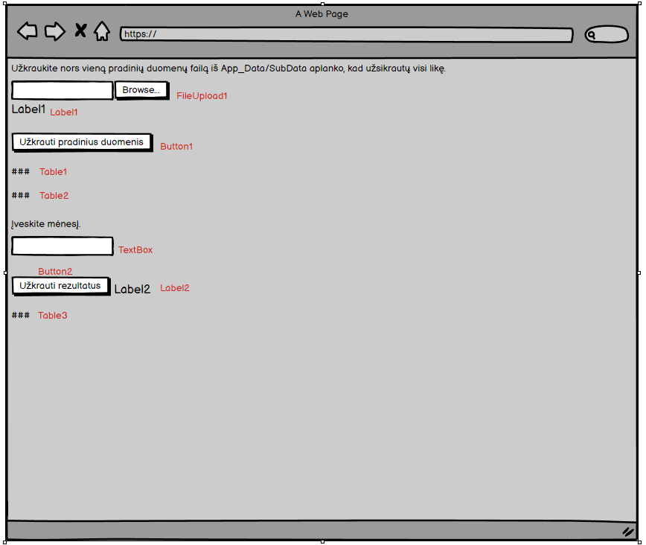

## Sąsajoje panaudotų komponentų keičiamos savybės

|  |  |  |
| --- | --- | --- |
| Komponentas | Savybė | Reikšmė |
| Button1 | Text | Užkrauti pradinius duomenis |
| Table1 | BorderWidth | 1px |
| Table1 | GridLines | Both |
| Table1 | CssClass | Header1 |
| Table1 | ForeColor | Black |
| Table2 | BorderWidth | 1px |
| Table2 | GridLines | Both |
| Table2 | CssClass | Header1 |
| Table2 | ForeColor | Black |
| Table3 | BorderWidth | 1px |
| Table3 | GridLines | Both |
| Table3 | CssClass | Header1 |
| Table3 | CssClass | Header2 |
| Table3 | ForeColor | Black |
| Button2 | Text | Užkrauti rezultatus |

## Klasių diagrama

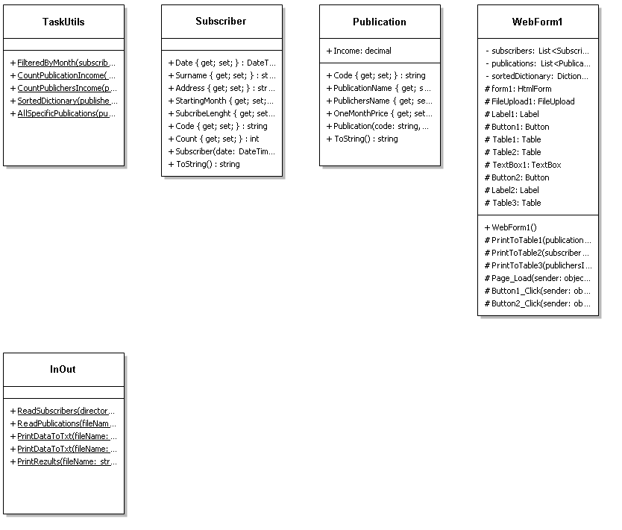

## Programos vartotojo vadovas

Kai atidarome programą, matome vieną vietą skirtą įkeltis nors vienam duomenų failui iš App_Data/SubData aplanko. Pasirinkus vieną duomenų failą, reikia spausti mygtuką: „Užkrauti pradinius duomenis“. Mygtuką paspaudus yra sudaromos dvi pradinių duomenų lentelės. Taip pat pradiniai duomenys yra išspausdinami į GivenData.txt failą. Kai yra užkrauti pradiniai duomenys vartotojas gali spustelti ant laukelio: „Įveskite mėnesį“ ir įvesti tam tikrą mėnesį intervale nuo 1 iki 12. Tada galima spausti mygtuką: „Užkrauti rezultatus“. Paspaudus mygtuką yra užsikraunama trečioji lentelė ir į Rezults.txt išspausdinami gauti rezultatai. Jeigu pradiniai duomenys nėra užkraunami, tai ir rezultatai nėra spausdinami į ekraną ir rezultatų failus. Užkrauti duomenys ekrane yra išsaugomi ir perkrovus puslapį.

## Programos tekstas

InOut.cs

using System;

using System.Collections.Generic;

using System.Linq;

using System.Text;

using System.Threading.Tasks;

using System.IO;

namespace Lab5

{

/// <summary>

/// Class that reads and prints information

/// </summary>

public static class InOut

{

/// <summary>

/// Method that reads information about subscribers from .txt file and forms a list

/// </summary>

/// <param name="directoryName">Name of a data file</param>

/// <returns>Formated list</returns>

public static List<Subscriber> ReadSubscribers(string directoryName)

{

List<Subscriber> AllSubscribers = new List<Subscriber>();

foreach (string fileName in Directory.GetFiles(directoryName, "*.txt"))

{

try

{

string[] Lines = File.ReadAllLines(fileName);

DateTime Date = DateTime.Parse(Lines[0]);

for (int i = 1; i < Lines.Length; i++)

{

string[] Values = Lines[i].Split(';');

string surname = Values[0];

string address = Values[1];

int startingMonth = int.Parse(Values[2]);

int subcribeLenght = int.Parse(Values[3]);

string code = Values[4];

int count = int.Parse(Values[5]);

Subscriber subcriber = new Subscriber(Date, surname, address, startingMonth, subcribeLenght, code, count);

AllSubscribers.Add(subcriber);

}

}

catch(Exception )

{

}

}

return AllSubscribers;

}

/// <summary>

/// Method that reads information about publications from .txt file and forms a list

/// </summary>

/// <param name="fileName">Name of a data file</param>

/// <returns>Formated list</returns>

public static List<Publication> ReadPublications(string fileName)

{

List<Publication> AllPublications = new List<Publication>();

string[] Lines = File.ReadAllLines(fileName);

foreach (string line in Lines)

{

string[] Values = line.Split(';');

string code = Values[0];

string publicationName = Values[1];

string publichersName = Values[2];

decimal oneMonthPrice = decimal.Parse(Values[3]);

Publication publication = new Publication(code, publicationName, publichersName, oneMonthPrice, 0);

AllPublications.Add(publication);

}

return AllPublications;

}

/// <summary>

/// Method that prints information about publications to .txt file

/// </summary>

/// <param name="fileName">Name of a rezults file</param>

/// <param name="publications">List of publications</param>

public static void PrintDataToTxt(string fileName, List<Publication> publications)

{

using (var writer = File.AppendText(fileName))

{

writer.WriteLine(new string('-', 93));

writer.WriteLine(string.Format("| {0, -20} | {1, -20} | {2, -20} | {3, 20} |", "Kodas", "Pavadinimas", "Leidėjo pavadinimas", "Vieno mėnesio kaina"));

writer.WriteLine(new string('-', 93));

foreach (Publication publication in publications)

{

writer.WriteLine(publication.ToString());

}

writer.WriteLine(new string('-', 93));

writer.WriteLine();

writer.Close();

}

}

/// <summary>

/// Method that prints information about subscribers to .txt file

/// </summary>

/// <param name="fileName">Name of a rezults file</param>

/// <param name="subscribers">Subscribers list</param>

public static void PrintDataToTxt(string fileName, List<Subscriber> subscribers)

{

using (var writer = File.AppendText(fileName))

{

writer.WriteLine(new string('-', 162));

writer.WriteLine(string.Format("| {0, -20} | {1, -20} | {2, -20} | {3, 20} | {4, 20} | {5, -20} | {6, 20} |", "Įvedimo data", "Pavardė", "Adresas", "Laikotarpio pradžia", "Laikotarpio ilgis", "Leidinio kodas", "Leidinių kiekis"));

writer.WriteLine(new string('-', 162));

foreach (Subscriber subscriber in subscribers)

{

writer.WriteLine(subscriber.ToString());

}

writer.WriteLine(new string('-', 162));

writer.WriteLine();

writer.Close();

}

}

/// <summary>

/// Method that prints rezults to .txt file

/// </summary>

/// <param name="fileName">Name of a rezults file</param>

/// <param name="publichersInfo">Formated dictionary of publishers and their income</param>

/// <param name="publications">List of publications</param>

public static void PrintRezults(string fileName, Dictionary<string, decimal> publichersInfo, List<Publication> publications)

{

using (var writer = File.CreateText(fileName))

{

writer.WriteLine(string.Format("| {0, 25} | {1, -25} | {2, -25} | {3, 25} |" + "---->", "Leidėjo pajamos", "Leidėjo pavadinimas", "Leidėjo leidiniai", "Leidinių atneštos pajamos"));

foreach (var publisher in publichersInfo)

{

writer.Write(string.Format("| {0, 25} | {1, -25} |", publisher.Value, publisher.Key));

List<Publication> selectedPublications = TaskUtils.AllSpecificPublications(publications, publisher.Key);

foreach (Publication publication in selectedPublications)

{

writer.Write(string.Format(" {0, -25} | {1, 25} |", publication.PublicationName, publication.Income));

}

writer.WriteLine();

}

writer.Close();

}

}

}

}

Publication.cs

using System;

using System.Collections.Generic;

using System.Linq;

using System.Web;

namespace Lab5

{

/// <summary>

/// Class of publication data

/// </summary>

public class Publication

{

/// <summary>

/// Publication code

/// </summary>

public string Code { get; set; }

/// <summary>

/// Name of the publication

/// </summary>

public string PublicationName { get; set; }

/// <summary>

/// Publisher's name

/// </summary>

public string PublichersName { get; set; }

/// <summary>

/// Publication's one month price

/// </summary>

public decimal OneMonthPrice { get; set; }

/// <summary>

/// Publications income

/// </summary>

public decimal Income = 0;

/// <summary>

/// Publication constructor

/// </summary>

/// <param name="code">Publication code</param>

/// <param name="publicationName">Name of the publication</param>

/// <param name="publichersName">Publisher's name</param>

/// <param name="oneMonthPrice">Publication's one month price</param>

/// <param name="income">Publications income</param>

public Publication(string code, string publicationName, string publichersName, decimal oneMonthPrice, decimal income)

{

this.Code = code;

this.PublicationName = publicationName;

this.PublichersName = publichersName;

this.OneMonthPrice = oneMonthPrice;

this.Income = income;

}

/// <summary>

/// Overriden ToString method

/// </summary>

/// <returns>Formated line of text</returns>

public override string ToString()

{

return string.Format("| {0, -20} | {1, -20} | {2, -20} | {3, 20} |", Code, PublicationName, PublichersName, OneMonthPrice);

}

}

}

Subscriber.cs

using System;

using System.Collections.Generic;

using System.Linq;

using System.Web;

namespace Lab5

{

/// <summary>

/// Class of subscriber data

/// </summary>

public class Subscriber

{

/// <summary>

/// Date of when a subscriber was put on a formated list

/// </summary>

public DateTime Date { get; set; }

/// <summary>

/// Subscribers surname

/// </summary>

public string Surname { get; set; }

/// <summary>

/// Subscribers address

/// </summary>

public string Address { get; set; }

/// <summary>

/// Starting date of the subscribtion

/// </summary>

public int StartingMonth { get; set; }

/// <summary>

/// Subscribtion lenght

/// </summary>

public int SubcribeLenght { get; set; }

/// <summary>

/// Code of the publication

/// </summary>

public string Code { get; set; }

/// <summary>

/// Number of publications

/// </summary>

public int Count { get; set; }

/// <summary>

/// Subscriber's constructor

/// </summary>

/// <param name="date">Date of when a subscriber was put on a formated list</param>

/// <param name="surname">Subscribers surname</param>

/// <param name="address">Subscribers address</param>

/// <param name="startingMonth">Starting date of the subscribtion</param>

/// <param name="subcribeLenght">Subscribtion lenght</param>

/// <param name="code">Code of the publication</param>

/// <param name="count">Number of publications</param>

public Subscriber(DateTime date, string surname, string address, int startingMonth, int subcribeLenght, string code, int count)

{

this.Date = date;

this.Surname = surname;

this.Address = address;

this.StartingMonth = startingMonth;

this.SubcribeLenght = subcribeLenght;

this.Code = code;

this.Count = count;

}

/// <summary>

/// Overriden ToString method

/// </summary>

/// <returns></returns>

public override string ToString()

{

return string.Format("| {0, -20:yyyy-MM-dd} | {1, -20} | {2, -20} | {3, 20} | {4, 20} | {5, -20} | {6, 20} |", Date, Surname, Address, StartingMonth, SubcribeLenght, Code, Count);

}

}

}

TaskUtils.cs

using System;

using System.Collections.Generic;

using System.Linq;

using System.Linq.Expressions;

using System.Web;

namespace Lab5

{

/// <summary>

/// Class that does calculations

/// </summary>

public static class TaskUtils

{

/// <summary>

/// Method that forms a list of subscribers filtered by month

/// </summary>

/// <param name="subscribers">List of subscribers</param>

/// <param name="month">Certain month</param>

/// <returns>Formated list</returns>

public static List<Subscriber> FilteredByMonth(List<Subscriber> subscribers, int month)

{

List<Subscriber> selectedSubscribers = new List<Subscriber>();

subscribers.ForEach(subscriber =>

{

{

int subscribtionPeriod = subscriber.StartingMonth + subscriber.SubcribeLenght;

int startAgain = 1000;

for (int i = subscriber.StartingMonth; i <= subscribtionPeriod; i++)

{

if (i > 12)

{

startAgain = i - 12;

}

if (i == month || startAgain == month)

{

selectedSubscribers.Add(subscriber);

}

}

}

});

return selectedSubscribers;

}

/// <summary>

/// Method that counts income of publications

/// </summary>

/// <param name="subscribers">List of subscribers</param>

/// <param name="publications">List of publications</param>

public static void CountPublicationIncome(List<Subscriber> subscribers, List<Publication> publications)

{

subscribers.ForEach(subscriber =>

{

publications.ForEach(publication =>

{

if (subscriber.Code == publication.Code)

{

publication.Income = publication.Income + subscriber.Count * publication.OneMonthPrice;

}

});

});

}

/// <summary>

/// Method that forms a dictionary of publishers and their income

/// </summary>

/// <param name="publications">List of publications</param>

/// <returns>Formated dictionary</returns>

public static Dictionary<string, decimal> CountPublichersIncome(List<Publication> publications)

{

Dictionary<string, decimal> totalIncome = new Dictionary<string, decimal>();

List<string> list = new List<string>();

publications.ForEach(publication =>

{

if (!list.Contains(publication.PublichersName) && publication.Income != 0)

{

decimal sum = publications.Where(x => x.PublichersName == publication.PublichersName).Sum(p => p.Income);

list.Add(publication.PublichersName);

totalIncome.Add(publication.PublichersName, sum);

}

});

return totalIncome;

}

/// <summary>

/// Method that forms a sorted dictionary of certain keys and values

/// </summary>

/// <param name="publishersInfo">Dictionary of publishers and their income</param>

/// <returns>Formated dictionary</returns>

public static Dictionary<string, decimal> SortedDictionary(Dictionary<string, decimal> publishersInfo)

{

publishersInfo = publishersInfo.OrderByDescending(x => x.Value).ThenByDescending(x => x.Key).ToDictionary(x => x.Key, y => y.Value);

return publishersInfo;

}

/// <summary>

/// Method that forms a list of certain publishers

/// </summary>

/// <param name="publications">List of publications</param>

/// <param name="publicher">Publisher's name</param>

/// <returns>Formated list</returns>

public static List<Publication> AllSpecificPublications(List<Publication> publications, string publicher)

{

publications = publications.Where(x => x.PublichersName == publicher).ToList();

return publications;

}

}

}

Main2.cs

using System;

using System.Collections.Generic;

using System.Linq;

using System.Web;

using System.Web.UI;

using System.Web.UI.WebControls;

using System.IO;

namespace Lab5

{

/// <summary>

/// Web form

/// </summary>

public partial class WebForm1 : System.Web.UI.Page

{

/// <summary>

/// Method that forms a first table

/// </summary>

/// <param name="publications">List of publications</param>

protected void PrintToTable1(List<Publication> publications)

{

TableRow row0 = new TableRow();

TableCell cell0 = new TableCell();

TableCell cell1 = new TableCell();

TableCell cell2 = new TableCell();

TableCell cell3 = new TableCell();

cell0.Text = "Kodas";

cell1.Text = "Pavadinimas";

cell2.Text = "Leidėjo pavadinimas";

cell3.Text = "Vieno mėnesio kaina";

row0.Cells.Add(cell0);

row0.Cells.Add(cell1);

row0.Cells.Add(cell2);

row0.Cells.Add(cell3);

row0.CssClass = "Header1";

Table1.Rows.Add(row0);

foreach (Publication publication in publications)

{

TableRow row1 = new TableRow();

TableCell cell4 = new TableCell();

TableCell cell5 = new TableCell();

TableCell cell6 = new TableCell();

TableCell cell7 = new TableCell();

cell4.Text = string.Format("{0}", publication.Code);

cell5.Text = string.Format("{0}", publication.PublicationName);

cell6.Text = string.Format("{0}", publication.PublichersName);

cell7.Text = string.Format("{0}", publication.OneMonthPrice);

row1.Cells.Add(cell4);

row1.Cells.Add(cell5);

row1.Cells.Add(cell6);

row1.Cells.Add(cell7);

Table1.Rows.Add(row1);

}

}

/// <summary>

/// Method that forms a second table

/// </summary>

/// <param name="subscribers">List of subscribers</param>

protected void PrintToTable2(List<Subscriber> subscribers)

{

TableRow row0 = new TableRow();

TableCell cell0 = new TableCell();

TableCell cell1 = new TableCell();

TableCell cell2 = new TableCell();

TableCell cell3 = new TableCell();

TableCell cell4 = new TableCell();

TableCell cell5 = new TableCell();

TableCell cell6 = new TableCell();

cell0.Text = "Įvedimo data";

cell1.Text = "Pavardė";

cell2.Text = "Adresas";

cell3.Text = "Laikotarpio pradžia";

cell4.Text = "Laikotarpio ilgis";

cell5.Text = "Leidinio kodas";

cell6.Text = "Leidinių kiekis";

row0.Cells.Add(cell0);

row0.Cells.Add(cell1);

row0.Cells.Add(cell2);

row0.Cells.Add(cell3);

row0.Cells.Add(cell4);

row0.Cells.Add(cell5);

row0.Cells.Add(cell6);

row0.CssClass = "Header1";

Table2.Rows.Add(row0);

foreach (Subscriber subscriber in subscribers)

{

TableRow row1 = new TableRow();

TableCell cell7 = new TableCell();

TableCell cell8 = new TableCell();

TableCell cell9 = new TableCell();

TableCell cell10 = new TableCell();

TableCell cell11 = new TableCell();

TableCell cell12 = new TableCell();

TableCell cell13 = new TableCell();

cell7.Text = string.Format("{0:yyyy-MM-dd}", subscriber.Date);

cell8.Text = string.Format("{0}", subscriber.Surname);

cell9.Text = string.Format("{0}", subscriber.Address);

cell10.Text = string.Format("{0}", subscriber.StartingMonth);

cell11.Text = string.Format("{0}", subscriber.SubcribeLenght);

cell12.Text = string.Format("{0}", subscriber.Code);

cell13.Text = string.Format("{0}", subscriber.Count);

row1.Cells.Add(cell7);

row1.Cells.Add(cell8);

row1.Cells.Add(cell9);

row1.Cells.Add(cell10);

row1.Cells.Add(cell11);

row1.Cells.Add(cell12);

row1.Cells.Add(cell13);

Table2.Rows.Add(row1);

}

}

/// <summary>

/// Method that forms a third table

/// </summary>

/// <param name="publichersInfo">Formated dictionary of publishers and their income</param>

/// <param name="publications">List of publications</param>

protected void PrintToTable3(Dictionary<string, decimal> publichersInfo, List<Publication> publications)

{

foreach (var publisher in publichersInfo)

{

TableRow row0 = new TableRow();

TableCell cell0 = new TableCell();

TableCell cell1 = new TableCell();

cell0.Text = "Leidėjo pavadinimas";

cell1.Text = "Leidėjo pajamos";

row0.Cells.Add(cell0);

row0.Cells.Add(cell1);

row0.CssClass = "Header1";

Table3.Rows.Add(row0);

TableRow row1 = new TableRow();

TableCell cell2 = new TableCell();

TableCell cell3 = new TableCell();

cell2.Text = string.Format("{0}", publisher.Key);

cell3.Text = string.Format("{0}", publisher.Value);

row1.Cells.Add(cell2);

row1.Cells.Add(cell3);

Table3.Rows.Add(row1);

TableRow row2 = new TableRow();

TableCell cell4 = new TableCell();

TableCell cell5 = new TableCell();

cell4.Text = "Leidėjo leidiniai";

cell5.Text = "Leidinių atneštos pajamos";

row2.Cells.Add(cell4);

row2.Cells.Add(cell5);

row2.CssClass = "Header2";

Table3.Rows.Add(row2);

List<Publication> selectedPublications = TaskUtils.AllSpecificPublications(publications, publisher.Key);

foreach (Publication publication in selectedPublications)

{

TableRow row3 = new TableRow();

TableCell cell6 = new TableCell();

TableCell cell7 = new TableCell();

cell6.Text = string.Format("{0}", publication.PublicationName);

cell7.Text = string.Format("{0}", publication.Income);

row3.Cells.Add(cell6);

row3.Cells.Add(cell7);

Table3.Rows.Add(row3);

}

}

}

}

}

StyleSheet.css

.Header1{

background-color:aqua;

}

.Header2 {

background-color: antiquewhite;

}

WebForm1.aspx

<%@ Page Language="C#" AutoEventWireup="true" CodeBehind="WebForm1.aspx.cs" Inherits="Lab5.WebForm1" %>

<!DOCTYPE html>

<html xmlns="http://www.w3.org/1999/xhtml">

<head runat="server">

<title></title>

<link href="StyleSheet.css" rel="stylesheet" type="text/css" />

</head>

<body>

<form id="form1" runat="server">

<div>

Užkraukite nors vieną pradinių duomenų failą iš App_Data/SubData aplanko, kad užsikrautų visi likę.<br />

<br />

<asp:FileUpload ID="FileUpload1" runat="server" />

<br />

<asp:Label ID="Label1" runat="server"></asp:Label>

<br />

<br />

<asp:Button ID="Button1" runat="server" OnClick="Button1_Click" Text="Užkrauti pradinius duomenis" />

<br />

<br />

<asp:Table ID="Table1" runat="server" BorderWidth="1px" ForeColor="Black" GridLines="Both">

</asp:Table>

<br />

<asp:Table ID="Table2" runat="server" BorderWidth="1px" ForeColor="Black" GridLines="Both">

</asp:Table>

<br />

Įveskite mėnesį.<br />

<asp:TextBox ID="TextBox1" runat="server"></asp:TextBox>

&nbsp;<br />

<br />

<asp:Button ID="Button2" runat="server" Text="Užkrauti rezultatus" OnClick="Button2_Click" />

&nbsp;

<asp:Label ID="Label2" runat="server"></asp:Label>

<br />

<br />

<asp:Table ID="Table3" runat="server" BorderWidth="1px" ForeColor="Black" GridLines="Both">

</asp:Table>

</div>

</form>

</body>

</html>

WebForm1.aspx.cs

using System;

using System.Collections.Generic;

using System.Linq;

using System.Web;

using System.Web.UI;

using System.Web.UI.WebControls;

using System.IO;

//Main function of this program is to do all kinds of calculations with given data of devices in shops

//Vytenis Kriščiūnas

namespace Lab5

{

/// <summary>

/// Web form

/// </summary>

public partial class WebForm1 : System.Web.UI.Page

{

/// <summary>

/// List of subscribers

/// </summary>

List<Subscriber> subscribers = new List<Subscriber>();

/// <summary>

/// List of publications

/// </summary>

List<Publication> publications = new List<Publication>();

/// <summary>

/// Dictionary of sorted information

/// </summary>

Dictionary<string, decimal> sortedDictionary = new Dictionary<string, decimal>();

/// <summary>

/// Method that prints information to the screen when page loads

/// </summary>

/// <param name="sender">An object variable</param>

/// <param name="e">EventArgs variable</param>

protected void Page_Load(object sender, EventArgs e)

{

Label1.Text = "Pradiniai duomenys nepasirinkti";

subscribers = Session["1"] as List<Subscriber>;

publications = Session["2"] as List<Publication>;

sortedDictionary = Session["4"] as Dictionary<string, decimal>;

if (subscribers != null && publications != null)

{

Label1.Text = "Pradiniai duomenys užkrauti";

PrintToTable1(publications);

PrintToTable2(subscribers);

}

if (sortedDictionary != null)

{

PrintToTable3(sortedDictionary, publications);

}

}

/// <summary>

/// Prints and reads given information when the first button is clicked

/// </summary>

/// <param name="sender">An object variable</param>

/// <param name="e">EventArgs variable</param>

protected void Button1_Click(object sender, EventArgs e)

{

for (int i = Table1.Rows.Count - 1; i >= 0; i--)

{

Table1.Rows.RemoveAt(i);

}

for (int i = Table2.Rows.Count - 1; i >= 0; i--)

{

Table2.Rows.RemoveAt(i);

}

for (int i = Table3.Rows.Count - 1; i >= 0; i--)

{

Table3.Rows.RemoveAt(i);

}

Session.Clear();

string FilesPath = Server.MapPath("App_Data/SubData");

string FilePath = Server.MapPath("App_Data/PublicationsData.txt");

string GivenData = Server.MapPath("App_Data/Rezults/GivenData.txt");

File.Delete(GivenData);

Label1.Text = "Pradiniai duomenys nepasirinkti";

Label2.Text = "";

if (FileUpload1.HasFile)

{

Label1.Text = "Pradiniai duomenys užkrauti";

subscribers = InOut.ReadSubscribers(FilesPath);

publications = InOut.ReadPublications(FilePath);

Session["1"] = subscribers;

Session["2"] = publications;

InOut.PrintDataToTxt(GivenData, publications);

InOut.PrintDataToTxt(GivenData, subscribers);

PrintToTable1(publications);

PrintToTable2(subscribers);

}

}

/// <summary>

/// Prints and does calculations when the second button is clicked

/// </summary>

/// <param name="sender">An object variable</param>

/// <param name="e">EventArgs variable</param>

protected void Button2_Click(object sender, EventArgs e)

{

string Rezults = Server.MapPath("App_Data/Rezults/Rezults.txt");

File.Delete(Rezults);

Label2.Text = "";

try

{

publications.ForEach(x => x.Income = 0);

for (int i = Table3.Rows.Count - 1; i >= 0; i--)

{

Table3.Rows.RemoveAt(i);

}

List<Subscriber> selectedSubscribers = TaskUtils.FilteredByMonth(subscribers, int.Parse(TextBox1.Text));

if (selectedSubscribers[0].Surname != null)

{

TaskUtils.CountPublicationIncome(selectedSubscribers, publications);

Dictionary<string, decimal> publishersInfo = TaskUtils.CountPublichersIncome(publications);

sortedDictionary = TaskUtils.SortedDictionary(publishersInfo);

Session["4"] = sortedDictionary;

InOut.PrintRezults(Rezults, sortedDictionary, publications);

PrintToTable3(sortedDictionary, publications);

}

}

catch (Exception)

{

Label2.Text = "Užkrauti rezultatų nepavyko.";

}

}

}

}

## Pradiniai duomenys ir rezultatai

Pirmi duomenys

Data1.txt

2002-05-03

Jasikevicius;Pil 71;6;3;OF 1;2

Paulavicius;Osupipo 2;4;3;OF 2;1

Valancius;Pakalnio 5;3;7;IF 3;5

Toms;Pusu 5;7;1;LF 1;10

Data2.txt

2003-05-03

Jasikevicius;Pil 71;6;3;OF 1;2

Paulavicius;Osupipo 2;4;3;OF 2;1

Valancius;Pakalnio 5;3;7;IF 3;5

Data3.txt

2006-05-03

Jasikevicius;Pil 71;6;3;OF 1;2

Paulavicius;Osupipo 2;4;3;OF 2;1

Valancius;Pakalnio 5;3;7;IF 3;5

PublicationData.txt

OF 1;Zara;Rytas;10

OF 2;Dora;Rytas;15

IF 3;Lolas;Kauno diena;5

LF 1;Diras;Sauksmas;1000

GivenData.txt

---------------------------------------------------------------------------------------------

| Kodas | Pavadinimas | Leidėjo pavadinimas | Vieno mėnesio kaina |

---------------------------------------------------------------------------------------------

| OF 1 | Zara | Rytas | 10 |

| OF 2 | Dora | Rytas | 15 |

| IF 3 | Lolas | Kauno diena | 5 |

| LF 1 | Diras | Sauksmas | 1000 |

---------------------------------------------------------------------------------------------

------------------------------------------------------------------------------------------------------------------------------------------------------------------

| Įvedimo data | Pavardė | Adresas | Laikotarpio pradžia | Laikotarpio ilgis | Leidinio kodas | Leidinių kiekis |

------------------------------------------------------------------------------------------------------------------------------------------------------------------

| 2002-05-03 | Jasikevicius | Pil 71 | 6 | 3 | OF 1 | 2 |

| 2002-05-03 | Paulavicius | Osupipo 2 | 4 | 3 | OF 2 | 1 |

| 2002-05-03 | Valancius | Pakalnio 5 | 3 | 7 | IF 3 | 5 |

| 2002-05-03 | Toms | Pusu 5 | 7 | 1 | LF 1 | 10 |

| 2003-05-03 | Jasikevicius | Pil 71 | 6 | 3 | OF 1 | 2 |

| 2003-05-03 | Paulavicius | Osupipo 2 | 4 | 3 | OF 2 | 1 |

| 2003-05-03 | Valancius | Pakalnio 5 | 3 | 7 | IF 3 | 5 |

| 2006-05-03 | Jasikevicius | Pil 71 | 6 | 3 | OF 1 | 2 |

| 2006-05-03 | Paulavicius | Osupipo 2 | 4 | 3 | OF 2 | 1 |

| 2006-05-03 | Valancius | Pakalnio 5 | 3 | 7 | IF 3 | 5 |

------------------------------------------------------------------------------------------------------------------------------------------------------------------

Rezults.txt

| Leidėjo pajamos | Leidėjo pavadinimas | Leidėjo leidiniai | Leidinių atneštos pajamos |---->

| 10000 | Sauksmas | Diras | 10000 |

| 105 | Rytas | Zara | 60 | Dora | 45 |

| 75 | Kauno diena | Lolas | 75 |

Vartotojo sąsaja

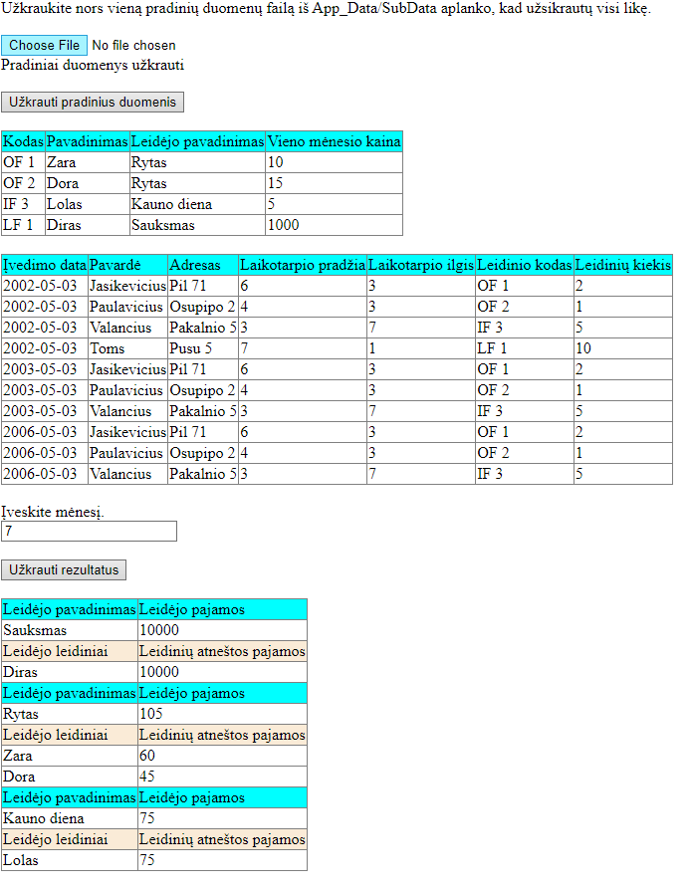

Antri duomenys

Data1.txt

2002-05-03

Toms;Pusu 5;7;1;LF 1;10

Data2.txt – Šis failas yra tuščias.

Data3.txt – Šis failas yra tuščias.

PublicationData.txt

LF 1;Diras;Sauksmas;1000

GivenData.txt

---------------------------------------------------------------------------------------------

| Kodas | Pavadinimas | Leidėjo pavadinimas | Vieno mėnesio kaina |

---------------------------------------------------------------------------------------------

| LF 1 | Diras | Sauksmas | 1000 |

---------------------------------------------------------------------------------------------

------------------------------------------------------------------------------------------------------------------------------------------------------------------

| Įvedimo data | Pavardė | Adresas | Laikotarpio pradžia | Laikotarpio ilgis | Leidinio kodas | Leidinių kiekis |

------------------------------------------------------------------------------------------------------------------------------------------------------------------

| 2002-05-03 | Toms | Pusu 5 | 7 | 1 | LF 1 | 10 |

------------------------------------------------------------------------------------------------------------------------------------------------------------------

Rezults.txt

| Leidėjo pajamos | Leidėjo pavadinimas | Leidėjo leidiniai | Leidinių atneštos pajamos |---->

| 10000 | Sauksmas | Diras | 10000 |

Vartotojo sąsaja

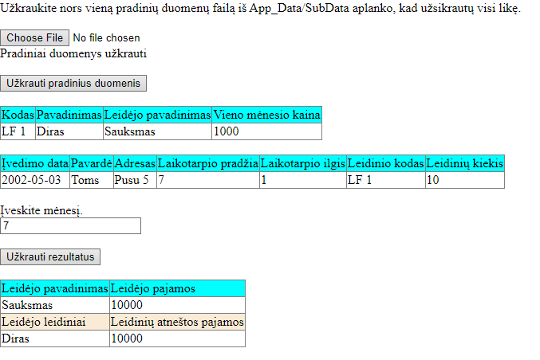

## Dėstytojo pastabos